Compression Garments and Recovery from Exercise – A Meta-Analysis
Freddy Brown¹, Conor Gissane¹, Glyn Howatson^{2, 4}, Ken van Someren³, Charles Pedlar¹, Jessica Hill¹
School of Sport, Health and Applied Science,
¹ School of Sport, Health and Applied Science, St Mary’s University College, Twickenham, UK
² Faculty of Health and Life of Sciences, Northumbria University, Newcastle Upon Tyne, UK
³ GSK Human Performance Lab, GlaxoSmithKline Consumer Healthcare, London, UK
⁴ Water Research Group, Northwest University, Potchefstroom, South Africa

Corresponding author:
Freddy Brown
Email: Freddy.Brown@stmarys.ac.uk
Affiliation: School of Sport, Health and Applied Science, St Mary’s University College, Twickenham, UK
Telephone: +44 (0) 7746 075 151

Compression Garments and Recovery from Exercise – A Meta-Analysis
Running title - Compression Garments and Recovery from Exercise

Word Count - 5945

Abstract
Background: Adequate recovery from exercise is essential to maintain performance throughout training and competition. While compression garments (CG) have been demonstrated to accelerate recovery, the literature is clouded by conflicting results and uncertainty over the optimal conditions of use.
Objectives: A meta-analysis was conducted to assess the effects of compression garments on the recovery of strength, power and endurance performance following an initial bout of resistance, running, or non-load bearing endurance (metabolic) exercise.
Methods: Change-score data were extracted from 23 peer-reviewed studies on healthy participants. Recovery was quantified by converting into standardized mean effect sizes (ES [± 95% confidence interval (CI)]). The effects of time (0-2 h, 2-8 h, 24 h, > 24 h), pressure (≤ 15 mmHg Vs. > 15 mmHg) and training status (trained Vs. untrained) were also assessed.
Results: Compression garments demonstrated small, very likely benefits (p < 0.001, ES = 0.38 [95% CI 0.25, 0.51]), which were not influenced by pressure (p = 0.06) or training status (p = 0.64). Strength recovery was subject to greater benefits than other outcomes (p < 0.001, ES = 0.62 [95% CI 0.39, 0.84]), displaying large, very likely benefits at 2-8 h (p < 0.001, ES = 1.14 [95% CI 0.72, 1.56]) and > 24 h (p < 0.001, ES = 1.03 [95% CI 0.48, 1.57]). Recovery from using CG was greatest following resistance exercise (p < 0.001, ES = 0.49 [95% CI 0.37, 0.61]), demonstrating the largest, very likely benefits at > 24 h (p < 0.001, ES = 1.33 [95% CI 0.80, 1.85]). Recovery from metabolic exercise (p = 0.01) was significant, although large, very likely benefits emerged only for cycling performance at 24 h post-exercise (p = 0.01, ES = 1.05 [95% CI 0.25, 1.85]).
Conclusion: The largest benefits resulting from CG were for strength recovery from 2-8 h, and > 24 h. Considering exercise modality, compression most effectively enhanced recovery from resistance exercise, particularly at time-points > 24 h. The use of CG would also be recommended to enhance next-day cycling performance. The benefits of CG in relation to applied pressures and participant training status are unclear and limited by the paucity of reported data.
Key Points
• Small, significant and very likely benefits on exercise recovery can be achieved through use of compression garments (CG).
• The greatest benefits from CG are evident in recovery of strength performance and from resistance exercise, which may imply that CG ameliorate muscle damage.
• Next day cycling performance was also subject to large very likely benefits following the use of CG.

1. Introduction
1.1 Background
Establishing effective recovery methods for elite athletes is essential in order to increase the likelihood of victory, and to maintain training intensity in the face of ever improving performances and increasing training loads [1, 2]. While maintaining a high volume and intensity of training is necessary for optimising training adaptation [3] athletes must also aim to preserve competitive performance throughout multiple weekly [4], or even daily contests [5]. In short, athletes who recover faster are likely to perform better and train harder [6].
Recent years have seen the emergence of a number of interventions aimed at accelerating recovery, including cold water immersion [7], contrast bathing [8], and compression garments [9]. However, recovery demands following training are highly specific to the intensity, duration and modality of exercise [10]. For example, whereas cycling performance is limited by metabolite accumulation and substrate depletion [11], it is also subject to relatively low levels of muscle damage, in comparison to load bearing exercise [12]. Such specificity may in part explain the conflicting evidence surrounding many emerging recovery interventions, as the damage incurred by different activities will require distinct physiological processes for regeneration [13]. Proper consideration of both exercise modality and subsequent performance outcome is therefore integral to the efficacy of any recovery strategy [10, 13].

In particular, the use of compression garments (CG) for recovery has been the subject of much speculation over the physiological mechanisms responsible [9, 14]. Compression has been proposed to prevent performance deterioration and improve recovery by accelerating nutrient delivery [15, 16] and metabolite removal [17, 18], as well by ameliorating post-exercise oedema, delayed onset muscle soreness (DOMS), and muscle damage [19]. More importantly, such physiological benefits to recovery are frequently observed alongside accelerated recovery of muscular power [20], strength [21, 22] and endurance. As athletic performance is a composite of many physiological and psychological factors, it is possible that CG aid recovery on a number of levels. One of the most thoroughly investigated mechanisms for the benefits of CG [16, 19, 21] is the potential of such garments to minimise the symptoms of the exercise induced muscle damage (EIMD) which typically occurs as a result of unaccustomed or eccentric exercise [23]. Whilst eccentric exercise is beneficial for training power [24, 25], strength and hypertrophy [26], such exercise is extremely damaging. Strength production may be impaired for up to 10 days [27, 28], while EIMD is also associated with both swelling and DOMS which typically peak between 36 and 48 h [19]. Furthermore, as any load-bearing exercise will induce EIMD due to the inherent eccentric nature of running [12], muscle damage is an inescapable part of training for the majority of athletes.

Whilst the mechanisms behind the recovery benefits of CG are still unclear, the application of external compression is known to influence several areas of haemodynamic and cellular function [29]. In a clinical setting CG have been shown to compress dilated veins and reduce venous reflux to enhance venous return and reduce oedema [30]. This also increases “muscle pump” to accelerate blood flow [31]. A similar mechanism may underlie the benefits of CG in an exercise setting. For example, enhanced recovery of strength and power performance is frequently reported alongside reduced levels of oedema [19]. While the successful management of oedema helps to reduce DOMS and increase mobility [16], this effect may also attenuate the progression of muscle damage. Fluid accumulation in muscle tissue increases osmotic pressure and subsequent cell lysis [32], while CG have been shown to reduce cellular trauma alongside swelling [30, 32]. Reductions in circulating levels of the intramuscular protein creatine kinase (CK) are frequently reported when CG are worn following exercise [19, 20, 33]. Haemodynamic effects of CG have also been postulated to aid recovery by enhancing levels of nutrient delivery [15, 16] and metabolite removal [34, 35]. Accordingly, observations of reduced muscle damage following post-exercise compression have been suggested to reflect enhanced cellular regeneration and protein synthesis [16] made possible by enhanced circulation [17].

Despite the prevailing consensus shifting in favour of CG as a recovery aid [9, 22, 36], recent reviews highlight inconsistent and variable results [9, 14, 34, 37]. For example, the recovery of strength has been frequently improved by CG at time-points over 24 h, with reported benefits over controls consistently ranging from between 5% and 10% [9, 19, 21, 34, 38]. Conversely, CG were associated with impaired recovery of acceleration (2.5%) compared with controls following a three day basketball tournament [6], while recent reviews suggest compression confers only trivial effects on recovery from running [37, 39]. These discrepancies are likely due to the specific nature of post-exercise recovery demands arising from distinct exercise challenges and subsequent performance measures [12]. Variation in the populations studied may also influence the efficacy of CG [14, 40]. EIMD is known to elicit protective neurophysiological adaptations that reduce the damage arising from subsequent bouts [41]. This phenomenon has been termed repeated bout effect and has been seen to last at least six months in untrained participants [40], becoming less pronounced as tolerance to EIMD improves in line with training status [41]. Training history may therefore influence the efficacy of CG. In addition, variation in the duration of CG application, whether CG are worn during and after, or after exercise only, as well as the assessment of recovery at different time-points, all continue to obstruct researchers’ ability to draw definitive conclusions [14, 34, 39].

As compression garments are defined by the capacity to provide external pressure to the body surface [14], it could be argued that controlling for exerted pressure is the foremost priority for making any firm conclusions on efficacy. Many clinical benefits of CG appear to be proportional to the pressure they exert, from reducing swelling [29, 42] to augmenting blood-flow [43]. However, many studies have neglected to report the pressures applied by CG [22], have calculated pressures by indirect modelling techniques [19], estimated pressures from manufacturer recommendations [33] or have cited pressures measured in prior trials [44]. These inconsistencies have prevented definitive conclusions being made on the effects of CG pressure on recovery [34, 39] as indirect measures would likely be inaccurate given the wide variation arising from anthropometric differences [45]. As a result, off-the-shelf garments fitted according to the height and mass of an individual are unlikely to fit correctly. The relationship between the pressures exerted by CG and the ensuing recovery benefits has yet to be elucidated.
1.2 Objectives
The aim of this analysis was to systematically review the effects of CG for exercise recovery, in relation to exercise modality, subsequent performance outcomes, the duration and timing of CG application, participant training status and applied pressure.

2. Methods
2.1 Literature Search
Randomised controlled trials (RCTs) on the use of CG for performance-recovery in healthy humans were identified following a search of academic databases using the following terms: ((compression garment OR compression tights OR compression stockings OR tights OR stockings OR garments) AND recovery AND (exercise OR EIMD OR performance OR recovery OR sport OR athlete)). The databases SPORTDiscus, Web of Science and PubMed were used to identify academic papers (written in English), from the start of records until May 2016. Relevant papers were used for reference and citation searching. Only articles from peer-reviewed academic journals were included. Results were also screened with use of the Web of Science filters for “categories” (biochemical research methods OR biochemistry OR molecular biology OR biology OR physiology OR applied chemistry OR materials science OR biomaterials OR sport sciences OR engineering (biomedical)) AND “research areas” (sport sciences OR life sciences OR biomedicine OR biochemistry OR molecular biology).

Figure 1. Schematic of study selection, from initial search to included studies

2.2 Outcome variables
Changes from baseline scores were extracted from studies that assessed the effects of CG (all types) compared to a control condition on the recovery of maximal physical performance following exercise. Standardized mean effect sizes (ES) were calculated from the differences in pre-post change scores between CG and control groups, using the standard deviation of these changes (SD_{change}). Accepted performance outcomes included the following; strength, power, and endurance. Power outcomes had to measure the rate at which force was applied, and therefore included jump height, sprint speed/time, and wattage from force dynamometry protocols. Endurance performance however, was defined as any continuous measured outcome which surpassed 1 min duration and would be limited by aerobic capacity (below which outcomes were classified as power). Strength measures must have reported performance in units of mass, weight or force, and included force dynamometry, as well as total and maximum loads lifted in resistance protocols. To differentiate between trials assessing recovery and performance, only studies that featured a temporal separation between an initial damaging intervention and subsequent performance tests were included. For example, bouts of repeated sprinting or resistance exercise that featured rests between sets met our criteria if CG were worn throughout recovery periods.

2.3 Inclusion and exclusion criteria
Studies that did not yield change-score data were excluded from the analysis. Trials were excluded if CG were used in combination with an additional treatment (e.g. nutritional supplements), and if CG were not worn during or immediately after exercise (within two hours). Studies were therefore excluded if CG were worn only throughout exercise and subsequently removed before the recovery period. Studies of clinical populations were excluded, as were studies that failed to provide sufficient data for the analysis of effect size.

2.4 Data collection and risk of bias assessment
Change scores were extracted or calculated from selected studies. Where insufficient raw data were reported, these were requested from corresponding authors or extrapolated from figures after digital magnification. In accordance with current guidelines for conducting meta-analyses [46], where SD_{change} was not available, values were calculated using a correlation coefficient derived from studies which provided sufficient data [33, 44, 47]. Results were assessed with the I² statistic, quantifying the percentage of variability in ES from heterogeneity, rather than chance [48]. This was used to guide subsequent subgroup analysis. Risk of bias (Figure 2) was reported in accordance with current consensus [46].

2.5 Stratification of studies
Studies were categorised into three groups, according to the characteristics of the exercise used prior to the CG recovery intervention. The stratification was guided by the results of previous research, noting differences in recovery demands between high-intensity sports and lab-based eccentric damage protocols [7]. Accordingly, papers were grouped into studies on resistance exercise (defined as those which specifically targeted muscle damage with resistance training, force dynamometry or drop-jumps), running, and metabolic exercise protocols (defined as non-load bearing endurance exercise, which included cycling or skiing ergometry). Subsequently, results were also analysed according to performance measures, being divided into strength, power and endurance outcomes. Furthermore, the relative benefits of CG were assessed in relation to the time-point of subsequent testing, results being grouped into those taken at 0-2 h, 2-8 h, 24 h, and > 24 h. Additionally, the influence of pressure on recovery was assessed by grouping studies into those which applied a (directly measured) minimum of ≥ 15 mmHg at the thigh, or those which utilised looser fitting garments. This level of compression pressure is required for enhanced venous return [43]. Finally, studies were also grouped according to participant training status, trained individuals being defined as those regularly competing in a given sport, belonging to a sports club, or those regularly exercising three or more times per week. Participants were classified as untrained if described as such by the authors [19, 49], or were inexperienced in the exercise modality that was studied [50, 51].
2.6 Statistical analysis
Data were analysed using the RevMan statistical software package (Version 5.0., Copenhagen: The Nordic Cochrane Centre, The Cochrane Collaboration, 2007) [46]. Standardized mean effect sizes and 95% confidence intervals (CI) were reported as (ES [LCL, UCL]), where LCL and UCL represent the lower and upper 95% confidence limits respectively. Subgroup-differences were presented as p values with χ² scores, while the likelihood of independent results were presented as p values alongside corresponding z scores. The threshold values for standardized changes were as follows: ≤ 0.2 (trivial), > 0.2 (small), > 0.5 (moderate), > 0.8 (large), where 0.2 was taken to represent the smallest worthwhile effect [52]. Setting the threshold for statistical significance at p = 0.05, changes were deemed very likely beneficial if the 95% confidence interval cleared the threshold for the smallest worthwhile change [36, 52]. Effects were deemed unlikely beneficial if the 95% CI extended across the threshold for the smallest worthwhile change.

3. Results

3.1 Summary
In total, 136 data-points from 23 studies were included in the analysis of the effect of CG over time (Table 1, Figure 1). These spanned from 1995 to 2015, and included a total of 348 participants (256 males and 92 females). Trials featured the use of graduated tights (11 trials, 149 participants), stockings (two trials, 40 participants), knee socks/calf sleeves (two trials, 44 participants), arm sleeves (four trials, 71 participants), whole body garments (three trials, 34 participants), and a sleeved top (one trial, 10 participants). After omitting anthropometric data from one study which reported insufficient results, the mean age and body-mass of the participants were 30 ± 6 y and 72.2 ± 8.4 kg, respectively. These data were also used to compare and quantify the effects of CG for different performance outcomes, exercise modalities, and participant training status. A significant (p < 0.001, z = 5.53), small and very likely beneficial effect of compression on recovery was observed when compared to a control group (ES = 0.38 [95% CI 0.25, 0.51]). Risk of bias is indicated in Figure 2.
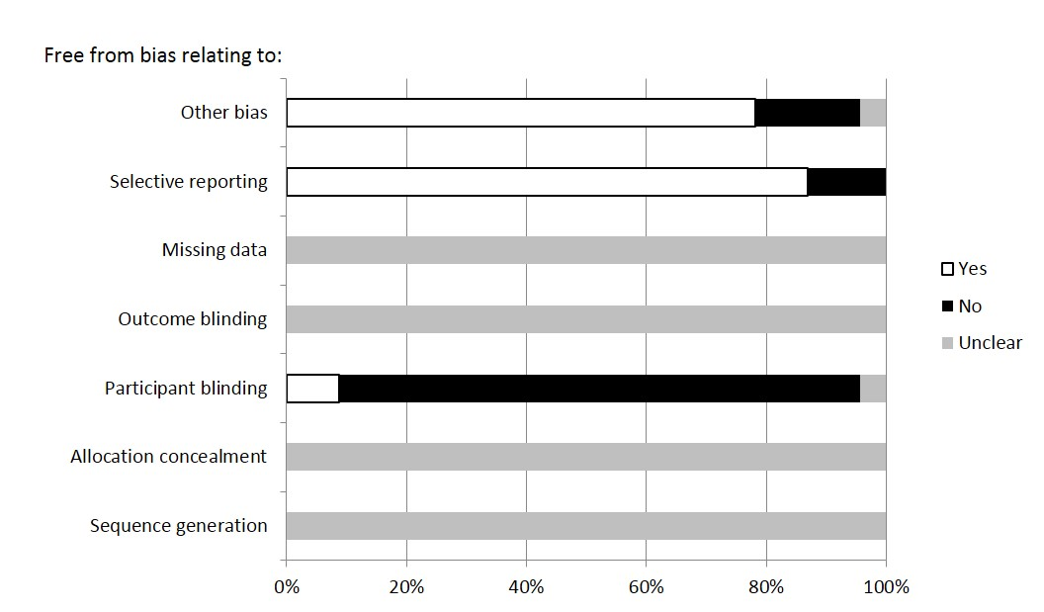
Figure 2. Risk of bias analysis according to Cochrane Collaboration guidelines [46]

Table 1. Details of studies included in the meta-analysis
Study | Subjects^{a,b} | Design | Protocol | Exercise modality | Minimum pressure (mmHg)^{c} | Garments | Performance test | Performance outcome | Time-points
Ali et al. 2007 [53] | 14 recreational male runners (22 ± 1 y) | Crossover RCT | MSFT | Running | 18^{d,e} | GT | MSFT | Endurance | 1 h
Armstrong et al. 2014 [54] | 33 recreational marathon runners (23 males, 10 females, 39 ± 7 y) | Parallel RCT | Marathon | Running | 30^{e,f} | KS | ↑Incremental treadmill TTE | Endurance | 14 d
Bieuzen et al. 2014 [47] | 11 highly trained male runners (35 ± 10 y) | Crossover RCT | Simulated trail races (15.6 km with 6.6 km hills) | Running | 25^{e,f} | CS | MVC_{knee}; CMJ | Strength, power | 1 h, 24 h, 48 h
Born et al. 2014 [55] | 12 competitive female athletes (25 ± 3 y) | Crossover RCT | 30 x 30 m sprints (1.min⁻¹) | Running | 18.3^{d,e} | GT | ↓Sprint time: 30 x 30 m^{30 min} (1.min⁻¹) | Power | 10 min, 20 min, 30 min
Davies et al. 2009 [33] | 11 basketball and netball players (4 males, 7 females, 22 ± 9 y) | Crossover RCT | 5 x 20 drop-jumps | Running | 15^{e,f} | GT | Sprint time: 5 m, 10 m, 20 m; CMJ | Power | 48 h
Duffield and Portus 2007 [56] | 10 physically fit, male, club-level cricket players (22 ± 3 y) | Crossover RCT | Sprints (30 x 20 m, with 1 min jogging) | Running | Not stated^{e} | WB | Sprint time: 10 m; throwing distance | Power | 0, 10 min, 20 min, 24 h
Duffield et al. 2008 [57] | 14 male rugby players (19 ± 1 y) | Crossover RCT | 2 x consecutive days of simulated games (80 min sprint and agility circuit) | Running | Not stated^{g} | GT | Sprint time: 5 x 20 m (25 m recovery jog); PP_{scrum} | Power | 24 h
Duffield et al. 2010 [58] | 11 male rugby players (21 ± 3 y) | Crossover RCT | 10 x 20 m sprints and 100 x DL bounds | Running | 10^{e,f} | GT | Sprint time: 10 x 20 m;  100 x DL bounds;  MVC_{knee} | Power | 0, 2 h, 24 h
Hill et al. 2014 [21] | 24 recreational marathon runners (17 males, 7 females, 44 ± 11 y) | Parallel RCT | Marathon | Running | 9.9^{d,e} | GT | MVC_{knee} | Strength | 0, 24 h, 48 h, 72 h
Montgomery et al. 2008 [6] | 29 male basketball players (19 ± 2 y) | Parallel RCT | 3 day basketball tournament | Running | 18^{e,f} | GS | Sprint time: 20 m, ↓25 m^{72 h}; CMJ | Power | 24 h, 48 h, 72 h
Pruscino et al. 2013 [59] | 8 highly trained male field-hockey players (22 ± 2 y) | Crossover RCT | 75 min match simulation exercise protocol (LIST) | Running | 4.8^{d,e} | GT | ↑MP CMJ x 5^{48 h}; squat jump | Power | 1 h, 24 h, 48 h
Rugg et al. 2012 [60] | 14 competitive runners (8 males, 6 females, 28 ± 14 y) | Crossover RCT | 15 min run (incremental: 50%, 70%, 85% HRR) | Running | Not stated^{g} | GT | ↑CMJ | Power | 15 min
Carling et al. 1995 [50] | 23 healthy, untrained college students (7 males, 16 females, 26 ± 4 y) | Parallel RCT | 70 x MVCECC_{elbow} | Resistance | 17^{e,f} | AS | MVC_{elbow} | Strength | 10 min, 24 h, 48 h, 72 h
Cerquiera et al. 2015 [51] | 13 untrained young males (21 ± 1 y) | Parallel RCT | 30 x MVCECC_{elbow} | Resistance | Not stated^{g} | AS | MVC_{elbow} | Strength | 24 h, 48 h, 72 h, 96 h
Goto and Morishima 2014 [22] | 9 strength trained male recreational athletes (21 ± 1 y) | Crossover RCT | 3–5 x 10 @ 70% 1RM for 9 (whole body) exercises | Resistance | Not stated^{g} | WB | ↑Bench press 1RM^{3 h, 5 h, 8 h};  ↑MVC_{knee}^{24 h} | Strength | 1 h, 3 h, 5 h, 8 h, 24 h
Jakeman et al. 2010 [38] | 17 physically active females (21 ± 2 y) | Parallel RCT | 10 x 10 drop-jumps | Resistance | 14.9^{e,f} | GT | ↑Squat jump^{24h, 48h, 72h, 96h};  ↑CMJ^{48 h};  ↑MCV_{knee}^{24 h, 48 h, 72 h, 96 h} | Strength, power | 1 h, 24 h, 48 h, 72 h, 96 h
Kraemer et al. 2001 [19] | 15 healthy, untrained males (22 ± 3 y) | Paired parallel RCT | 2 x 50 bicep curls (MVCECC_{elbow} every 4th; 3 min rest) | Resistance | 10^{e,f} | AS | ↑MVC_{elbow}^{48 h, 72 h};  ↑P_{pk} MVC_{elbow}^{24 h, 48 h, 72 h} | Strength, power | 24 h, 48 h, 72 h
Kraemer et al. 2001 [49] | 20 untrained females (21 ± 3 y) | Parallel RCT | 2 x 50 bicep curls (MVCECC_{elbow} every 4th; 3 min rest), isometric hold | Resistance | 10^{e,f} | WB | ↑MVC_{elbow}^{48 h, 72 h, 96 h};  ↑P_{pk} MVC_{elbow}^{48 h, 72 h, 96 h} | Strength, power | 24 h, 48 h, 72 h, 96 h
Martorelli et al. 2015 [61] | 15 resistance trained men (23 ± 4 y) | Crossover RCT | 6 x 6 bench press @50% 1RM, 1 min rest | Resistance | Not stated^{g} | AS | MP_{bench}  (6 x 6 @50% 1RM);  MVC_{bench} | Power | 2 min 30 s, 5 min, 7 min 30 s, 10 min, 12 min 30 s, 30 min
Argus 2012 [62] | 11 highly trained male cyclists (39 ± 7 y) | Crossover RCT | 3 x 30 s sprints (20 min rest) | Metabolic | 18^{d,e} | GS | Sprint power: 3 x 30 s (30 min rest) | Power | 30 min
de Glanville and Hamlin 2012 [35] | 14 trained multisport male athletes (20 ± 2 y) | Crossover RCT | 40 km TT | Metabolic | 6^{d,e} | GT | ↓40 km TT | Endurance | 24 h
Driller and Halson 2013 [44] | 10 highly-trained male cyclists (31 ± 6 y) | Crossover RCT | 30 min cycling (15-min @70% PPO, 15-min TT) | Metabolic | 11.8^{d,e} | GT | ↑MP 15 min TT | Endurance | 1 h
Sperlich et al. 2014 [63] | 10 well-trained male athletes (25 ± 4 y) | Crossover RCT | Sprint_{ski} (3 x 3 min)  3 min rest (MP) | Metabolic | 9^{d,g} | ST | Sprint_{ski} (3 x 3 min,  3 min rest) | Endurance | 18 min

a All participants categorised as ‘untrained’ in subsequent analyses labelled as such; all other participants, including ‘physically active’ and ‘athletes’ etc, categorised as ‘trained’.
b Age data are mean ± SD
c Minimum pressure applied by garments (or pressure given at the thigh if minimum pressure not recorded).
d Pressure measured directly.
e Pressure applied after exercise.
f Target/modelled pressure.
g Pressure applied during and after exercise.
MSFT = multi-stage fitness test; RM = repetition maximum; Resistance = resistance exercise with eccentric component; Metabolic = cardiovascular exercise with minimal eccentric component; MVC_{knee} = maximal voluntary contraction knee flexion; MVCECC_{elbow} = maximal eccentric voluntary contraction elbow flexion; MVC_{elbow} = maximal voluntary contraction elbow flexion; MVC_{bench} = maximal voluntary contraction bench press; sprint_{ski} = skiing ergometer sprint; PP_{scrum} = peak scrum-power; P_{pk} = peak power; RCT = randomised controlled trial; TTE = graduated time to exhaustion test (treadmill); TT = time trial; DL = double leg; PPO = peak power-output; LIST = Loughborough intermittent shuttle test, CMJ = countermovement jump, HRR = heart rate reserve, MP = mean power; MP_{bench} = mean power bench press; PMS = perceived muscle-soreness; GT = graduated tights; GS = graduated stockings; KS = knee socks/calf sleeves; AS = arm sleeves; WB = whole body garments; ST = sleeved top; ↑ = Significant increase from compression (p < 0.05); ↓ = Significant decrease from compression (p < 0.05). Increases or decreases are related to units of measurement, with an increase in time to exhaustion, power, strength or jump height indicating improved performance. Decreases in sprint times or time trial times indicate improved performance.

3.2 Analysis of pressure
Three studies were identified in the high pressure group, applying pressures from 18-18.3 mmHg [53, 55, 62], while five studies [21, 35, 44, 59, 63] reported directly measuring pressures < 15 mmHg (4.8-11.8 mmHg). No effect of compression-pressure on the magnitude of recovery was apparent following extraction of 24 data-points from the eight identified studies which took direct measurements at the garment-skin interface (p = 0.06, χ² = 3.46). This trend towards improved recovery favoured the lower pressure group (ES = 0.16 [95% CI -0.06, 0.38]) in comparison to trials applying greater pressures (ES = -0.28 [95% CI -0.70, 0.13]).

3.3 Training status
No significant difference was found between the effects of CG on the recovery of trained and untrained participants across all time-points, considering all exercise modalities and performance outcomes (p = 0.64, χ² = 0.21). Subgroup analysis resulted in no meaningful reduction of heterogeneity, I² values of 66% and 63% for trained and untrained participants respectively, compared to 66% for the combined group. Both trained (p < 0.001, z = 4.84) and untrained populations (p = 0.007, z = 2.70) experienced significant benefits from CG on recovery. However, whilst the small benefits of CG were very likely beneficial for trained participants, as demonstrated by the 95% CI failing to transect the threshold for the smallest worthwhile effect (ES = 0.37 [95% CI 0.22, 0.51]), this was not the case for untrained participants (ES = 0.45 [95% CI 0.12, 0.78]).

3.4 Time-point analysis
When all performance measures were considered, CG-mediated recovery was significantly influenced by time-point (p < 0.001, χ² = 31.6). This was reflected in reduced heterogeneity in three of the four time-periods analysed with I² values of 0%, 0%, 65%, 82% being reported for the 0-2 h, 2-8 h, 24 h and > 24 h time-points respectively, compared to 66% for the combined group. Whilst recovery was significantly enhanced by CG at each time-point (Figures 3-5), effects were trivial and unlikely beneficial at 0-2 h (p = 0.01, z = 2.52; ES = 0.14 [95% CI 0.03, 0.24]). However, later time-points were subject to significant (moderate and large) effects, including 2-8 h (p < 0.001, z = 5.33, ES = 1.14 [95% CI 0.72, 1.56]), 24 h (p = 0.003, z = 2.97, ES = 0.49 [95% CI 0.17, 0.82]) and > 24 h (p < 0.001, z = 4.14, ES = 0.76 [95% CI 0.40, 1.12]).

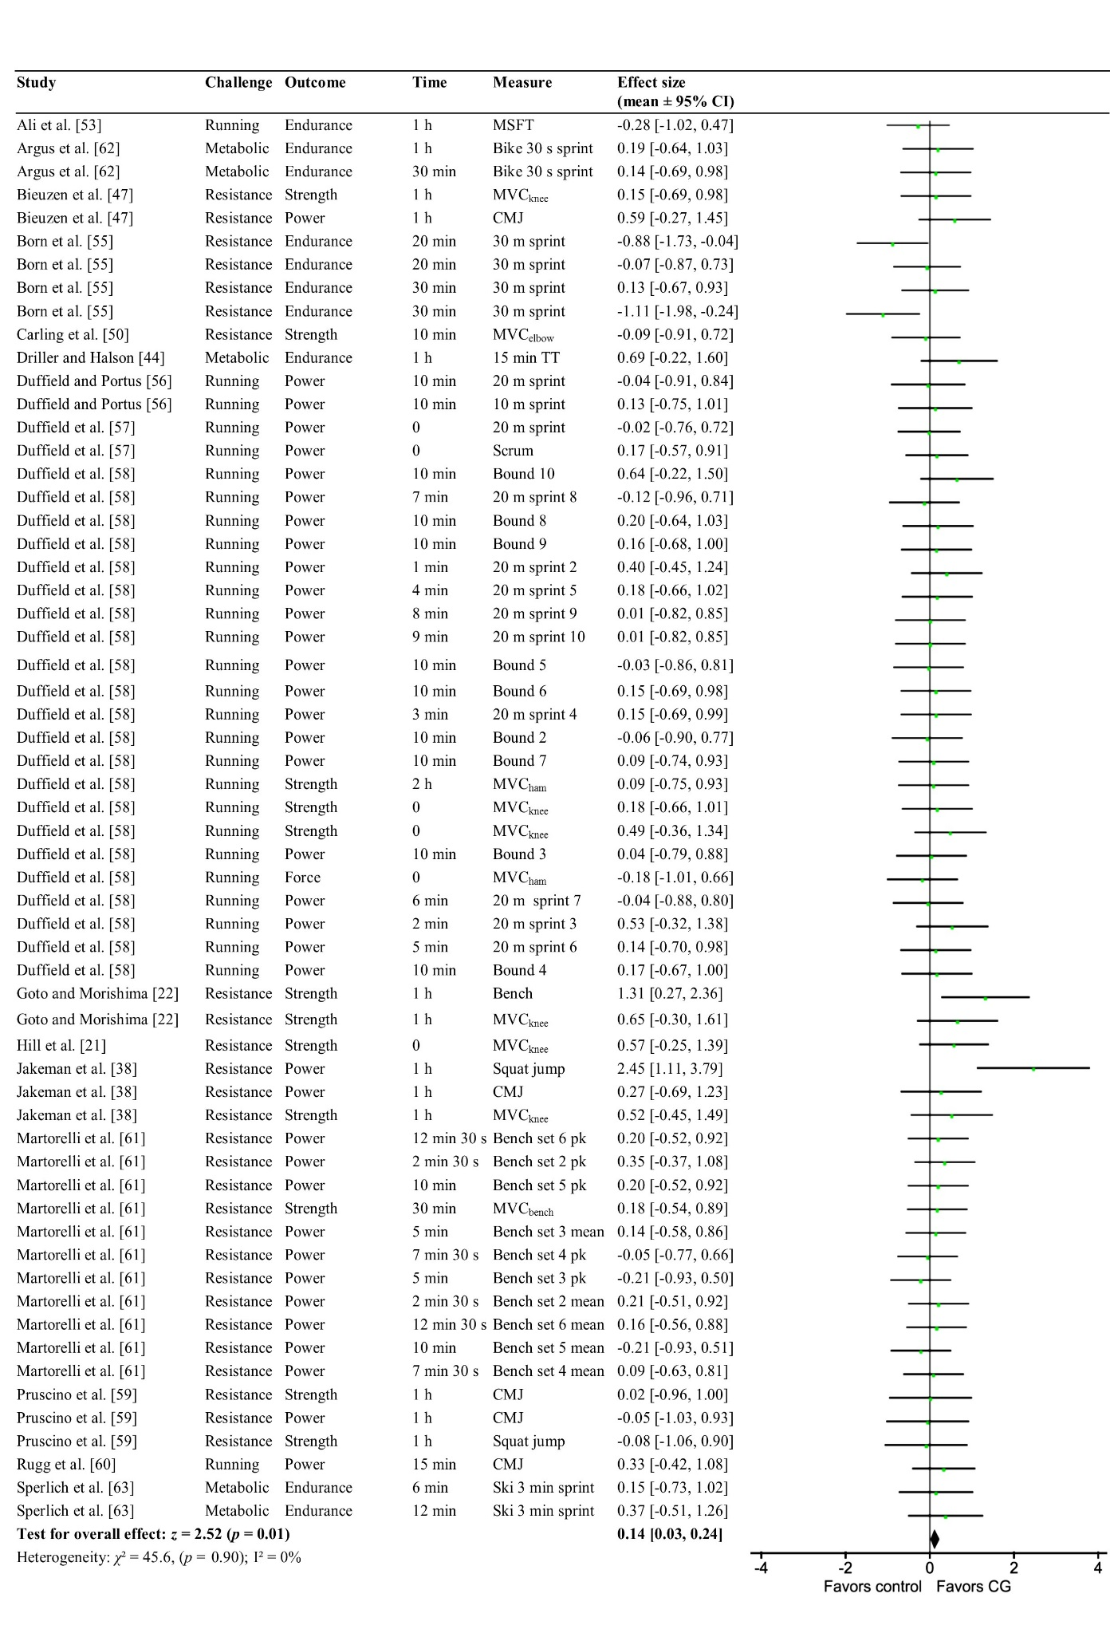

Figure 3. Forest plot illustrating the effects of compression garments (CG) compared to control on all measures of recovery at 0-2 h. The results represent part of a comparison with 2-8 h, 24 h and > 24 h time-points and have been weighted accordingly. Square boxes represent the standardized mean effect for each study, with lines demonstrating 95% confidence intervals. A diamond represents the overall standardized mean effect. Resistance = resistance exercise with eccentric component; Metabolic = cardiovascular exercise with minimal eccentric component; 0 = post-exercise; MSFT = multi-stage fitness test; MVC = maximal voluntary contraction; knee = knee extension; elbow = elbow flexion; ham = hamstring flexion; pk = peak; CMJ = counter-movement jump; TT: time trial; PP_{scrum} = peak scrum-power; bench = bench press; ski = skiing ergometer; CI = confidence interval

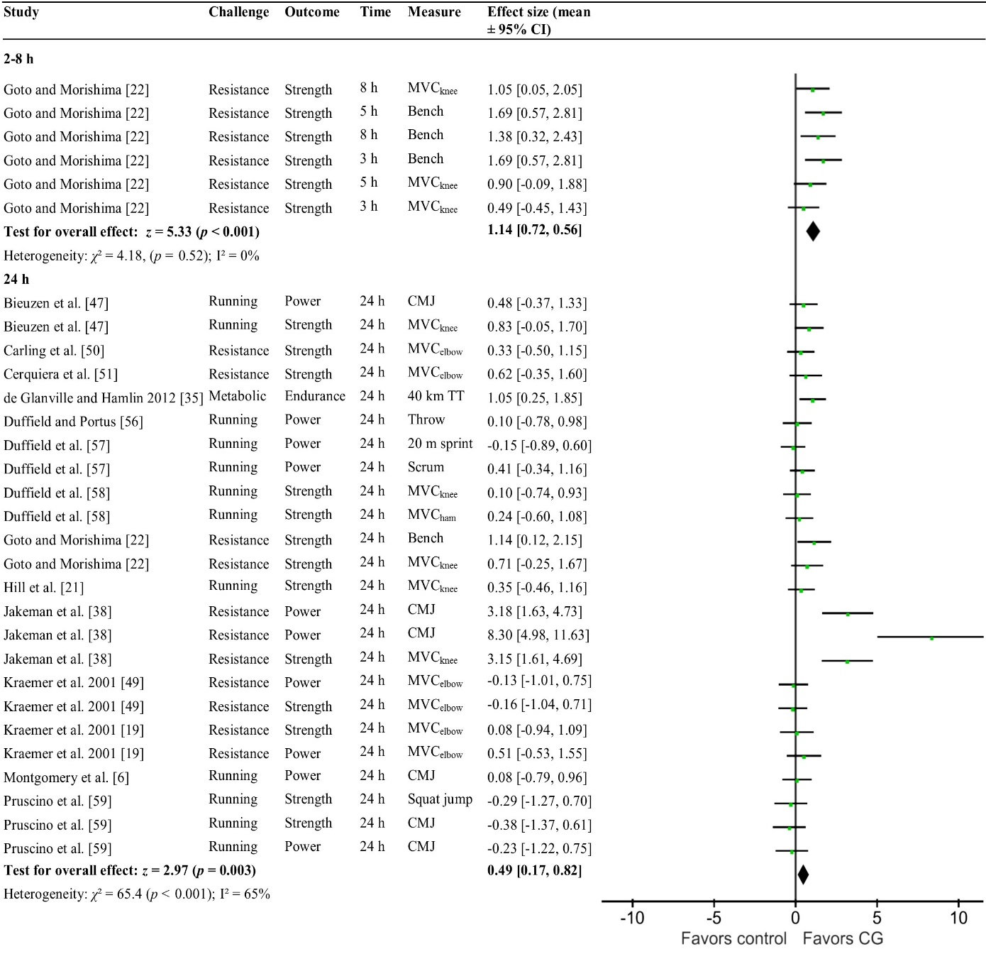
Figure 4. Forest plot illustrating the effects of compression garments (CG) compared to control on all measures of recovery at 2-8 h and 24 h. The results represent part of a comparison with 0-2 and 24 h time-points and have been weighted accordingly. Square boxes represent the standardized mean effect for each study, with lines demonstrating 95% confidence intervals. A diamond represents the overall standardized mean effect. Resistance = resistance exercise with eccentric component; Metabolic = cardiovascular exercise with minimal eccentric component; 0 = post-exercise; MVC = maximal voluntary contraction; knee = knee extension; elbow = elbow flexion; ham = hamstring flexion; throw = maximal throwing distance; CMJ = counter-movement jump; TT: time trial; PP_{scrum} = peak scrum-power; bench = bench press; CI = confidence interval

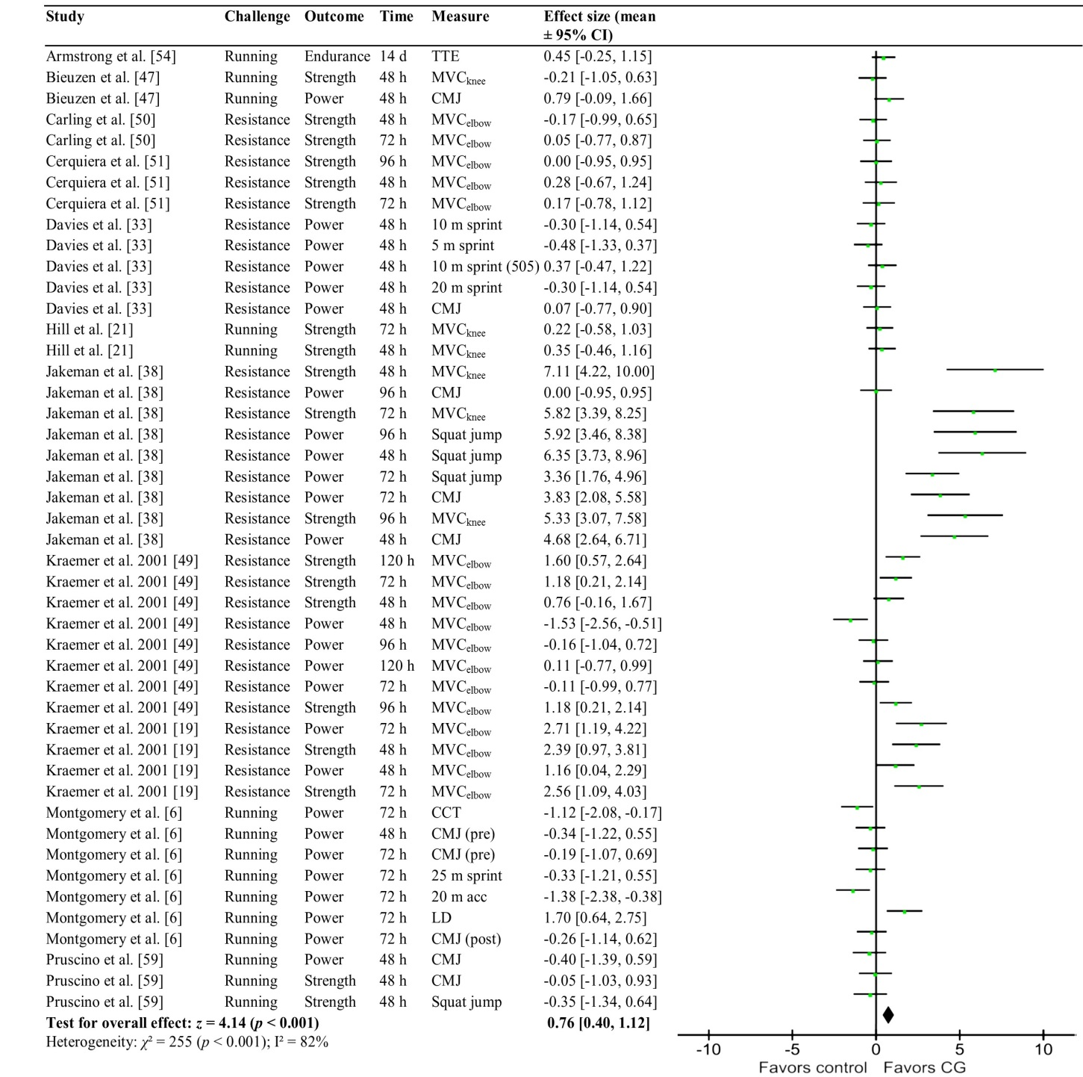
Figure 5. Forest plot illustrating the effects of compression garments (CG) compared to control on all performance measures of recovery at > 24 h. The results represent part of a comparison with 0-2, 2-8 h and 24 h time-points and have been weighted accordingly. Square boxes represent the standardized mean effect for each study, with lines demonstrating 95% confidence intervals. A diamond represents the overall standardized mean effect. Resistance = resistance exercise with eccentric component; 0 = post-exercise; MVC = maximal voluntary contraction; knee = knee extension; elbow = elbow flexion; acc = average acceleration; CMJ = counter-movement jump; CI = confidence interval; TTE = graduated time to exhaustion test (treadmill); 505 = agility test; CCT = (basketball) court coverage time; LD = (basketball) line drill; pre = pre-match; post = post-match

3.5 The Effects of compression garments on recovery outcomes
The magnitude of CG-mediated recovery was significantly different (p = 0.03, χ² = 6.94) between performance outcomes (strength, power and endurance – Figures 6-8). Accordingly, I² values were smaller in two of three subgroups (strength = 64%, power = 66%, endurance = 22%) compared to the total group (I²= 66%). Strength recovery was subject to the largest benefits from CG (p < 0.001, z = 5.30), which were moderate in magnitude and very likely beneficial (ES = 0.62 [95% CI 0.39, 0.84]). The effects of CG on strength recovery were significantly greater than on power over all time-points (p = 0.008, χ² = 6.93). No other differences between outcomes were apparent. Analysis of strength recovery at different times revealed significant (p < 0.001, z = 5.33) large, very likely beneficial effects at 2-8 h (ES = 1.14 [95% CI 0.72, 1.56]) and > 24 h (p < 0.001, z = 3.70, ES = 1.03 [95% CI 0.48, 1.57]).

The effects of CG on power recovery (Figure 7) were significant across all time-points (p = 0.008, z = 2.64), although the small effect was not very likely to represent a worthwhile benefit (ES = 0.23 [95% CI 0.06, 0.41]). Significant but not very likely benefits from CG on the recovery of power were demonstrated only at > 24 h (p = 0.02, z = 2.31, ES = 0.59 [95% CI 0.09, 1.10]).

The recovery of endurance performance over all time-points, following all exercise challenges (including both running and metabolic exercise) was also significantly improved with the use of CG (p = 0.04, z = 2.04). Endurance recovery was subject to small but not very likely benefits from CG (ES = 0.39 [95% CI 0.02, 0.77] – Figure 8). A significant (p = 0.01, z = 2.58), large and very likely beneficial effect was apparent at 24 h (ES = 1.05 [95% CI 0.25, 1.85]), with no effects at either 0-2 h or > 24 h.

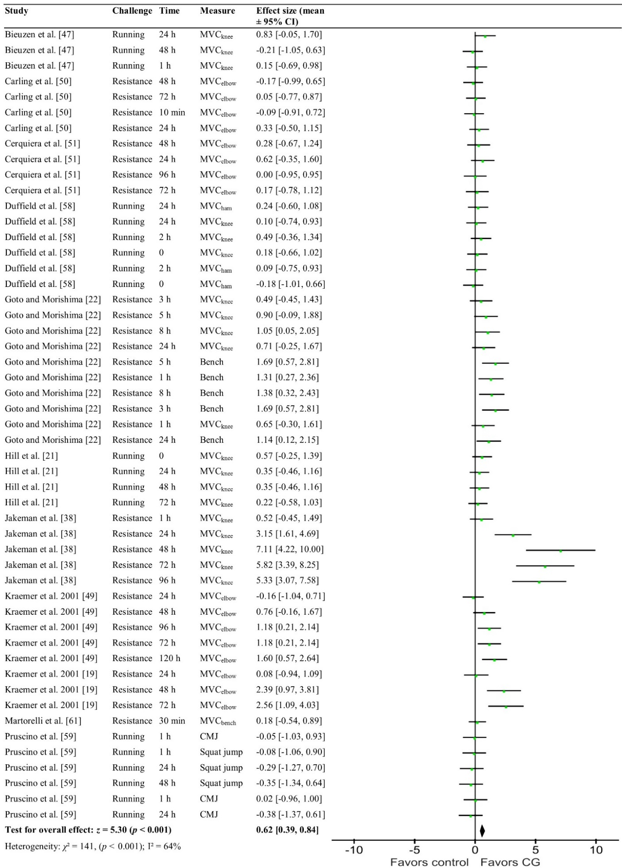Figure 6. Forest plot illustrating the effects of compression garments (CG) compared to control on strength recovery at all time points. The results represent part of a comparison with power and endurance performance and have been weighted accordingly. Square boxes represent the standardized mean effect for each study, with lines demonstrating 95% confidence intervals. A diamond represents the overall standardized mean effect. Resistance = resistance exercise with eccentric component; 0 = post-exercise; MVC = maximal voluntary contraction; knee = knee extension; elbow = elbow flexion; ham = hamstring flexion; bench = bench press; CMJ = counter-movement jump
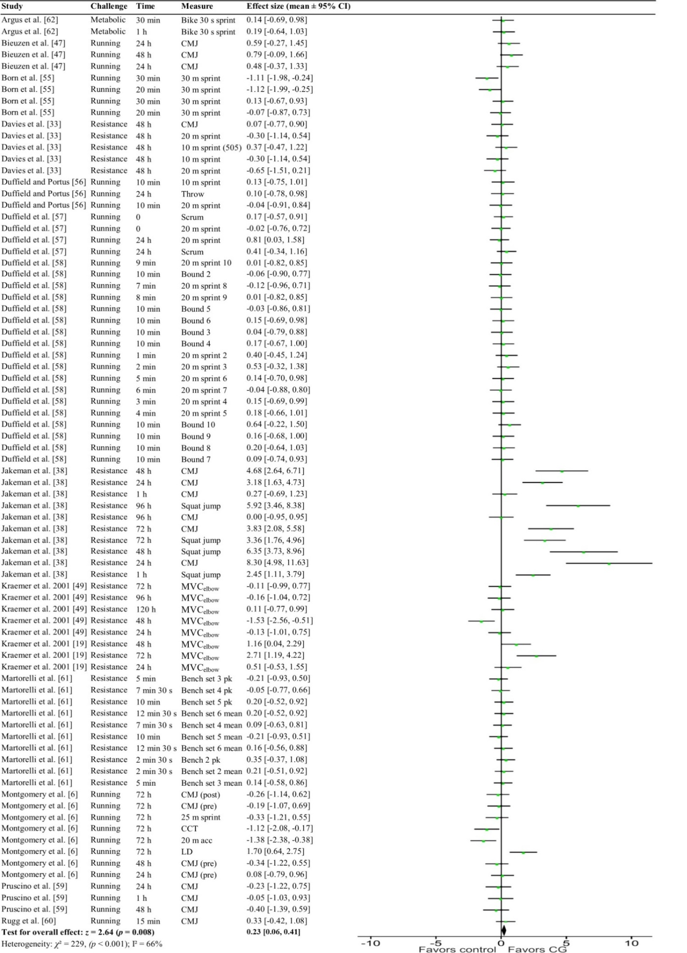

Figure 7. Forest plot illustrating the effects of compression garments (CG) compared to control on power recovery at all time points. The results represent part of a comparison with strength and endurance performance and are weighted accordingly. Square boxes represent the standardized mean effect for each study, with lines demonstrating 95% confidence intervals. A diamond represents the overall standardized mean effect. Resistance = resistance exercise with eccentric component; 0 = post-exercise; MVC = maximal voluntary contraction; knee = knee extension; elbow = elbow flexion; bench = bench press; CMJ = counter-movement jump; CCT = (basketball) court coverage time; LD = (basketball) line drill; pre = pre-match; post = post-match; pk = peak; acc = acceleration; 505 = agility test; throw = maximal throwing distance; PP_{scrum} = peak scrum-power; bound = double leg bound

Figure 8. Forest plot illustrating the effects of compression garments (CG) compared to controls on recovery of endurance performance at all time points. The results represent part of a comparison with strength and power performance and have been weighted accordingly. Square boxes represent the standardized mean effect for each study, with lines demonstrating 95% confidence intervals. A diamond represents the overall standardized mean effect. Metabolic = cardiovascular exercise with minimal eccentric component; 0 = post-exercise; TT = time trial; TTE = graduated time to exhaustion trial (treadmill); ski = skiing ergometer

3.6 The benefits of CG for different types of damaging exercise
There was a significant effect of exercise modality on the effects of CG over all time-points (Figures 9-11), for all measures of recovery (p < 0.001, χ² = 28.6). Heterogeneity, as shown by the I² statistic, was lower in two of the three subgroups (resistance = 79%, running = 0%, metabolic = 0%) compared to the combined data-set (I² = 66%). Recovery from resistance exercise (Figure 9) was subject to the greatest effects (ES = 0.49 [95% CI 0.37, 0.61]), which although small, were very likely beneficial and significant (p < 0.001, z = 8.09). Analysing the resistance exercise group separately revealed large, very likely (ES = 1.14 [95% CI 0.72, 1.56]), and significant (p < 0.001, z = 5.33) benefits at 2-8 h, as well as at 24 h (p = 0.004, z = 2.92, ES = 1.10 [95% CI 0.36, 1.83]) and > 24 h (p < 0.001, z = 4.97, ES = 1.33 [95% CI 0.80, 1.85]). In contrast, the impact of CG on recovery was insignificant (p = 0.23, z = 1.20), trivial, and unlikely following running (ES = 0.06 [95% CI -0.04, 0.17]). Accordingly, the effects on CG on recovery were significantly greater following resistance exercise compared to running (p < 0.001, χ² = 27.6).

The recovery of endurance performance following metabolically challenging (non-load-bearing) exercise was subject to significant (p = 0.01, z = 2.49) benefits from CG. However, these moderate benefits were unlikely (ES = 0.44 [95% CI 0.09, 0.79]). When analysed independently, the effects of CG on recovery from metabolic exercise were significant only at the 24 h time-point (p = 0.01, z = 2.58). This effect was large and very likely beneficial (ES= 1.05 [95% CI 0.25, 1.85]).

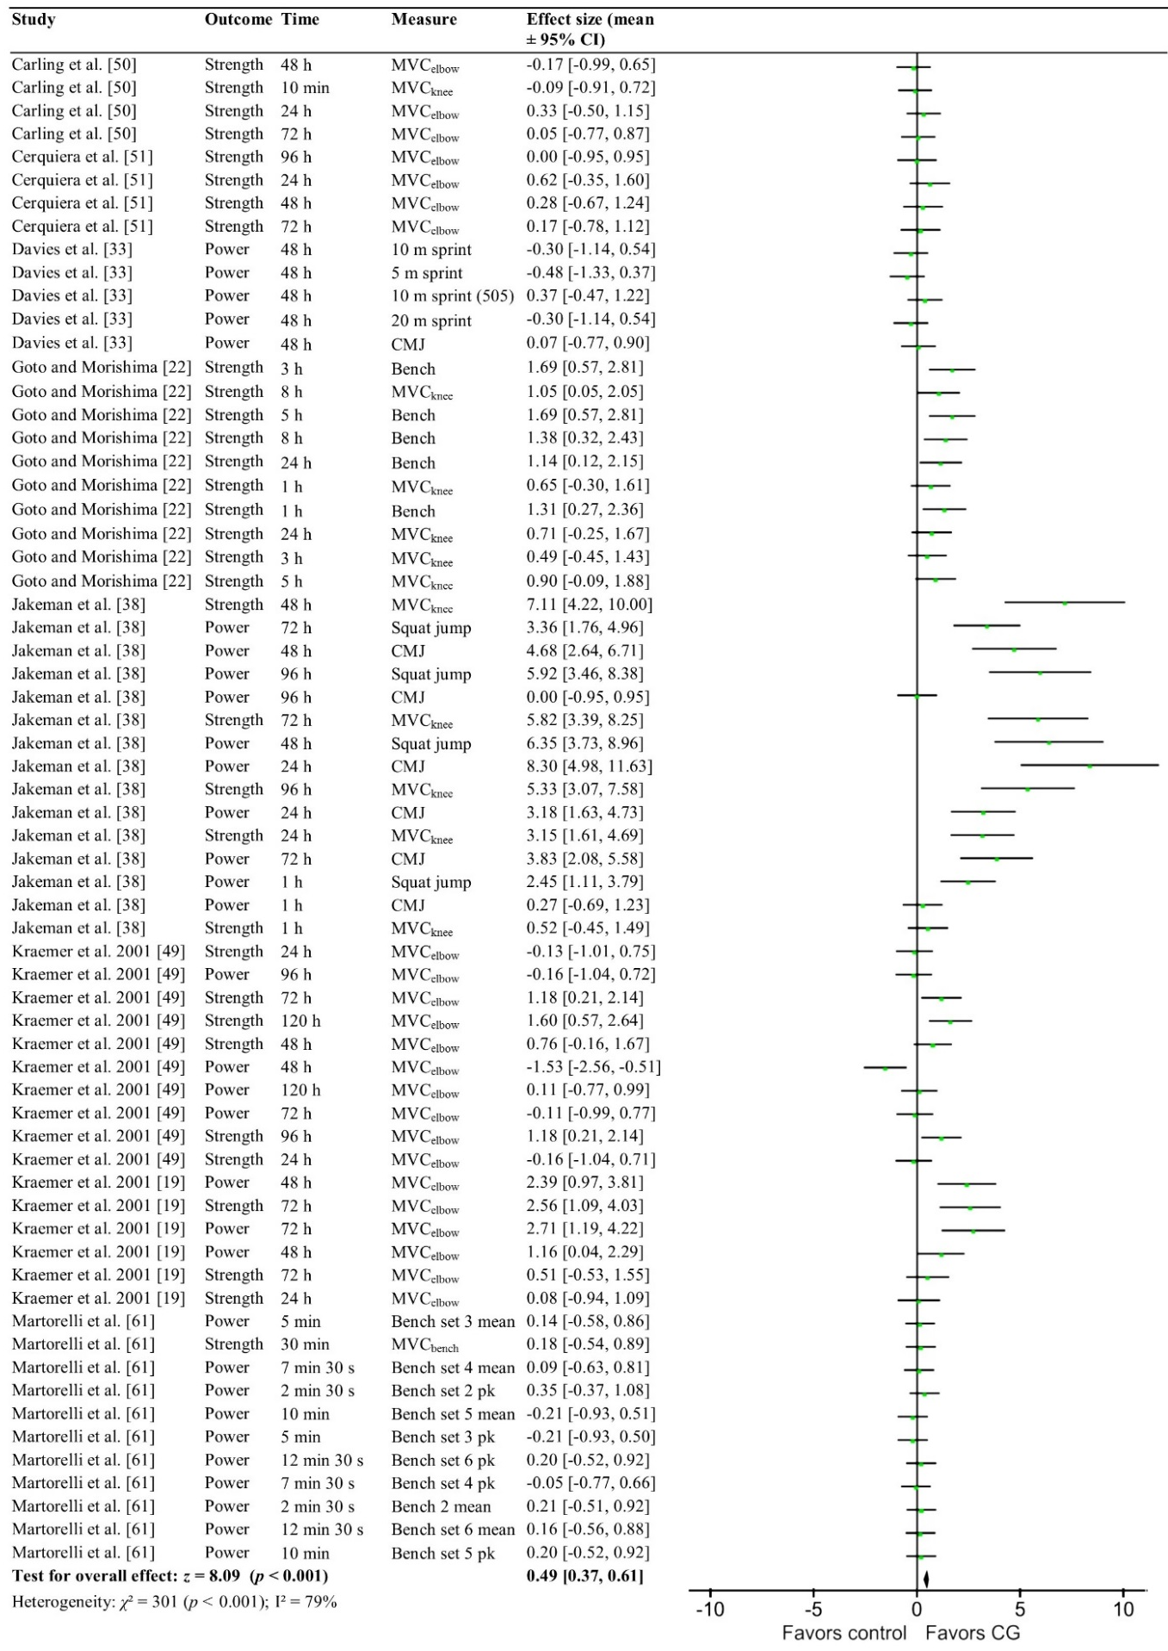Figure 9. Forest plot illustrating the effects of compression garments (CG) compared to control on all recovery measures following resistance exercise at all time points. The results represent part of a comparison with running, and non-running endurance (metabolic) exercise challenges, and have been weighted accordingly. Square boxes represent the standardized mean effect for each study, with lines demonstrating 95% confidence intervals. A diamond represents the overall standardized mean effect. MVC = maximal voluntary contraction; 0 = post-exercise; knee = knee extension; elbow = elbow flexion; bench = bench press; CMJ = counter-movement jump; pk = peak; 505 = agility test
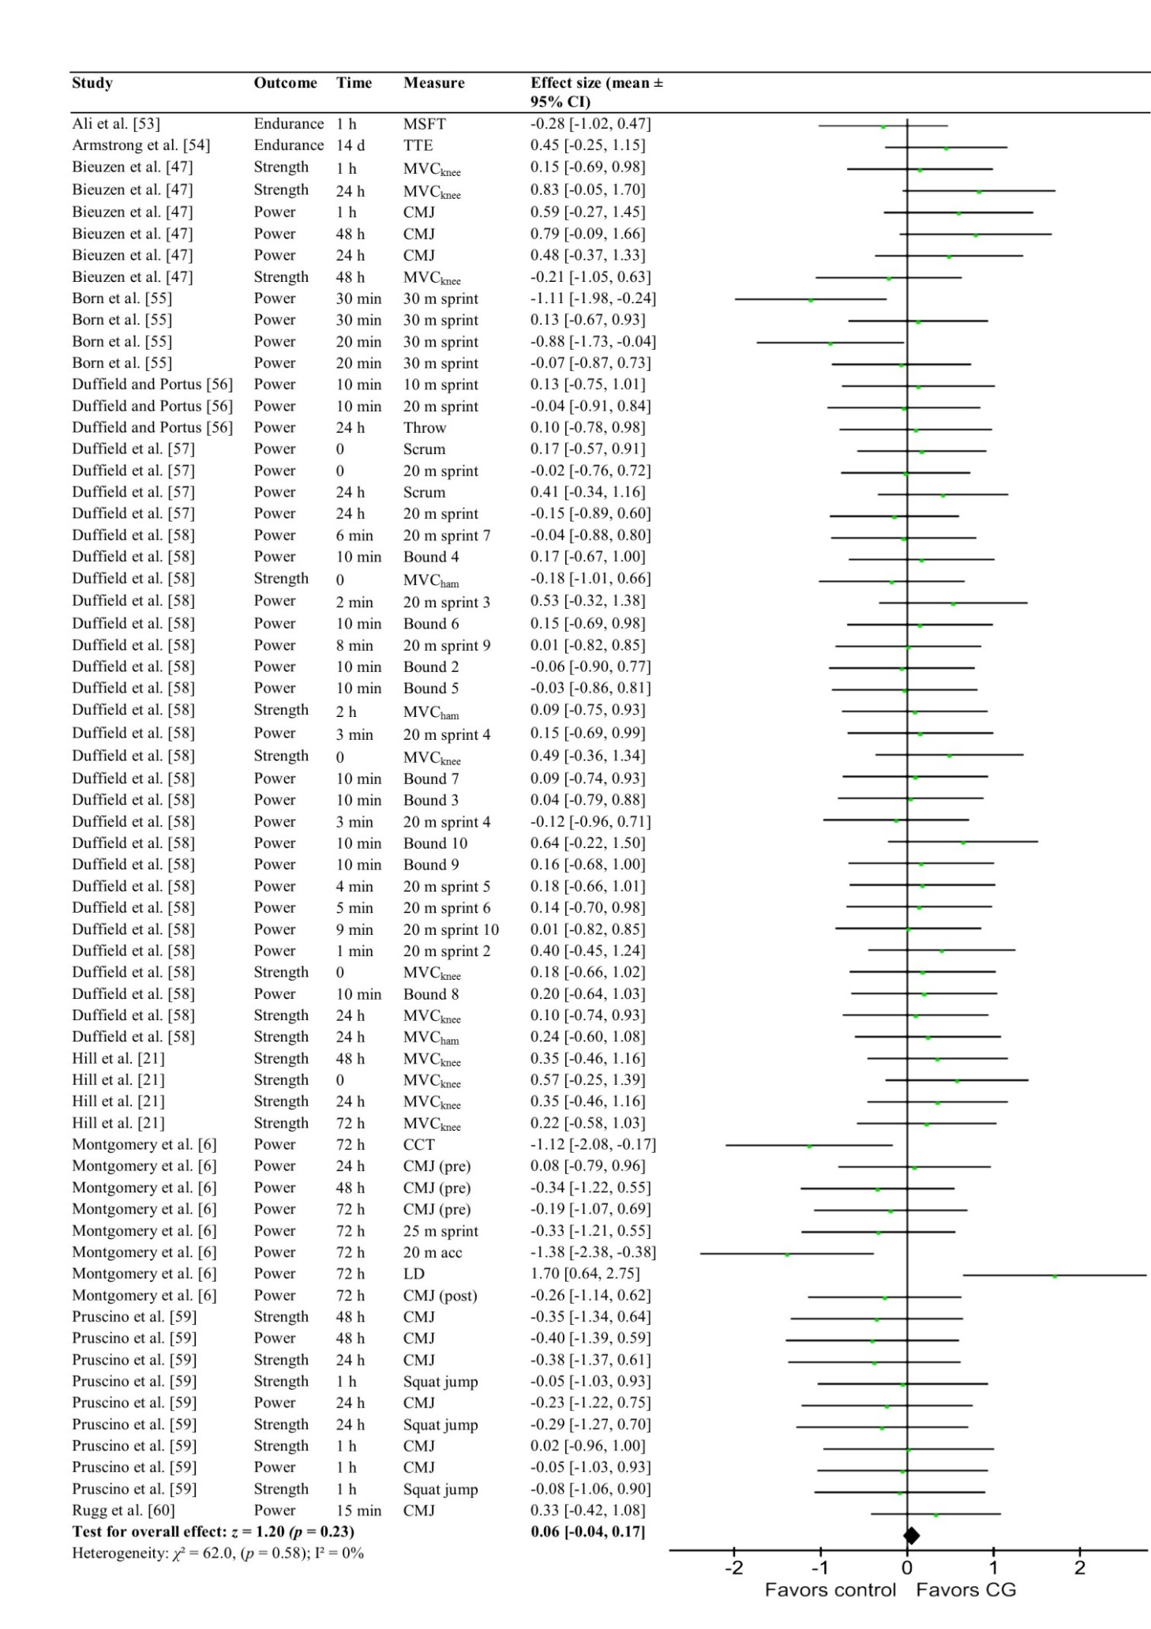

Figure 10. Forest plot illustrating the effects of compression garments (CG) compared to control on all recovery measures following running-based exercise at all time points. The results represent part of a comparison with eccentric exercise and non-running endurance exercise challenges, and have been weighted accordingly. Square boxes represent the standardized mean effect for each study, with lines demonstrating 95% confidence intervals. A diamond represents the overall standardized mean effect. 0 = postexercise; MSFT = multi-stage fitness test; MVC = maximal voluntary contraction; knee = knee extension; ham = hamstring flexion; CMJ = counter-movement jump; TTE = graduated time to exhaustion trial (treadmill); PP_{scrum} = peak scrum-power; LD = (basketball) line drill; CCT = (basketball) court coverage time; acc = acceleration; throw = maximal throwing distance; bound = double leg bound; pre = pre-match; post = post-match

Figure 11. Forest plot illustrating the effects of compression garments (CG) compared to controls on all recovery measures following metabolic (non-running endurance) exercise at all time points. The results represent part of a comparison with running-based and resistance exercise, and have been weighted accordingly. Square boxes represent the standardized mean effect for each study, with lines demonstrating 95% confidence intervals. A diamond represents the overall standardized mean effect. 0 = postexercise; TT = time trial; ski = skiing ergometer

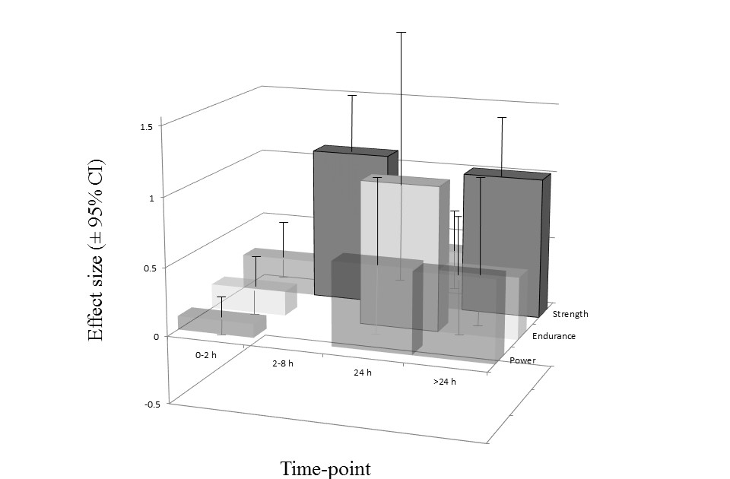
Figure 12. A comparison of the effects of compression garments with controls on all measures of performance recovery at all time-points. Columns represent the standardized mean effect at each time point, with error bars demonstrating 95% confidence intervals (CI). The threshold values for standardized changes were as follows: ≤0.2 (trivial), > 0.2 (small), > 0.5 (moderate), > 0.8 (large). Effects were deemed very likely if the 95% CI did not cross below the threshold for the smallest worthwhile effect (filled columns with solid borders). Transparent columns without borders indicate that the 95% CI transected the threshold for the smallest worthwhile effect. CI = confidence interval

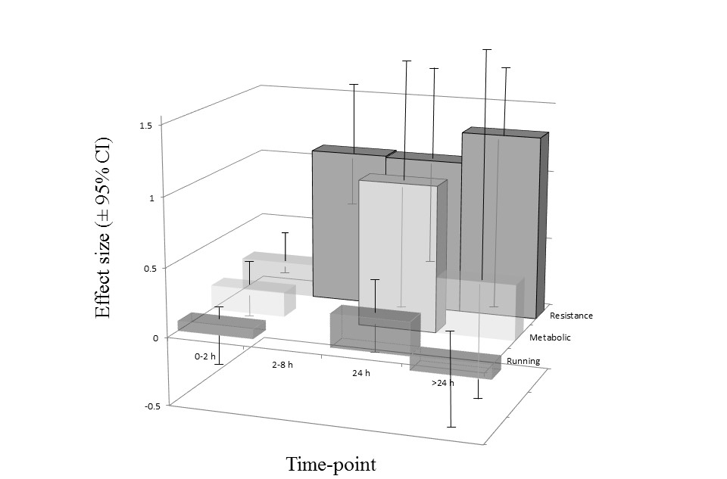Figure 13. A comparison of the effects of compression garments with controls on recovery from all exercise challenges at all time-points. Columns represent the standardized mean effect at each time point, with error bars demonstrating 95% confidence intervals (CI). The threshold values for standardized changes were as follows: ≤0.2 (trivial), > 0.2 (small), > 0.5 (moderate), > 0.8 (large). Effects were deemed very likely if the 95% CI did not cross below the threshold for the smallest worthwhile effect (filled columns with solid borders). Transparent columns without borders indicated that the 95% CI transected the threshold for the smallest worthwhile effect. Metabolic = cardiovascular exercise with minimal eccentric component; resistance = resistance training or drop-jumps

4. Discussion
This meta-analysis, which included 136 data-points from 23 studies, is the first to evaluate the effects of CG in relation to performance outcomes, exercise challenges, training status and recovery time-points. Its findings may help inform practice by identifying the optimal conditions under which CG may aid recovery. In summary, CG would seem to be most effective for recovery from resistance exercise, and prior to strength performance. Large, very likely benefits were demonstrated in these conditions, as well as for next-day cycling performance. The benefits of CG in relation to applied pressures and participant training status are unclear and limited by the paucity of reported data.

4.1 Performance Outcomes

These data demonstrate that CG exert a preferential effect on strength recovery. Whilst previous analyses have reported a tendency for CG to exert greater relative effects on power recovery [9, 64], these analyses were less extensive. Hill et al. [21] reported a tendency towards larger effects for power recovery compared to strength, following the analysis of 17 power outcomes from six studies and 16 strength outcomes from five studies (a total of eight studies and 33 data-points). Similarly, Marques-Jimenez et al. [64] recently reported a tendency towards comparatively greater effects on power recovery after analysing 30 power outcomes from five studies and 45 strength outcomes from eight studies (nine studies and 75 data-points in total). However, the present results from the analysis of 136 data-points demonstrate a significantly larger effect from CG on strength compared to power, while very likely benefits were apparent for strength outcomes only (Figure 6, Figure 12). Analysing the recovery from specific exercise challenges seems to mirror these findings, as CG were most effective following resistance or plyometric exercise (Figure 9, Figure 10, Figure 13). This finding is supported by numerous studies which demonstrate that CG serve to attenuate symptoms of muscle damage [17, 19, 20]. Furthermore, compression garments demonstrated large, very likely benefits on strength recovery at > 24 h, when muscle damage and associated force decrements are greatest [27, 28]. This suggests that compression enhances force recovery by ameliorating EIMD.

4.2 Compression, muscle damage and strength recovery
Within the studies reviewed, the greatest levels of muscle damage were observed following resistance exercise. The greatest circulating levels of CK for example, were reported to reach 1350 U.L⁻¹ following two sets of 50 bicep curls with 12 maximal eccentric contractions [19]. In contrast, far lower [CK] values of 353 U.L⁻¹ [58] and 305 U.L⁻¹ [47] were elicited by repeated sprint protocols. These findings are consistent with existing literature which suggests that resistance exercise typically leads to greater levels of muscle damage than running [65-67], while non-load bearing exercise is subject to even less eccentric load [12]. Although running can result in comparable levels of EIMD to resistance exercise, for example, following a marathon [21], levels of EIMD reported throughout the literature are generally lower than those from resistance training [68].

The large benefits of CG on both strength recovery and recovery from resistance exercise are concordant with a role in ameliorating muscle damage. The results of this meta-analysis support this theory in three main ways. Firstly, force recovery is intimately linked to muscle damage, being impaired to a greater extent by EIMD than either running [69] or power outcomes [19, 20, 70] from 24-48 h. Secondly, the observed time-course of recovery for both resistance exercise and strength performance lends further weight to the idea that CG ameliorate muscle damage. Apart from the 2-8 h time-point, very likely benefits to recovery for both strength performance (ES = 1.03 [95% CI 0.48, 1.57]) and following resistance exercise (ES = 1.33 [95% CI 0.80, 1.85]) were only apparent at > 24 h. A delayed recovery from resistance exercise is a common feature of EIMD [27], while impairments to strength are known to persist for longer than power [70, 71]. Strength recovery at time points > 24 h post-exercise will depend upon the attenuation of EIMD [70, 71]. Finally, markers of muscle damage, although not quantified in this meta-analysis, were greatly attenuated by CG in studies on strength recovery and resistance exercise. Where measured, reductions in CK activity were reported in parallel with both improved strength performance and DOMS [17, 19, 20], while four studies to demonstrate significant benefits from CG also reported lower levels of swelling compared to controls [19, 22, 44, 49]. Interestingly, oedema has been suggested to play a mechanistic role in the progression of muscle damage, rather than simply representing a symptom of EIMD. It is thought that the infiltration of fluid into muscle cells increases osmotic pressure, leading to further cell lysis and muscle damage [30, 32]. Compression garments may therefore enhance recovery by ameliorating swelling to limit the progression of EIMD [17, 19, 20].

In contrast to the long-term benefits of compression, some of the greatest effects of CG on strength recovery were demonstrated at 2-8 h. All data were extracted from a single trial which assessed the effects of CG over 24 h recovery from resistance training [22]. The authors reported faster recovery of upper body strength (chest-press 1 RM) over the first 8 h (p < 0.05). However, the mechanisms of action over these time-points were unclear as the CG and control groups displayed similar levels of lactate, muscle damage (myoglobin and CK), anabolic hormones (insulin like growth factor-1 and free testosterone), and inflammation, as shown by interleukin 6, and interleukin 1 [22]. It is interesting that whilst the effects of muscle temperature on strength and power performance are well established [72], and may explain both detrimental [73] and ergogenic [74] effects of recovery interventions, the effects of temperature as a mediating factor on compression have yet to be defined. Other mechanisms proposed to explain the short-term recovery benefits of CG include proprioceptive or neuromuscular effects [75], improved lactate clearance [18, 58, 61, 63] and increased oxygen saturation [76].

4.3 Compression, power recovery, and running
In contrast to resistance exercise, no likely recovery benefits from CG were demonstrated following running. This finding is in agreement with previous research, with a recent review of 32 trials using CG during or after running reporting insignificant effects on recovery [37]. An earlier review of 23 peer-reviewed papers, 11 of which were studies on recovery from running, also found insignificant effects from CG [39]. The mechanisms by which load bearing exercise retards recovery are complex and varied, and include muscle damage and the depletion of endogenous energy substrates [77], the accumulation of metabolic by-products [78, 79] and impaired neuromuscular function [80]. It is therefore unsurprising that ameliorating muscle damage alone is often insufficient to aid recovery from running [33, 81], as this milieu of degenerative processes is unlikely to be wholly addressed by a single recovery method. Generating power too, depends on a varied combination of physiological factors, including neuromuscular [70], coordinative [82] and tendon-mediated components [83]. This will reduce the relative influence of muscle damage, and potentially, the benefits of CG. Compression may have also failed to provide very likely benefits on power recovery due to the wide variation in the performance measures studied. The current analysis grouped together power outputs for squat jumps, counter-movement jumps, numerous resistance exercises (at various loads and velocities), and various running and ergometer-based sprint protocols. The large number of outcomes analysed here (79 data-points) compared to previous meta-analyses (17 and 30 data points for the analyses of Hill et al. and Marques-Jimenez et al., respectively) may further explain the conflict between results [6, 33, 38, 47, 55-62]. As the recovery rates of these different movements are unique to their neuromuscular profiles [84, 85], any positive impacts from CG which stem purely from attenuating muscle damage will vary according to outcome measures.

4.4 Compression, metabolic exercise and endurance performance
Compression-mediated recovery following metabolic exercise, and prior to endurance performance, were subject to only small, significant but unlikely benefits (Figures 8, 11, 12, 13). As studies featuring metabolic exercise modalities subjected participants to minimal eccentric load, muscle damage would have been far lower in this group than for load bearing exercise [12]. Subsequent endurance performance is also known to be far less affected by EIMD than strength [69]. The trivial recovery benefits of CG for endurance training are therefore consistent with a role in ameliorating muscle damage.

Although large, very likely beneficial effects of CG were apparent at 24 h following metabolic exercise or prior to endurance performance, no recovery benefits following endurance exercise were apparent at 0-2 h. Such a finding is perhaps surprising given reports of CG enhancing metabolite clearance throughout repeated sprints [63], and immediately post exercise [34]. It is likely that variations in athlete training status, the duration of recovery, and the specific demands of individual exercise challenges are responsible for inconsistencies in short term effects [86, 87]. For instance, although enhanced lactate clearance from CG failed to improve recovery of repeated ski performance over three x three min bouts in competitive endurance athletes [63], the reported peak lactate ([La]_{pk}) values of 2.8 – 3.0 mmol/L would have been unlikely to limit performance. Such levels are well below [La]_{pk} values of 13.5 ± 0.9 mmol/L [88] and 7.28 ± 1.85 mmol/L [89] previously reported in collegiate and elite cross-country skiers respectively. Conversely, CG were associated with both improvements in post-exercise lactate and improved recovery in the second of two 30 min cycling time trials, separated by 1 h [44]. The reported mean post-exercise [La]_{pk} value of 10.3 ± 2.2 mmol/L would have been physiologically relevant to recovery and subsequent performance at 1 h. In contrast, the significant and very likely benefits of CG at 24 h in metabolic trials cannot be attributed to improved lactate metabolism. No benefits on post-exercise [La]_{pk} were reported following either of two bouts when CG were worn throughout each of two daily 40 km time trials and the intervening 24 h [35].

As with trials of resistance exercise, positive effects of CG on endurance have also been reported alongside reductions in swelling [44]. A significant attenuation of the post-exercise increase in thigh circumference was reported alongside improved subsequent performance in the CG group (30 min time-trial), 1 h after the initial 30 min cycling bout [44]. However, no measures of leg circumference were taken in the only trial which assessed recovery of endurance performance at 24 h [35]. It is therefore impossible to confirm whether CG served to enhance next-day recovery by ameliorating swelling. Conversely, compression-mediated reductions in post-exercise swelling were not significant in any of the running studies, in line with the lack of CG efficacy in this group [6, 33]. The conditions for optimal CG efficacy may be influenced by likelihood of post-exercise swelling at a specific time-point.

4.5 Pressure
The effects of CG on recovery were not different between trials applying garment-pressures more or less than 15 mmHg (p = 0.06, χ² = 3.46). However, only 24 data-points from eight trials were identified where garment pressures had been measured directly. The apparent trend towards poorer recovery in the higher pressure group likely reflects the fact that all of these studies reported endurance measures. In comparison, data from the lower pressure trials will have been skewed by the inclusion of studies on resistance exercise and strength recovery, which displayed a preferential treatment effect from CG. Although greater pressures have been demonstrated to be more beneficial for reducing T2 relaxation times throughout recovery [90], to date no evidence exists to suggest an enhanced effect on the recovery of performance. Methodological inconsistencies in measuring pressure, as well as variations between exercise protocols, continue to obscure the effects of garment pressure on recovery [34, 39]. More research is required to quantify the effects of CG in relation to the pressures they apply.

4.6 Training Status
The results of this analysis would suggest that the effects of CG are not dependent on training status. However, the definition of training status is prone to subjective bias, not least due to heterogeneity in the populations studied. The participants studied by Jakeman [38] for example, exercised a minimum of three times per week and included representatives of competitive university teams (personal communication, John Jakeman). However, athletes were excluded if actively involved in lower body resistance or plyometric training, despite including athletes competing regularly, and participating in sprint-training. Therefore, this cohort could theoretically have included both high-performance athletes that routinely sustained muscle damage from load bearing exercise, as well as recreational exercisers with no prior experience of running or resistance training (for example swimmers and cyclists). Further bias may have resulted from the fact that all of the participants in the untrained group belonged to just four trials of resistance exercise [17, 19, 50, 51]. This exercise modality was associated with the largest recovery benefits from CG. The potential for training status to influence the efficacy of CG is still unknown, but a case could be made for a preferential effect in either group. As the repeated bout effect minimises subsequent levels of DOMS and performance decrements in trained participants [41, 91], it could be feasible that untrained individuals stand to gain the most from CG. However, it is also possible that this greater degree of muscle damage could mask anything other than very large benefits from compression. There is a lack of studies analysing the effects of CG in untrained participants in activities other than resistance exercise. More trials with untrained participants are required which provide direct measurements of garment-pressures.

4.7 Limitations
The strength of the conclusions drawn from this analysis are limited to a large degree by methodological differences amongst the trials reviewed. Both performance outcomes and exercise protocols were subject to heterogeneity, with power outcomes in particular being subject to varied mechanical, neuromuscular, and technical requirements [33, 55-58].

Meaningful interpretations of these results, as well as assessment of the quality of included studies, was made difficult by inconsistencies in data reporting. No trials gave information on randomisation, and whilst compression trials are inherently prone to control issues, none reported data on the effectiveness of blinding (Figure 2). Whilst this analysis focused on performance recovery, more consistent reporting of physiological measures would also help to clarify the mechanisms responsible. This would help strengthen recommendations on the particular exercise modalities and subsequent performance outcomes for which CG are most effective. Consistent reporting of swelling, CK, and DOMS, as well as skin temperature, lactate concentration and neuromuscular function, could help elucidate the mechanisms responsible for specific recovery benefits. Furthermore, the subjective and inconsistent nature of reporting participant characteristics among the studies reviewed also obscured the effects of training status.

Particular analyses were also limited by the small numbers of eligible studies. For example, drawing valid conclusions on the effects of pressure was not possible, as only eight trials directly recorded compression pressures [21, 35, 36, 53, 55, 59, 62, 63]. Finally, the large, very likely benefits reported for strength recovery at 2-8 h following resistance exercise [22] and for next-day cycling performance respectively [35] were both based on the results of single studies. More research on recovery in these scenarios, as well as the physiological mechanisms involved, could help confirm the optimal conditions for compression.

5. Conclusions
Compression would seem to be most effective for improving long term (> 24 h) recovery from exercise that elicits a large degree of muscle damage, such as resistance or plyometric exercise. Regarding performance outcomes, CG confer the largest benefits to strength from 2-8 h [22], or > 24 h. A large, very likely beneficial effect also exists for next-day cycling performance. These findings could provide effective guidance on the use of CG to optimise performance-recovery following training or competition.
From this meta-analysis, CG would be recommended to aid the recovery of:
- Maximal strength at least 24 h post-exercise (for example in strength and power athletes undertaking resistance training programmes)
- Strength and power performance following resistance training or eccentric exercise
- Next-day cycling performance
Further investigation of the mechanisms involved for recovery from specific forms of exercise is required to provide further guidance on the effective use of CG.

Compliance with ethical standards
Funding
No sources of funding were used to assist in the preparation of this article.
Conflicts of Interest
Freddy Brown, Conor Gissane, Glyn Howatson, Ken van Someren, Charles Pedlar and Jessica Hill declare that they have no conflicts of interest relevant to the content of this review.

References
1. Spilsbury KL, Fudge BW, Ingham SA, et al. Tapering strategies in elite British endurance runners. Eur J Sport Sci. 2015;15(5):367-73.
2. Tobin DP. Advanced strength and power training for the elite athlete. Strength Cond J. 2014;36(2):59-65.
3. Laursen PB. Training for intense exercise performance: high‐intensity or high‐volume training? Scand J Med Sci Sports. 2010;20(s2):1-10.
4. Appleby B, Newton RU, Cormie P. Changes in strength over a 2-year period in professional rugby union players. J Strength Cond Res. 2012;26(9):2538-46.
5. Lopez V, Galano GJ, Black CM, et al. Profile of an American amateur rugby union sevens series. Am J Sports Med. 2012 January 1, 2012;40(1):179-84.
6. Montgomery PG, Pyne DB, Hopkins WG, et al. The effect of recovery strategies on physical performance and cumulative fatigue in competitive basketball. J Sports Sci. 2008 Sep;26(11):1135-45.
7. Leeder J, Gissane C, van Someren K, et al. Cold water immersion and recovery from strenuous exercise: a meta-analysis. Br J Sports Med. 2011;46:233–40.
8. Elias GP, Varley MC, Wyckelsma VL, et al. Effects of water immersion on posttraining recovery in Australian footballers. Int J Sports Physiol Perform. 2012 Dec;7(4):357-66.
9. Hill J, Howatson G, van Someren K, et al. Compression garments and recovery from exercise-induced muscle damage: a meta-analysis. Br J Sports Med. 2014 Sep;48(18):1340-6.
10. Howatson G, Leeder J, Van Someren K. The BASES Expert Statement on Athletic Recovery Strategies. The Sports and Exercise Scientist. 2016:6-7.
11. Hawley JA, Palmer GS, Noakes TD. Effects of 3 days of carbohydrate supplementation on muscle glycogen content and utilisation during a 1-h cycling performance. Eur J Appl Physiol Occup Physiol. 1997;75(5):407-12.
12. Thomas TR, Ziogas G, Smith T, et al. Physiological and perceived exertion responses to six modes of submaximal exercise. Res Q Exerc Sport. 1995;66(3):239-46.
13. Stephens JM, Halson S, Miller J, et al. Cold water immersion for athletic recovery: one size does not fit all. Int J Sports Physiol Perform. 2017;12(1):2-9.
14. MacRae BA, Cotter JD, Laing RM. Compression garments and exercise: garment considerations, physiology and performance. Sports Med. 2011 Oct 1;41(10):815-43.
15. Wilcock IM, Cronin JB, Hing WA. Physiological response to water immersion: a method for sport recovery? Sports Med. 2006;36(9):747-65.
16. Kraemer WJ, Volek JS, Bush JA, et al. Influence of compression hosiery on physiological responses to standing fatigue in women. Med Sci Sports Exerc. 2000;32(11):1849-58.
17. Kraemer WJ, Bush JA, Wickham RB, et al. Influence of compression therapy on symptoms following soft tissue injury from maximal eccentric exercise. J Orthop Sports Phys Ther. 2001;31(6):282-90.
18. Berry MJ, McMurray RG. Effects of graduated compression stockings on blood lactate following an exhaustive bout of exercise. Am J Phys Med Rehabil. 1987 Jun;66(3):121-32.
19. Kraemer WJ, Bush JA, Wickham RB, et al. Continuous compression as an effective therapeutic intervention in treating eccentric-exercise-induced muscle soreness. J Sport Rehabil. 2001;10(1):11-23.
20. Kraemer WJ, Flanagan SD, Comstock BA, et al. Effects of a whole body compression garment on markers of recovery after a heavy resistance workout in men and women. J Strength Cond Res. 2010;24(3-D): 804–14.
21. Hill JA, Howatson G, van Someren KA, et al. Influence of compression garments on recovery after marathon running. J Strength Cond Res. 2014 Aug;28(8):2228-35.
22. Goto K, Morishima T. Compression garment promotes muscular strength recovery after resistance exercise. Med Sci Sports Exerc. 2014 Dec;46(12):2265-70.
23. Armstrong RB. Initial events in exercise-induced muscular injury. Med Sci Sports Exerc. 1990 Aug;22(4):429-35.
24. Kraemer WJ, Adams K, Cafarelli E, et al. American College of Sports Medicine position stand. Progression models in resistance training for healthy adults. Med Sci Sports Exerc. 2002;34(2):364-80.
25. Adams K, O'Shea JP, O'Shea KL, et al. The effect of six weeks of squat, plyometric and squat-plyometric training on power production. J Strength Cond Res. 1992;6(1):36-41.
26. Farthing JP, Chilibeck PD. The effects of eccentric and concentric training at different velocities on muscle hypertrophy. Eur J Appl Physiol. 2003;89(6):578-86.
27. Vincent H, Vincent K. The effect of training status on the serum creatine kinase response, soreness and muscle function following resistance exercise. Int J Sports Med. 1997;18(6):431-7.
28. Clarkson PM, Nosaka K, Braun B. Muscle function after exercise-induced muscle damage and rapid adaptation. Med Sci Sports Exerc. 1992 May;24(5):512-20.
29. Liu R, Lao T, Kwok Y, et al. Effects of graduated compression stockings with different pressure profiles on lower-limb venous structures and haemodynamics. Adv Therapy. 2008;25(5):465-78.
30. Sarin S, Scurr J, Smith P. Mechanism of action of external compression on venous function. Br J Surg. 1992;79(6):499-502.
31. Chauveau M. Effects of compression on venous haemodynamics. In: Gardon-Mollard C RA, editor. Compression therapy. Paris: Masson; 1999. p. 23-8.
32. Foldi E, Foldi M, Weissleder H. Conservative treatment of lymphoedema of the limbs. Angiology. 1985;36(3):171-80.
33. Davies V, Thompson KG, Cooper SM. The effects of compression garments on recovery. J Strength Cond Res. 2009 Sep;23(6):1786-94.
34. Born DP, Sperlich B, Holmberg HC. Bringing light into the dark: effects of compression clothing on performance and recovery. Int J Sports Physiol Perform. 2013 Jan;8(1):4-18.
35. de Glanville KM, Hamlin MJ. Positive effect of lower body compression garments on subsequent 40-kM cycling time trial performance. J Strength Cond Res. 2012;26(2):480-6.
36. Driller MW, Halson SL. The effects of wearing lower body compression garments during a cycling performance test. Int J Sports Physiol Perform. 2013 May;8(3):300-6.
37. Engel FA, Holmberg HC, Sperlich B. Is there evidence that runners can benefit from wearing compression clothing? Sports Med. 2016 Dec;46(12):1939-52.
38. Jakeman JR, Byrne C, Eston RG. Lower limb compression garment improves recovery from exercise-induced muscle damage in young, active females. Eur J Appl Physiol. 2010 Aug;109(6):1137-44.
39. Beliard S, Chauveau M, Moscatiello T, et al. Compression garments and exercise: no influence of pressure applied. J Sports Sci Med. 2015 Mar;14(1):75-83.
40. Nosaka k, Sakamotot K, Newton M, et al. The repeated bout effect of reduced-load eccentric exercise on elbow flexor muscle damage. Eur J Appl Physiol. 2001;85(1):34-40.
41. Howatson G, Van Someren K, Hortobagyi T. Repeated bout effect after maximal eccentric exercise. Int J Sports Med. 2007;27(8):557-63.
42. Platts SH, Tuxhorn JA, Ribeiro LC, et al. Compression garments as countermeasures to orthostatic intolerance. Aviat Space Environ Med. 2009;80(5):437-42.
43. Watanuki S, Murata H. Effects of wearing compression stockings on cardiovascular responses. Ann Physiol Anthropol. 1994 May;13(3):121-7.
44. Driller MW, Halson SL. The effects of lower-body compression garments on recovery between exercise bouts in highly-trained cyclists. J Strength Cond. 2013;2(1):45-50.
45. Hill JA, Howatson G, van Someren KA, et al. The variation in pressures exerted by commercially available compression garments. Sports Eng. 2015;18(2):115-21.
46. Cochrane-Collaboration. Review manager (RevMan)[computer program]. Copenhagen: The Nordic Cochrane Centre, The Cochrane Collaboration; 2011.
47. Bieuzen F, Brisswalter J, Easthope C, et al. Effect of wearing compression stockings on recovery after mild exercise-induced muscle damage. Int J Sports Physiol Perform. 2014 Mar;9(2):256-64.
48. Higgins JP, Thompson SG, Deeks JJ, et al. Measuring inconsistency in meta-analyses. BMJ. 2003;327(7414):557-60.
49. Kraemer WJ, Bush JA, Wickham RB, et al. Influence of compression therapy on symptoms following soft tissue injury from maximal eccentric exercise. Eur J Appl Physiol Occup Physiol. 2001 Jun;31(6):282-90.
50. Carling J, Francis K, Lorish C. The effects of continuous external compression on delayed-onset muscle soreness (DOMS). Int J Rehabil Health. 1995;1(4):223-35.
51. Cerqueira MS, Borges LS, dos Santos Rocha JA, et al. Twelve hours of a compression sleeve is not enough to improve the muscle recovery of an exercise-damaged upper arm. Apunts Med Esport. 2015;50(185):23-8.
52. Batterham AM, Hopkins WG. Making meaningful inferences about magnitudes. Int J Sports Physiol Perform. 2006;2(1):50-7.
53. Ali A, Caine MP, Snow BG. Graduated compression stockings: physiological and perceptual responses during and after exercise. J Sports Sci. 2007 Feb 15;25(4):413-9.
54. Armstrong SA, Till ES, Maloney SR, et al. Compression socks and functional recovery following marathon running: a randomized controlled trial. J Strength Cond Res. 2015 Feb;29(2):528-33.
55. Born DP, Holmberg HC, Goernert F, et al. A novel compression garment with adhesive silicone stripes improves repeated sprint performance–a multi-experimental approach on the underlying mechanisms. BMC Sports Sci Med Rehabil. 2014;6(1):21.
56. Duffield R, Portus M. Comparison of three types of full-body compression garments on throwing and repeat-sprint performance in cricket players. Br J Sports Med. 2007 Jul;41(7):409-14; discussion 14.
57. Duffield R, Edge J, Merrells R, et al. The effects of compression garments on intermittent exercise performance and recovery on consecutive days. Int J Sports Physiol Perform. 2008 Dec;3(4):454-68.
58. Duffield R, Cannon J, King M. The effects of compression garments on recovery of muscle performance following high-intensity sprint and plyometric exercise. J Sci Med Sport. 2010;13(1):136-40.
59. Pruscino CL, Halson S, Hargreaves M. Effects of compression garments on recovery following intermittent exercise. Eur J Appl Physiol. 2013 Jun;113(6):1585-96.
60. Rugg S, Sternlicht E. The effect of graduated compression tights, compared with running shorts, on counter movement jump performance before and after submaximal running. J Strength Cond Res. 2013 Apr;27(4):1067-73.
61. Martorelli SS, Martorelli AS, Pereira MC, et al. Graduated compression sleeves: effects on metabolic removal and neuromuscular performance. J Strength Cond Res. 2015 May;29(5):1273-8.
62. Argus CK, Driller MW, Ebert TR, et al. The effects of 4 different recovery strategies on repeat sprint-cycling performance. Int J Sports Physiol Perform. 2013 Sep;8(5):542-8.
63. Sperlich B, Born DP, Zinner C, et al. Does upper-body compression improve 3 x 3-min double-poling sprint performance? Int J Sports Physiol Perform. 2014 Jan;9(1):48-57.
64. Marques-Jimenez D, Calleja-Gonzalez J, Arratibel I, et al. Are compression garments effective for the recovery of exercise-induced muscle damage? A systematic review with meta-analysis. Physiol Behav. 2016 Jan 1;153:133-48.
65. Baird MF, Graham SM, Baker JS, et al. Creatine-kinase and exercise-related muscle damage implications for muscle performance and recovery. J Nutr Metab. 2012;2012:960363.
66. Paschalis V, Koutedakis Y, Jamurtas AZ, et al. Equal volumes of high and low intensity of eccentric exercise in relation to muscle damage and performance. J Strength Cond Res. 2005;19(1):184-8.
67. Howatson G, Van Someren KA. The prevention and treatment of exercise-induced muscle damage. Sports Med. 2008;38(6):483-503.
68. Allen D. Eccentric muscle damage: mechanisms of early reduction of force. Acta Physiol Scand. 2001;171(3):311-9.
69. Marcora S, Bosio A. Effect of exercise‐induced muscle damage on endurance running performance in humans. Scand J Med Sci Sports. 2007;17(6):662-71.
70. Byrne C, Eston R. The effect of exercise-induced muscle damage on isometric and dynamic knee extensor strength and vertical jump performance. J Sports Sci. 2002 May;20(5):417-25.
71. Ide BN, Leme TCF, Lopes CR, et al. Time course of strength and power recovery after resistance training with different movement velocities. J Strength Cond Res. 2011;25(7):2025-33.
72. Girard O, Carbonnel Y, Candau R, et al. Running versus strength-based warm-up: acute effects on isometric knee extension function. Eur J Appl Physiol. 2009 Jul;106(4):573-81.
73. Halson SL. Does the time frame between exercise influence the effectiveness of hydrotherapy for recovery. Int J Sports Physiol Perform. 2011;6(2):147-59.
74. Cook C, Holdcroft D, Drawer S, et al. Designing a warm-up protocol for elite bob-skeleton athletes. Int J Sports Physiol Perform. 2013 Mar;8(2):213-5.
75. Kraemer WJ, Bush JA, Bauer JA, et al. Influence of compression garments on vertical jump performance in NCAA division I volleyball players. J Strength Cond Res. 1996;10(3):180-3.
76. Dermont T, Morizot L, Bouhaddi M, et al. Changes in tissue oxygen saturation in response to different calf compression sleeves. J Sports Med (Hindawi Publ Corp). 2015;2015:857904.
77. Krustrup P, Ørtenblad N, Nielsen J, et al. Maximal voluntary contraction force, SR function and glycogen resynthesis during the first 72h after a high-level competitive soccer game. Eur J Appl Physiol. 2011 Dec;111(12):2987-95.
78. Padilla S, Mujika I, Cuesta G, et al. Level ground and uphill cycling ability in professional road cycling. Med Sci Sports Exerc. 1999 Jun;31(6):878-85.
79. Pournot H, Bieuzen F, Duffield R, et al. Short term effects of various water immersions on recovery from exhaustive intermittent exercise. Eur J Appl Physiol. 2011 Jul;111(7):1287-95.
80. Cormack SJ, Newton RU, McGuigan RM. Neuromuscular and endocrine responses of elite players during an Australian rules football season. Int J Sports Physiol Perform. 2008;3:439-53.
81. Duffield R, Marino FE. Effects of pre-cooling procedures on intermittent-sprint exercise performance in warm conditions. Eur J Appl Physiol. 2007 Aug;100(6):727-35.
82. Mero A, Komi P, Gregor R. Biomechanics of sprint running. Sports Med. 1992;13(6):376-92.
83. Secomb JL, Lundgren LE, Farley OR, et al. Relationships between lower-body Muscle structure and lower-body strength, power, and muscle-tendon complex stiffness. J Strength Cond Res. 2015 Aug;29(8):2221-8.
84. Wilson MH, Deschenes MR. The neuromuscular junction: anatomical features and adaptations to various forms of increased, or decreased neuromuscular activity. Int J Neurosci. 2005;115(6):803-28.
85. Gathercole RJ, Sporer BC, Stellingwerff T, et al. Comparison of the capacity of different jump and sprint field tests to detect neuromuscular fatigue. J Strength Cond Res. 2015;29(9):2522-31.
86. Craig NP, Norton KI, Bourdon PC, et al. Aerobic and anaerobic indices contributing to track endurance cycling performance. Eur J Appl Physiol Occup Physiol. 1993;67(2):150-8.
87. Bell GJ, Petersen SR, Quinney HA, et al. The effect of velocity‐specific strength training on peak torque and anaerobic rowing power. J Sports Sci. 1989;7(3):205-14.
88. Mahood NV, Kenefick RW, Kertzer R, et al. Physiological determinants of cross-country ski racing performance. Med Sci Sports Exerc. 2001;33(8):1379-84.
89. Sandsund M, Sue-Chu M, Helgerud J, et al. Effect of cold exposure (− 15 C) and salbutamol treatment on physical performance in elite nonasthmatic cross-country skiers. Eur J Appl Physiol Occup Physiol. 1998;77(4):297-304.
90. Miyamoto N, Kawakami Y. Effect of pressure intensity of compression short-tight on fatigue of thigh muscles. Med Sci Sports Exerc. 2014 Nov;46(11):2168-74.
91. Falvo M, Schilling B, Smith A. Repeated bout effect is absent in resistance trained men. An electromyographic analysis. J Electromyogr Kinesiol. 2010;19(6):e529-e35.

