**Genetic predisposition to salt sensitivity and its effects on dietary salt taste perception and intake.** ByL. Pilic1 and Y. Mavrommatis1, 1*School of sport, health and applied science, St Mary’s University Twickenham TW1 4SX, UK*

Hypertension is one of the leading causes of cardiovascular diseases worldwide. It is largely a modifiable risk factor with dietary salt being one of the main contributors. Blood pressure (BP) response to dietary salt intake is not homogenous across population. This phenomenon is called salt sensitivity. Single nucleotide polymorphism (SNP) rs7571842 of the sodium-bicarbonate co-transporter (*SLC4A5*) gene has been particularly associated to salt sensitivity in Caucasian population, with A being the risk allele(1). In addition, genetic predisposition may affect dietary intake by altering taste perception(2). The aim of this ongoing study is to investigate whether genetic predisposition to salt sensitivity is associated to altered salt taste thresholds and habitual dietary salt intake.

To date, 13 participants (4 males, 9 females) have completed the study protocol. Salt taste detection (STDT) and recognition thresholds (STRT) were identified at baseline, using British Standards Institution (BSI) sensory analysis method (BS ISO 3972:2011). Habitual dietary salt intake was assessed with validated food frequency questionnaire (FFQ). DNA was extracted from stabilised saliva samples and genotyped using TaqMan® genotyping assay ID: C_197439_10 (Applied Biosystems, USA). Salt sensitivity was defined as the difference in mean arterial pressure (MAP) and systolic blood pressure (SBP) between 7-day low-salt (51.3 mmol/day sodium) and 7-day high-salt (307.8 mmol/day) diet. Dietary compliance was assessed based on 24-hour urinary sodium, potassium and creatinine excretion.

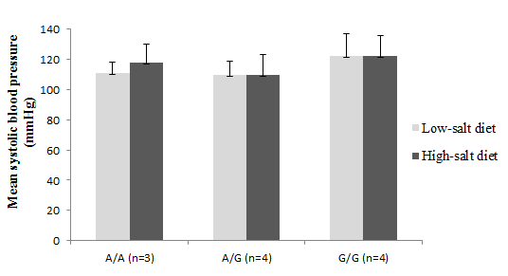



Fig. 1. Example of an allelic discrimination plot Fig. 2. SBP response to each diet by genotype

for the SNP rs7571842 in the study population status (participants with incomplete urinary samples

excluded from the analysis)

|  |  |  |  |  |  |  |
| --- | --- | --- | --- | --- | --- | --- |
|  | rs7571842 genotype | | | | | |
|  | A/A (n=4) | | A/G (n=4) | | G/G (n=5) | |
|  | Mean | SD | Mean | SD | Mean | SD |
| Age (years) | 36 | 7 | 35 | 9 | 27 | 12 |
| BMI (kg/m2) | 23.8 | 4.0 | 22.6 | 2.8 | 24.0 | 4.1 |
| SBP (mmHg) | 121 | 21 | 109 | 11 | 127 | 13 |
| DBP (mmHg) | 71 | 15 | 67 | 10 | 73 | 4 |
| STDT (mol/l) | 0.010 | 0.005 | 0.009 | 0.003 | 0.009 | 0.003 |
| STRT (mol/l) | 0.015 | 0.006 | 0.016 | 0.003 | 0.013 | 0.004 |
| FFQ (mg Na/day) | 2947 | 797 | 3636 | 889 | 2923 | 729 |

BMI, Body mass index; DBP, Diastolic blood pressure

There was no difference in SBP (Fig. 2) or MAP (data not shown) response to dietary intervention between rs7571842 genotype groups. There was no correlation between salt sensitivity of BP, salt taste thresholds and habitual salt intake (data not shown) or a difference in salt taste thresholds and dietary salt intake between rs7571842 genotypes. In conclusion, genetic variation in the *SLC4A5* gene is not associated to altered salt taste perception or intake.

1. Carey RM, Schoeffel CD, Gildea JJ *et al*. (2012) *Hypertension* **60**, 1359-66.
2. Dotson CD, Babich J, Steinle NI (2012) *Curr Nutr Rep,* **1**,175-183.