Changing predictions, stable recognition: Children’s representations of downward incline motion

Abstract

Various studies to-date have demonstrated children hold ill-conceived expressed beliefs about the physical world such as that one ball will fall faster than another because it is heavier. At the same time they also demonstrate accurate recognition of dynamic events. How these representations relate is still unresolved. This study examined 5- to 11-year-olds’ (N = 130) predictions and recognition of motion down inclines. Predictions were typically in error, matching previous work, but children largely recognised correct events as correct and rejected incorrect ones. The results also demonstrate while predictions change with increasing age, recognition shows signs of stability. The findings provide further support for a hybrid model of object representations and argue in favour of stable core cognition existing alongside developmental changes.

Keywords: Conceptual development; everyday physics; incline motion; object mass; core cognition

- Introduction

Evaluating and interpreting the physical world around us is of essence for survival in this world. This involves understanding the laws that govern it and being able to predict any outcomes to a degree that is sufficient for successful navigation through the world. This ability to preconceive shows itself from a young age, with children demonstrating an extensive repertoire of abilities to interpret and respond to the physical world. There is some debate as to how we are able to navigate this physical world in a sufficient manner, but one particular view posits that we hold core knowledge about the physical world that may be innate, and that this is enhanced over time through more concrete experiences (e.g. Baillargeon & Carey, 2012; Heintz, 2014; but also see e.g. Hood & Santos, 2009, for a wider discussion around the origins of such knowledge). However, many of the beliefs that children display in their explicit reasoning are to some extent erroneous and constructed on the basis of personal experiences (Bliss, 2008; Klaassen, 2005). Repeatedly, research has been able to document a wide range of such misconceptions in childhood and beyond (see Duit, 2009, for a comprehensive list of over 8,000 studies). One particularly ubiquitous domain is a set of beliefs about events involving moving objects, a domain we engage with essentially from birth (Planinic, Boone, Krsnik, & Beilfuss, 2006). These beliefs do not represent isolated ideas but conceptual structures called upon in reasoning, providing a coherent framework for understanding the world.
A key issue that requires further examination is the relationship between the core cognitive concepts of object motion and the explicit beliefs about motion events held at later ages. The skills required in producing explanations that help to predict outcomes of motion events, such as planning motion trajectories or being able to explain in advance the stopping point of an object following motion, need to draw on deliberation, reflection, and a conscious understanding of rules or decisions (Hogarth, 2001; Plessner & Czenna, 2008) – an explicit engagement with the relevant conceptual knowledge structures is required. However, “a great deal of our commonsense knowledge, and there is a large amount of it, is tacit” (Bliss, 2008, p. 123). Various studies have, in this context, demonstrated that across the lifespan infants (Friedman, 2002; Kannass, Oakes, & Wiese, 1999; Kim & Spelke, 1992), children (Hast & Howe, 2015; Howe, Taylor Tavares, & Devine, 2012, 2014; Kim & Spelke, 1999) and adults (Kaiser & Proffitt, 1984; Kaiser, Proffitt, Whelan, & Hecht, 1992; Naimi, 2011; Shanon, 1976) possess the ability to recognise physically correct motion trajectories and reject those that do not appear to be natural, even if the non-natural trajectories had been predicted in an explicit manner. These tasks may merely need to engage tacit knowledge structures set to provide quick responses without conscious awareness, eliciting feelings of familiarity with events (Collins, 2010; also see e.g. Kahneman, 2011, for a similar discussion around ‘System I’ and ‘System II’ representations). Some research suggests very young children engage in predictive anticipations when evaluating outcomes of object motion events (e.g. Lee & Kuhlmeier, 2013). However, these anticipations should probably not be regarded as explicit predictions since despite very initially displaying accurate looking, which may be accounted for by quick responses without conscious awareness, these children eventually chose an incorrect response, likely through some process of reflection and deliberation.
A current perspective on core cognition representations is that they act as an evolutionary scaffold for enrichment of knowledge in a manner that suggests the core cognition representations are stable but the outcomes of enrichment can take any form (Heintz, 2014) and explicit ideas, as opposed to tacit conceptions, are subject to conceptual change (Carey, 2015). Critical to the enrichment process are so-called cognitive causal chains in social communication processes where ideas are shared through verbal production and understanding. To date there are three views that try to explain the relationship between explicit predictions and tacit knowledge representations. The omission theory posits that explicit understanding is a partial version of the tacit representations. In the process of elevating tacit conceptions to the explicit level, elements are omitted, and this leads to differences between prediction and recognition (Kim & Spelke, 1999; Spelke & Hespos, 2001). The separate systems approach argues that explicit and tacit knowledge coexist in a mutually exclusive manner where depending on task requirements only the relevant system is accessed (Hogarth, 2001; Plessner & Czenna, 2008). Finally, a hybrid approach proposes two partially associated knowledge systems. Explicit knowledge is, in part, an embellishment of knowledge held at the tacit level, rather than being a reduced version as in omission (Carey, 2009; Hast & Howe, 2015; Howe, 2014; Howe et al., 2012, 2014). Trying to resolve which of these three views applies to representations of knowledge about object motion is an ongoing process – which the present study aims to support.
Most of the studies addressing tacit knowledge, regardless of age group, focus on falling objects, although there is also some consideration of motion along horizontal surfaces (e.g. Howe et al., 2014). However, explicit predictions for both object fall and motion along horizontals do not appear to be subject to significant age-related changes – for example, across different age groups children consistently predict that a heavy ball will fall faster than a light ball (although there is some subjectivity in these predictions; cf. Hast, 2014a). Motion down inclines, on the other hand, affords new insight. Various studies have examined children’s verbalised understanding of object motion down inclines, tackling the discussions from different angles. These include their understanding how incline height changes impact motion (Ferretti, Butterfield, Cahn, & Kerkman, 1985; Howe, Tolmie, & Rodgers, 1992; Inhelder & Piaget, 1958), or understanding speed changes (Ebersbach, Van Dooren, & Verschaffel, 2011; Piaget, 1970; Raven, 1972). Of particular note, however, are studies that highlight developmental changes in making predictions about motion down inclines which collectively indicate the significant role of object weight in these changes (Hast, 2016; Hast & Howe, 2012, 2013a; Howe, 1998). The latter research has shown that younger children typically expect light objects to roll down a slope faster than a heavy object, but older children believe the reverse to be true. These developmental changes in explicit conceptions indicate this topic provides a suitable opportunity to examine the relationship between explicit beliefs and tacit representations in more detail. Studies with infants afford first insight into this matter (Kannass, Oakes, & Wiese, 1999; Kim & Spelke, 1992).
The study outlined in this paper is thus an attempt to assess children’s predictions and recognition of object motion down inclines, by placing particular emphasis on the role of object weight. Being a fundamental concept of the physical world (Galili, 2001), object weight may help shed light on this matter due to the incoherent application to explicit predictions already evident in research. Yet it is a concept that appears to be in place early in development; the general ability to distinguish between heavy and light emerges within the first year of life (Hauf & Paulus, 2011; Hauf, Paulus, & Baillargeon, 2012; Molina, Guimpel, & Jouen, 2006; Molina & Jouen, 2003; Paulus & Hauf, 2011). To examine change versus stability, two main hypotheses are offered here. Given that the current literature suggests verbalised conceptions of motion down inclines show an age-related shift between light-faster and heavy-faster outcomes, it is already possible to anticipate that predictions will change with increasing age. This leaves us with stating that either 1) both prediction and recognition tasks show changes with increasing age, although these need not necessarily follow the same trends, or 2) predictions change with increasing age but recognition remains stable. Both of these hypotheses, as a result, provide further opportunity to clarify the relationship between explicit predictions and tacit knowledge. If omission explains the performance differences between tasks, then a similar pattern should emerge in recognition as in predictions – if variables other than weight are kept constant, then there should be no additional information that could have been omitted. If a separate systems approach applies, then highly accurate recognition should be expected, with same-speed trials unequivocally recognised as being correct. Finally, if a hybrid model is the best explanation for the relationship, then age-related consistency in same-speed trials being recognised as correct should be anticipated. At the same time, there should be some recognition of both heavy-faster and light-faster trials that reflect the same age-related shift as for predictions.
- Method

2.1 Participants

Participants were recruited from a state primary school in a suburban area of LOCATION, UK. Children were selected if parents did not object to their participation. To ensure understanding of research instructions, class teachers were asked to identify any non-native speakers of English to be sufficiently capable of being able to follow instructions for inclusion in the study. The final sample amounted to 130 children (71 girls). This final sample included 26 Year 1 children (13 girls; age M = 6.17 years, SD = 0.40), 35 Year 2 children (21 girls; age M = 7.11 years, SD = 0.39), 34 Year 4 children (20 girls; age M = 9.11 years, SD = 0.36) and 35 Year 6 children (17 girls; age M = 11.18 years, SD = 0.45). A further 10 children participated in the research but data were not considered for analysis due to insufficient completion of practice trials, not completing both tasks, or due to technical errors.

2.2 Design and Materials

Both the prediction and the recognition tasks used computer-presented scenarios involving two balls, a transparent tube and a wooden frame. For the prediction task these were still images, and for the prediction task they were motion videos. In both cases these were based on a dark green glass marble of 4 cm diameter weighing 75 g, and a bright pink table tennis ball of same diameter but weighing 3 g. A transparent acrylic tube of 101.5 cm length and with an internal diameter of 6.5 cm was used, with a wooden frame allowing the tube to be placed at an incline angle of approximately 30°. These materials were also made available to the children during the tasks to support full understanding of scenarios. This was done since simulations become more effective in meaning when they are supported by relevant tactile experiences (cf. Lazonder & Ehrenhard, 2014). Balls could be handled at any time, but the children were prevented from carrying out actions during the task, so deliberately letting the balls fall or rolling them along the table was not permitted. The scenarios for both prediction and recognition tasks were presented using DMDX, which also records response times (Forster & Forster, 2003). The order of scenarios within individual test stages was randomly varied via the computer program to reduce the likelihood of repeated identical orders across participants.

2.2.1 Prediction task

Scenarios were developed in PowerPoint. Each scenario showed a compilation of two pictures in each of which the tube was placed at an incline with the point of tube entry at a height of 15 cm. The two balls were shown being held by a hand at their initial point of anticipated motion at the tube entry. Beneath the scenarios were three brief possible motion outcomes written in large font against coloured backgrounds. The options read ‘A is faster’, ‘B is faster’ and ‘Same speed’ (see Figure 1, left). Each of the three response options had a different background colour; the left-hand option had a red background, the middle option had a yellow background, and the right-hand option had a blue background. Background colours always remained in the same order but response options were rotated across locations to produce three orders. Thus, a total of 36 scenarios were prepared for this task, amounting to all possible combinations of ball location, motion direction and response option location. Each child’s set of scenarios would maintain the same motion direction but would cover six trials – two heavy-faster, two light-faster and two same-speed trials – with each pair covering both ball locations. In addition, procedure familiarisation scenarios were developed in PowerPoint, with each scenario showing two squares of same or differing sizes with three options to choose from (‘A is bigger’, ‘B is bigger’, ‘Same size’). These scenarios were developed to allow a simple way for the children to understand how to work with the keyboard and to follow the general instructions of choosing one of three descriptions.

2.2.2 Recognition task

Scenarios were initially recorded with a Sony DCR-HC35E digital video camera recorder. Clips were filmed individually with one ball only, using the same set-up of transparent tube and wooden frame as in the prediction task, with the point of tube entry at a height of 15 cm. A hand would hold one of the two balls inside the upper end of the tube and release it. Clips were filmed to account for the two ball types, ensuring the two balls were always contrasting in colour but accounting for location (top versus bottom), and direction of incline (down to the left versus down to the right). Using Windows Movie Maker each of the clips was slowed down to half the speed. By compiling these clips three different scenario types were created. They either showed motion as it occurs naturally for both balls (‘same-speed’), or showed modified motion where, non-naturally, one ball was twice as fast as the other – either the heavy ball (‘heavy-faster’) or the light ball (‘light-faster’). The clips were then compiled to show two tubes within one scenario (see Figure 1, right), with both balls being released simultaneously. The hand release involved next to no movement, as the balls were only held down rather than grasped, so slowing down the motion had no noticeable impact on hand movement. The quality of any of the scenarios was not compromised between compilations, including where slowed-down clips had been used. All compiled video clips were 10 s long, with motion occurring at 5 s into the clip, to give enough opportunity to note ball locations. Response times were recorded from 0 s onwards, and trials were set to last for 30 s, after which the next trial would start if no response was given by the participant before then. In addition, procedure familiarisation scenarios were developed in PowerPoint, with each scenario either showing a blue circle or a red triangle. These scenarios did not involve any kind of motion but were developed to allow a simple way for the children to understand how to work with the keyboard and to follow the general instructions of accepting or rejecting a scenario.

[Insert figure 1 about here]

2.3 Procedure

All children were assessed on an individual basis for both tasks. To begin, each child was introduced to the two balls but was reminded that while they could be handled at any time they could not be dropped or rolled deliberately. The trials were presented on a Sony VAIO VGN-NR21J laptop and displayed on an external 15” LCD colour monitor connected to the laptop. An external KeySonicTM Nano Keyboard ACK-3400U, also connected to the laptop, was used for responding to the trials. The keyboard was masked to reduce distractions from unnecessary keys. Three keys were indicated by colour on the masking. Keys not used were disabled. One key was in the centre of the keyboard (yellow key); the other two were at the left end (red key) and at the right end (blue key) in the same row as the centre key. The colours of keys corresponded to the on-screen response option background. Each child completed both tasks and the two tasks were carried out approximately six weeks apart from one another.

2.3.1 Prediction task

With the monitor screen blank, the researcher familiarised the child with the monitor and the keyboard. The child was asked to point out each key according to its colour and was then asked to press the yellow key. This elicited an on-screen introduction to the materials. The child saw a series of diagrams of the monitor and keyboard, which the researcher used to explain the procedure by showing the link between response choices and keys to press. At the end of the introduction the child was told that there would be some easy trials to practice working with the keyboard. If children were unable to read the response options (typically the younger children) the researcher would watch the trials with them and read out the response options for them. Responses were always read out from left to right. The researcher pointed to the picture in question and the corresponding response option each time. During the procedure familiarisation phase the researcher would say to the child: “If you think the square on the top [researcher points at picture A] is bigger, press the red key. If you think the square on the bottom [researcher points at picture B] is bigger, press the yellow key. If you think they are both the same size, press the blue key”. For the test trials the child was given the following instruction: “If you think the ball on the top [researcher points at picture A] will roll down faster, press the red key. If you think the ball on the bottom [researcher points at picture B] will roll down faster, press the yellow key. If you think they will both roll down as fast as each other, press the blue key”. No motion occurred and children were not provided with feedback whether their response was correct or not. Each child was expected to respond to all trials shown, and the task took around 10 to 15 minutes per child.

2.3.2 Recognition task

For half of the children the ‘yes’ response was the red key on the left of the keyboard and the ‘no’ response the blue key on the right of the keyboard, and vice versa for the other half. During the procedure familiarisation phase, the child was given the following instruction: “Watch carefully, and decide as quickly as you can. I want you to look for a blue circle. Every time you see a blue circle, press ‘yes’ [researcher points to ‘yes’ key]. Every time you see a red triangle, press ‘no’ [researcher points to ‘no’ key]”. To support the explanation children were shown two sheets of paper next to the two keys, showing the word ‘yes’ accompanied by a green tick and the word ‘no’ accompanied by a red cross. The child was then asked to press the yellow key, which started the trials. For the test trials the child was given the following instruction: “You are going to see two hands holding these two balls [researcher points to both balls] inside the tube and letting them go. Watch carefully, and decide, as quickly as you can, whether it looks right or not. If it looks right, press ‘yes’ [researcher points to ‘yes’ key] and if it does not look right, press ‘no’ [researcher points to ‘no’ key]”. Children were not provided with feedback whether their response was correct or not. Each child was expected to respond to all trials shown, and the task took around 10 minutes per child.

- Results

For each outcome option in the prediction task – heavy-faster, light-faster or same-speed – a score of 0 (prediction not made) or 1 (prediction made) was allocated on each trial. For each of the same outcome options in the recognition task a score of 0 (trial judged as incorrect) or 1 (trial judged as correct) was allocated on each trial, regardless of whether the outcomes were actually correct. Mean scores were converted to percentages to allow for clearer comparison and were then analysed according to which types of trials were more likely to be predicted and more likely to be recognised as being correct. Wilcoxon signed-rank tests were used to compare trial type percentages with chance levels (33.3% for each prediction trial, 50% for each recognition trial). Friedman’s ANOVAs and post hoc Wilcoxon signed-rank tests with Bonferroni corrections were then used to examine differences between the three types of trials in each task type. Kruskal-Wallis tests and post-hoc Mann-Whitney tests with Bonferroni corrections were used to examine differences between age groups on each trial type. To examine any further details in the reasoning process of the recognition task Wilcoxon signed-rank tests, Kruskal-Wallis tests and post hoc Mann-Whitney tests were used to evaluate response times. In addition, Mann-Whitney tests were carried out to evaluate any differences related to gender, task order, left-right motion presentation, and response location on the keyboard. No significant differences were noted on any variables so these factors are not considered further. All data were analysed using SPSS 21.

3.1 Prediction task

[Insert figure 2 about here]

A summary of the results for the prediction task is shown in Figure 2. Overall heavy-faster predictions (M = 62.69%, SD = 46.12) occurred significantly more frequently than if performing at chance level, z = -7.37, p < .001, r = .54. The overall frequency of light-faster predictions (M = 32.95%, SD = 44.87) did not differ significantly from chance level performance. Finally, overall same-speed predictions (M = 4.36%, SD = 16.54) occurred significantly less frequently than if performing at chance level, z = -9.33, p < .001, r = .63. Overall, the heavy ball was predicted to be faster more frequently than the light ball, z = -3.45, p < .05, r = .21, and light-faster predictions in turn were more common than same-speed predictions, z = -5.79, p < .001, r = .34. There was no significant age-related variation for same-speed predictions. However, there were age-related shifts for both heavy-faster and light-faster predictions. Heavy-faster predictions increased with age, H(3) = 51.48, p < .001, J = 4678, z = 7.11, r = .53. Post-hoc evaluations show there was only a statistically significant change between Year 1 and Year 2 children. In the Year 1 group (M = 10.26%, SD = 29.47), predictions were significantly below chance level, z = -2.79, p < .05, r = .36. In the Year 2 group (M = 56.67%, SD = 44.13), predictions were already significantly above chance level, z = -3.13, p < .05, r = .35. This performance was maintained for Year 4 (M = 79.90%, SD = 38.22) and Year 6 children (M = 90.95%, SD = 28.40). Light-faster predictions, on the other hand, decreased with age, H(3) = 51.88, p < .001, J = 1688, z = -7.01, r = .52. Post-hoc evaluations again show there was only a statistically significant decrease between Year 1 and Year 2 children. In the Year 1 group (M = 87.18%, SD = 32.76), predictions were significantly above chance level, z = -4.65, p < .001, r = .54. In the Year 2 group, children no longer performed significantly differently from chance level (M = 36.19%, SD = 44.19). Both Year 4 children (M = 17.16%, SD = 35.65), z = -2.45, p < .05, r = .29, and Year 6 children (M = 4.76%, SD = 18.33) then made light-faster predictions significantly below chance level.

3.2 Recognition task

[Insert figure 3 about here]

A summary of the results for the recognition task is shown in Figure 3. Overall, heavy-faster trajectories (M = 29.23%, SD = 35.65) were rated as correct significantly below performance at chance level, z = -5.76, p < .001, r = .45. Light-faster trajectories (M = 26.92%, SD = 37.95) were also rated as correct significantly below chance level, z = -5.94, p < .001, r = .46. Same-speed trajectories (M = 75.38%, SD = 38.50), on the other hand, were rated as correct significantly above chance level, z = -6.29, p < .001, r = .48. Overall, same-speed trials were rated as correct more frequently than both the incorrect heavy-faster trajectories, z = -6.57, p < .001, r = .38, and the incorrect light-faster trajectories, z = -6.62, p < .001, r = .38, but there was no significant rating difference between the heavy-faster and the light-faster trials. There was no significant age-related variation for rating same-speed trajectories as correct. However, there were age-related shifts for both heavy-faster and light-faster trials. Ratings of heavy-faster trajectories as correct increased with age, H(3) = 16.13, p < .05, J = 4028, z = 4.07, r = .34. Post-hoc evaluations only show a statistically significant change between Year 1 and Year 4. In the Year 1 group (M = 9.62%, SD = 24.57), ratings were significantly below chance level, z = -4.38, p < .001, r = .52. In both the Year 2 group (M = 22.86%, SD = 28.03) and the Year 4 group (M = 33.82%, SD = 34.20), the pattern was repeated. In the Year 6 group, children no longer performed significantly differently from chance level (M = 45.71%, SD = 42.65). Ratings of light-faster trajectories as correct, on the other hand, decreased with age, H(3) = 18.26, p < .001, J = 2284, z = -4.21, r = .35. Post-hoc evaluations again only show a statistically significant change between Year 1 and Year 4. In the Year 1 group (M = 50.00%, SD = 42.43), ratings were not significantly different from chance level. Subsequently, the Year 2 children (M = 32.86%, SD = 41.91), z = -2.27, p < .05, r = .26, the Year 4 children (M = 22.06%, SD = 35.23), and the Year 6 children (M = 8.57%, SD = 19.12) all performed significantly below chance level.

3.3 Response time data

[Insert figure 4 about here]

Mean same-speed trial response times (M = 3135 ms, SD = 1343) were significantly lower than for both heavy-faster trials (M = 3728 ms, SD = 1071), z = -4.74, p < .001, r = .28, and light-faster trials (M = 3595 ms, SD = 1940), z = -3.87, p < .001, r = .23. However, mean response times for heavy-faster and light-faster trials did not differ significantly. Regardless of trial type, with increasing age children generally made faster responses, H(3) = 46.15, p < .001, J = 1562, z = -6.64, r = .50. Post-hoc evaluations show there was only a statistically significant improvement in response speed between Year 2 and Year 4. However, different age trends were noted for the different trial types. For heavy-faster trials, responses were slower with increasing age, H(3) = 22.80, p < .001, J = 4033, z = 3.66, r = .31. On the other hand, faster responses with increasing age were noted both for light-faster trials, H(3) = 90.76, p < .001, J = 987, z = -9.04, r = .62, and for same speed trials, H(3) = 38.10, p < .001, J = 1719, z = -5.99, r = .46. In all three cases, post-hoc analyses again show there was only a significant change from Year 2 to Year 4. In response to the age-related shift noted in the recognition outcomes, the heavy-faster and light-faster trials were both examined in more detail by comparing response times when both trials were rated as incorrect (both-rejection), one was rated as correct (one-acceptance), or both were rated as correct (both-acceptance). For heavy-faster trials mean both-rejection times (M = 3571 ms, SD = 1052) were lower than mean one-acceptance times (M = 3902 ms, SD = 1055), which in turn were lower than mean both-acceptance times (M = 3956 ms, SD = 1149). However, while mean response times were slower with more incorrect performance, these differences did not reach statistical significance. On the other hand, for light-faster trials there was significant variation in trial times, H(2) = 14.49, p < .05. Mean both-rejection times (M = 3197 ms, SD = 1921) were faster than mean one-acceptance times (M = 3741 ms, SD = 1792), but not significantly different. One-acceptance times, on the other hand, were significantly faster than mean both-acceptance times (M = 4937 ms, SD = 1615), z = -2.41, r = .33.

- Discussion

In selecting motion events down inclines and the role played by object weight, this study sought to address several questions. Firstly, are age-related shifts noted in explicit predictions of motion down inclines also manifest in children’s recognition of events, or are tacit representations different? Secondly, in light of typically erroneous predictions, how accurate is children’s recognition? Thirdly, what is the relational manifestation of the different knowledge levels? And finally, how can these findings contribute to ongoing discussions about initial core cognition and later conceptual development?
The prediction task results in sum show that children’s predictions across all age groups consistently lacked accuracy; only in rare instances did children select same-speed predictions. Conversely, there was an age-related shift in predictions from predominantly predicting the light ball to roll down faster in the youngest age group to predicting the heavy ball to roll down faster in the oldest age group. These findings are consistent with previous research noting similar changes across childhood (Hast, 2016; Hast & Howe, 2012, 2013a; Howe, 1998). Predictions made in this study can be considered to be explicit representations of conceptual knowledge, since very similar responses were obtained in tasks requiring children to give verbal justifications for their predictions using the same procedures and showing positive correlations between real-life object tasks and computer-presented versions of the same task (Hast & Howe, 2013b). However, alongside this shift across age groups it was clear to see that the same children were very competent at correctly recognising motion events in the second task. This included their ability to accept the physically natural events as correct in around 75% – significantly above chance – of trials, as well as their ability to reject the non-natural events to a similar degree. Overall, the high accuracy in recognition and the divergence from predictions found here is in line with previous studies examining tacit recognition of object motion (Friedman, 2002; Hast & Howe, 2015; Howe et al., 2012, 2014; Kaiser & Proffitt, 1984; Kaiser et al., 1992; Kannass et al., 1999; Kim & Spelke, 1992, 1999; Naimi, 2011; Shanon, 1976).
Although overall recognition accuracy was relatively high, like in previous work drawing direct comparisons between prediction and recognition there was mirroring of incorrect predictions within the recognition outcomes. However, unlike in these previous studies (e.g. Hast & Howe, 2015; Howe et al., 2012, 2014) the false alarms – recognising an event to be correct when in fact it is physically incorrect – were not stable across the age groups. Instead, these false alarms changed with increasing age in a manner similar to the children’s predictions. The younger children were more likely to select light-faster trials as correct but with increasing age the children were more likely to select heavy-faster trials as correct. These differences between prediction and recognition can best be explained through the presence of deliberation in the prediction task and absence thereof in the recognition task; and the response time data may exemplify this process. While explicit knowledge structures are associated with prolonged evaluation and a conscious examination (Hogarth, 2001; Plessner & Czenna, 2008), access to tacit knowledge structures can be gained through fast evaluation without conscious awareness (Collins, 2010). Indeed, for light-faster trials in the recognition task, response times were typically faster the older children were, combined with the increase in rejections of such trials, and for heavy-faster trials response times were slower. A more detailed examination of this relationship between response times and choice is required, though, for example by using time-constrained tasks that force responses at earlier points. Nonetheless as in previous work (Hast & Howe, 2015) there is good indication here that reflection during trials has led to accessing explicit knowledge structures, overriding the tacit expectations. Taken collectively, the hypothesis that both prediction and recognition tasks would show changes with increasing age has to be rejected here. Instead, the hypothesis posited at the outset that predictions change with increasing age but recognition remains stable must be accepted.
The stability-versus-change findings appear to reflect Heintz’s (2014, p. 211) notion of scaffolding on core cognition, where “old ideas are used in the generation of new ideas, and this is why they are stabilised … Numerous new ideas emerge from old ones and would not have evolved if the old ideas had not existed first”. Accordingly, recognition of incline motion events draws on a systemic network of domain-specific abilities such as object tracking and representations of material objects. This system may then merely need activation through a mapping process, and depending on the closeness of match between the external event and the internal resulting model the event is either accepted or rejected (Hast, 2014b). This can also be illustrated through other tasks where children make search errors when objects roll down ramps behind screens and the children have to pick the location where they think the object is to be found behind the screen (e.g Haddad, Chen, & Keen, 2011; Perry, Smith, & Hockema, 2008). These errors are guided by a representational momentum bias, whereby children will believe the object to be in a location attributable to the initially witnessed velocity of that object – even if this means passing through barriers. Children also show these errors when using relational information about objects, such as different sizes (Gresham, 2012). Although all motion in the recognition task in the present study was visible at all times, choices may still have been guided by such representations. Predictions at an explicit level also draw on core object cognition. However, through public representation in language or other explicit forms via a cognitive causal chain (Sperber, 2006; also see Heintz, 2014) – or by being at the receiving end of this chain – new ideas are constructed, leading to malleable conceptions that differ from their tacit representations without impacting the latter’s stability, much like the final message in a game of Chinese whispers.
This theoretical view also allows us to examine the relationship between explicit predictions and tacit representations of knowledge. Out of the three perspectives presented, the omission approach (Kim & Spelke, 1999; Spelke & Hespos, 2001) cannot explain the findings. If the differences noted between the two tasks in the present study were due to omission, then predictions should be a reduced version of recognition, leaving out conceptual elements of the tacit representation. While this would allow for general flexibility in predictions it is the content of the flexibility in this particular study that would argue against omission. Since the role of object weight in events such as falling or rolling down slopes can be seen as negligible for the purposes of everyday understanding, recognising same-speed trials as correct would not depend on any understanding of weight, and children are clearly able to recognise incline motion events. However, they do draw on object weight in making predictions, thus relying on addition rather than omission of conceptual information that leads to erroneous predictions. In place, both the separate systems (Hogarth, 2001; Plessner & Czenna, 2008) and the hybrid model (Carey, 2009; Hast & Howe, 2015; Howe, 2014; Howe et al., 2012, 2014) allow for such embellishment. However, the partial mirroring of the age-related shift in both prediction and recognition do favour the hybrid model rather than a stringent separation of the two.
The study can only offer restricted insight into solving this issue, though. There are many additional factors that need to be taken into account towards a more stringent understanding. For instance, what role might the size-weight illusion play in such processes? Children actively use an object’s size to predict its weight by around three and a half years of age (see e.g. Povinelli, 2012). Given that both balls in the present study were the same size – could this have guided the children’s expectations towards same speed recognition? Even though both tasks show different results, it is still worth evaluating the impact of this effect. Similarly, given that we have only relied on particular speed variations in the recognition task, how well does this translate onto other speeds, such as with one ball only being one and a half times faster? By incorporating further features such as different sizes but same weights, or different sizes and different weights, a clearer understanding might be gained about children’s representations of objects in dynamic events.

Acknowledgements

REMOVED FOR REVIEW PROCESS.

References

Baillargeon, R., & Carey, S. (2012). Core cognition and beyond: The acquisition of physical and numerical knowledge. In S. M. Pauen (Ed.), Early childhood development and later outcome (pp. 33-65). Cambridge: Cambridge University Press.
Bliss, J. (2008). Commonsense reasoning about the physical world. Studies in Science Education, 44, 123-155.
Carey, S. (2009). The origin of concepts. New York, NY: Oxford University Press.
Carey, S. (2015). Why theories of concepts should not ignore the problem of acquisition. In E. Margolis & S. Laurence (Eds.), The conceptual mind: New directions in the study of concepts (pp. 415-454). Cambridge, MA: MIT Press.
Collins, H. (2010). Tacit and explicit knowledge. Chicago, IL: University of Chicago Press.
Duit, R. (2009). Bibliography STCE: Students’ and teachers’ conceptions and science education. Retrieved October 23, 2014, from http://archiv.ipn.uni-kiel.de/stcse/
Ebersbach, M., Van Dooren, W., & Verschaffel, L. (2011). Knowledge on accelerated motion as measured by implicit and explicit tasks in 5 to 16 year olds. International Journal of Science and Mathematics Education, 9, 25-46.
Ferretti, R. P., Butterfield, E. C., Cahn, A., & Kerkman, D. (1985). The classification of children’s knowledge: Development on the balance-scale and inclined-plane task. Journal of Experimental Child Psychology, 39, 131-160.
Forster, K. I., & Forster, J. C. (2003). DMDX: A Windows display program with millisecond accuracy. Behavior Research Methods, Instruments, & Computers, 35, 116-124.
Friedman, W. J. (2002). Arrows of time in infancy: The representation of temporal-causal invariances. Cognitive Psychology, 44, 252-296.
Galili, I. (2001). Weight versus gravitational force: Historical and educational perspectives. International Journal of Science Education, 23, 1073-1093.
Gresham, L. J. (2012). Children’s core knowledge about physics: An attention-based account (Unpublished doctoral thesis). Cincinnati, OH: University of Cincinnati.
Haddad, J. M., Chen, Y., & Keen, R. (2011). Preschoolers search for hidden objects. Journal of Experimental Child Psychology, 109, 123-131.
Hast, M. (2014a). Exploring the shift in children’s incline motion predictions: Fragmentation and integration of knowledge as possible contributors. Journal of Educational and Developmental Psychology, 4(2), 74-81.
Hast, M. (2014b). Collaborating with the ‘more capable’ self: Achieving conceptual change in early science education through underlying knowledge structures. ReflectEd, St Mary’s Journal of Education, 3, 18-25.
Hast, M. (2016). Children’s reasoning about rolling down curves: Arguing the case for a two-component commonsense theory of motion. Science Education, 100, 837-848.
Hast, M., & Howe, C. (2012). Understanding the beliefs informing children’s commonsense theories of motion: The role of everyday object variables in dynamic event predictions. Research in Science & Technological Education, 30, 3-15.
Hast, M., & Howe, C. (2013a). Towards a complete commonsense theory of motion: The interaction of dimensions in children’s predictions of natural object motion. International Journal of Science Education, 35, 1649-1662.
Hast, M., & Howe, C. (2013b). The development of children’s understanding of speed change: A contributing factor towards commonsense theories of motion. Journal of Science Education and Technology, 22, 337-350.
Hast, M., & Howe, C. (2015). Children’s predictions and recognition of fall: The role of object mass. Cognitive Development, 36, 103-110.
Hauf, P., & Paulus, M. (2011). Experience matters: 11-month-old infants can learn to use material information to predict the weight of novel objects. Infant Behavior and Development, 34, 467-471.
Hauf, P., Paulus, M., & Baillargeon, R. (2012). Infants use compression information to infer objects’ weights: Examining cognition, exploration, and prospective action in a preferential‐reaching task. Child Development, 83, 1978-1995.
Heintz, C. (2014). Scaffolding on core cognition. In L. R. Caporael, J. R. Griesemer, & W. C. Wimsatt (Eds.), Developing scaffolds in evolution, culture, and cognition (pp. 209-228). Cambridge, MA: MIT Press.
Hogarth, R. M. (2001). Educating intuition. Chicago, IL: University of Chicago Press.
Hood, B. M., & Santos, L. R. (2009). The origins of object knowledge. Oxford: Oxford University Press.
Howe, C. J. (1998). Conceptual structure in childhood and adolescence: The case of everyday physics. London: Routledge.
Howe, C. (2014). “If you’ve seen it before, then you know”: Physical evidence and children’s trust in testimony. In E. J. Robinson & S. Einav (Eds.), Trust and skepticism: Children’s selective learning from testimony (pp. 151-162). Hove: Psychology Press.
Howe, C., Taylor Tavares, J., & Devine, A. (2012). Everyday conceptions of object fall: Explicit and tacit understanding in middle childhood. Journal of Experimental Child Psychology, 111, 351-366.
Howe, C., Taylor Tavares, J., & Devine, A. (2014). Children’s conceptions of physical events: Explicit and tacit understanding of horizontal motion. British Journal of Developmental Psychology, 32, 141-162.
Howe, C., Tolmie, A., & Rodgers, C. (1992). The acquisition of conceptual knowledge in science by primary school children: Group interaction and the understanding of motion down an incline. British Journal of Developmental Psychology, 10, 113-130.
Inhelder, B., & Piaget, J. (1958). The growth of logical thinking from childhood to adolescence (A. Parsons & S. Milgram, Trans.). London: Routledge & Kegan Paul.
Kahneman, D. (2011). Thinking, fast and slow. London: Allen Lane.
Kaiser, M. K., & Proffitt, D. R. (1984). The development of sensitivity to causally relevant dynamic information. Child Development, 55, 1614-1624.
Kaiser, M. K., Profitt, D. R., Whelan, S. M., & Hecht, H. (1992). Influence of animation on dynamical judgments. Journal of Experimental Psychology: Human Perception and Performance, 18, 669-690.
Kannass, K. N., Oakes, L. M., & Wiese, D. (1999). The development of infants’ perception of object movement along inclines. Cognitive Development, 14, 215-240.
Kim, I. K., & Spelke, E. (1992). Infants’ sensitivity to effects of gravity on visible object motion. Journal of Experimental Psychology: Human Behaviour and Performance, 18, 385-393.
Kim, I.-K., & Spelke, E. S. (1999). Perception and understanding of effects of gravity and inertia on object motion. Developmental Science, 2, 339-362.
Klaassen, K. (2005). The concept of force as a constitutive element of understanding the world. In K. Boersma, M. Goedhart, O. de Jong, & H. Eijkelhof (Eds.), Research and the quality of science education (pp. 447-457). Dordrecht: Springer.
Lazonder, A. W., & Ehrenhard, S. (2014). Relative effectiveness of physical and virtual manipulatives for conceptual change in science: How falling objects fall. Journal of Computer Assisted Learning, 30, 110-120.
Lee, V., & Kuhlmeier, V. A. (2013). Young children show a dissociation in looking and pointing behaviour in falling events. Cognitive Development, 28, 21-30.
Molina, M., & Jouen, F. (2003). Weight perception in 12-month-old infants. Infant Behavior and Development, 26, 49-63.
Molina, M., Guimpel, B., & Jouen, F. (2006). Weight perception in neonate infants. Journal of Integrative Neuroscience, 5, 505-517.
Naimi, A. (2011). Investigating the role and nature of prior knowledge in conceptual change: An fNIRS study (Unpublished master’s dissertation). Toronto: University of Toronto.
Paulus, M., & Hauf, P. (2011). Infants’ use of material properties to guide their actions with differently weighted objects. Infant and Child Development, 20, 423-436.
Perry, L. K., Smith, L. B., & Hockema, S. A. (2008). Representational momentum and children’s sensori-motor representations of objects. Developmental Science, 11, F17-F23.
Piaget, J. (1970). The child’s conception of movement and speed (G. E. T. Holloway & M. J. MacKenzie, Trans.). London: Routledge & Kegan Paul.
Planinic, M., Boone, W. J., Krsnik, R., & Beilfuss, M. L. (2006). Exploring alternative conceptions from Newtonian dynamics and simple DC circuits: Links between item difficulty and item confidence. Journal of Research in Science Teaching, 43, 150-171.
Plessner, H., & Czenna, S. (2008). The benefits of intuition. In H. Plessner, C. Betsch, & T. Betsch (Eds.), Intuition in judgement and decision making (pp. 251-265). New York, NY: Lawrence Erlbaum Associates.
Povinelli, D. J. (2012). World without weight: Perspectives on an alien mind. Oxford: Oxford University Press.
Raven, R. J. (1972). The development of the concept of acceleration in elementary school children. Journal of Research in Science Teaching, 9, 201-206.
Shanon, B. (1976). Aristotelianism, Newtonianism and the physics of the layman. Perception, 5, 241-243.
Spelke, E. S., & Hespos, S. (2001). Continuity, competence, and the object concept. In E. Dupoux (Ed.), Language, brain, and cognitive development: Essays in honor of Jacques Mehler (pp. 325-340). Cambridge, MA: MIT Press.
Sperber, D. (2006). Conceptual tools for a naturalistic approach to cultural evolution. In S. C. Levinson & P. Jaisson (Eds.), Evolution of culture: A Fyssen Foundation symposium (pp. 147-165). Cambridge, MA: MIT Press.

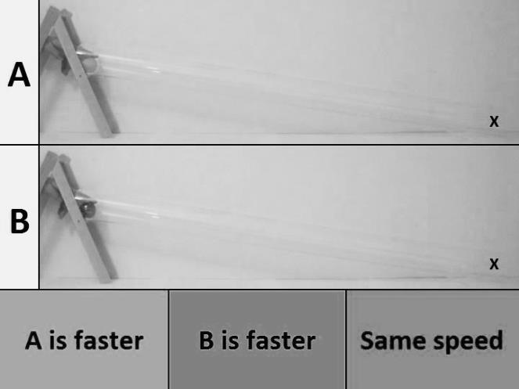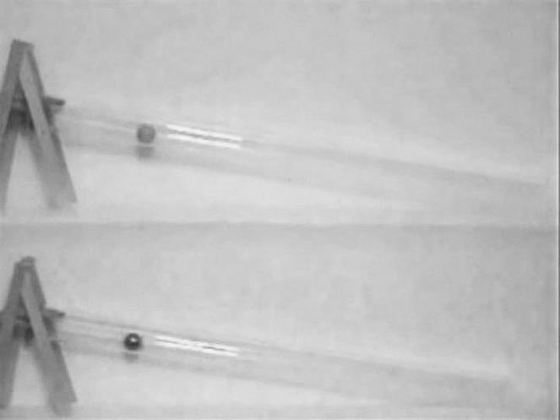
Figure 1. Scenario examples for prediction task (left) and recognition task (right).

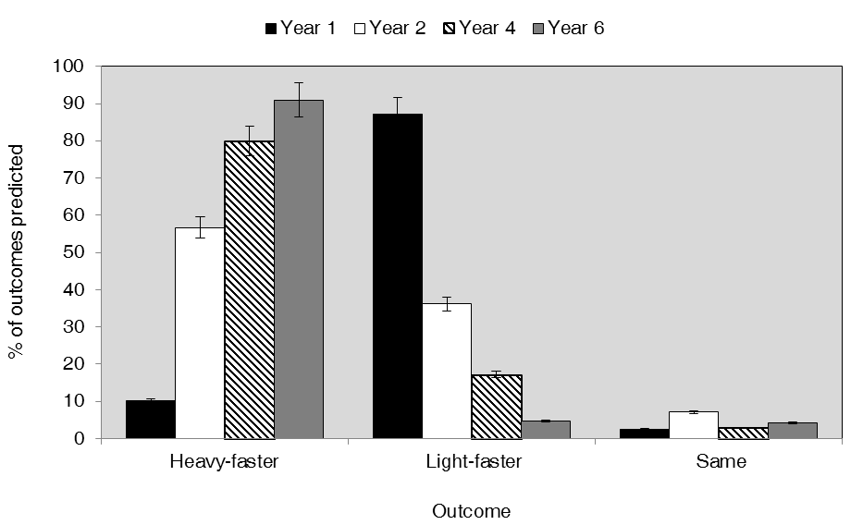
Figure 2. Percentages of predictions of each trial type by age group. The dashed line represents chance performance level.

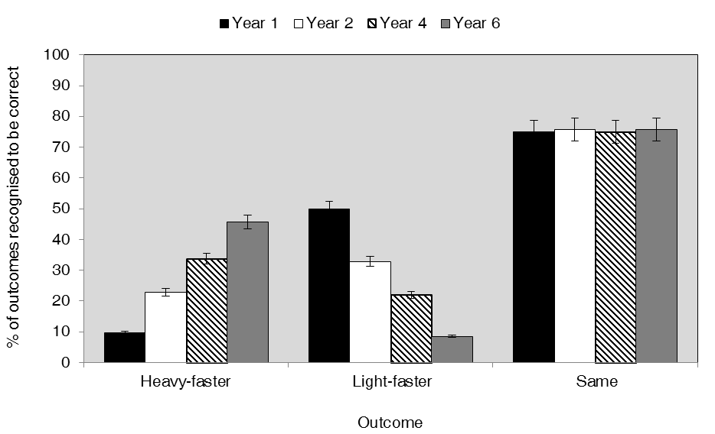
Figure 3. Percentages of recognition-as-correct of each trial type by age group. The dashed line represents chance performance level.

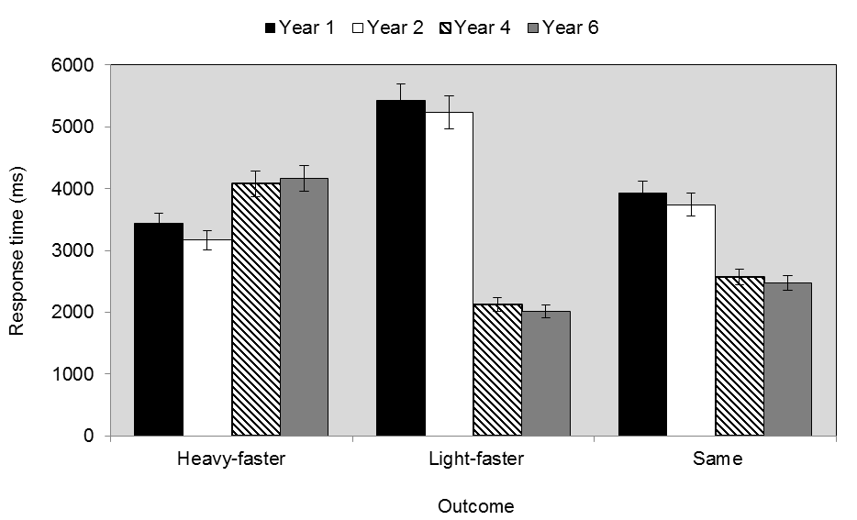
Figure 4. Response times for recognition task by trial type and age group.

The two tasks reported here were not counterbalanced. This was mainly due to time constraints in the materials development process. However, to check for counterbalancing effects a subsequent evaluation was completed with an additional smaller sample from the same age groups, with a few days’ gap between tasks. Analyses were conducted on predictions-first against predictions-second within the additional sample group, and then predictions from the main study against predictions from the additional sample (and the same for the recognition task). No significant differences on any levels were found.

