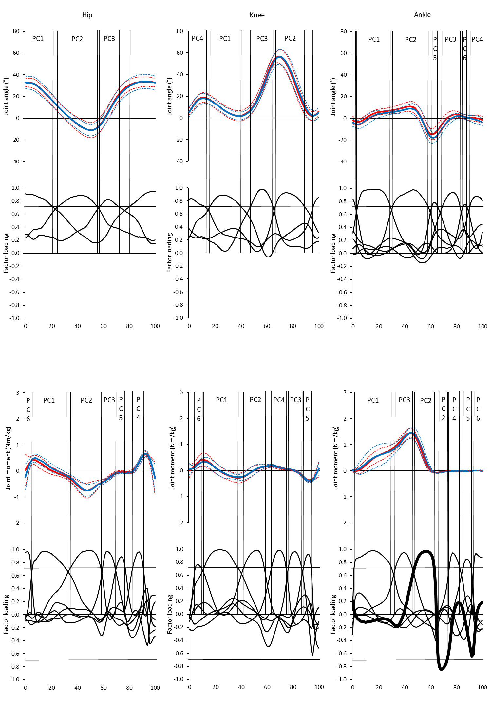
Figure 1.The mean ± 2SD sagittal plane joint angles and external joint moments of hip, knee and ankle and during level walking. Blue lines represent typically developing boys; the red lines represent haemophiliac boys. The dashed lines represent ± 2SD for each group. Normalised gait cycle is defined from foot contact of one limb to subsequent foot contact of the same foot, normalised as a percentage (%). Factor loading for each principal component are plotted beneath angle/moment plots (embolden line represents significant difference between groups) Vertical grey lines indicate significant PC factor scores and percentage of the gait cycle they represent. º: degrees.Nm: Newton metres; kg: kilogram.

