The Global Innovation Index as a Measure of Triple Helix Engagement
Emanuela Todeva, emanuela.todeva@stmarys.ac.uk
School of Business and Society, St. Mary’s University, UK

Abstract
This paper reviews the leading scoring systems for measuring innovation capabilities on a global scale providing comparability across developed and developing countries. Each Index is introduced with its background, methodology, and how it reflects on different Triple Helix constituencies. The first OECD framework developed a methodology for measuring business-led innovation, justified with the mid-twentieth century scientific believe, that universities merely supply labour markets, and government is performing a regulatory role, influencing the environment. The World Bank framework on measuring the knowledge Economy brings in a stronger system view with the role of institutions and late 20th century believes. The EU Innovation Scoreboard, while using the OECD methodology and measures for R&D intensity, expands in the direction of enablers from the university education, public sector research, direct and indirect financial support, and the accumulation of broader economic effects from the innovation process. The Global Innovation Index adds little to this portfolio, but offers a simplified version of innovation inputs, outputs and intensity measure, enabling to extend the comparability across countries. Overall the evolution of innovation indexing is moving towards a recognition of the complex and dynamic realities of interactions between university science, business innovation and government investment in system-level policies and projects, but the measurement remains focused on individual helices.

Keywords
Global innovation index
Triple helix framework
Knowledge economy
EU innovation scoreboard
Competitiveness
1.
Introduction
The global innovation index was created at the time of economic growth and prosperity. The measures of innovation were designed to measure the speed to prosperity and were not directly linked to global challenges or worldwide megatrends.
There are many issues and questions that emerge in relation to this gap. For example, is innovation helping to address global challenges? Can innovation help to tamper the impact of global demographic changes? How innovation can help in our capabilities to address health and inequality and well-being challenges? How innovation can contribute to accelerate the global efforts of humanity to address climate change and environmental catastrophe? Can innovation society gain enhanced decision making powers how to protect natural resources and energy? How innovation can help to improve and enhance the role of government, the state of the economy and jobs, or the scale of globalisation? Is the global innovation index helping to address the global challenges and megatrends?
There are many technologies for the future that are seen as driving growth and prosperity. Are the digital technologies for example shaped to drive change towards sustainable development? Are biotechnologies designed to enhance health, or to plug-in gaps in biopharmaceutical profitability? Are technologies such as electric vehicles and drones and biofuels directly mobilising productive assets to address environmental sustainability? Are nanomaterials and nanodevices designed to enhance human capacity, or they are planted in defence value chains? Who are the societal actors that have the decision-making power and capacity to match technology solutions to global challenges? (Fig. 1).
Science, technology and innovation policies worldwide are focused on driving growth and prosperity. Most of them are focused on the technology side and prescribe insufficiently who are the leading actors and what are the linkages that can deliver on these policies. Innovation is about flow of information and resources, spillover effects and positive externalities that emerge from collective and creative efforts.
Among the strategic sectors in UAE, education and technology appears separated [24]. Investment in technology and in education appear to have separate pathways. Can we separate education, innovation and technology developments without hindering the societal impact of innovation? Can we separate biotechnology and genomics from public health and disease management? What are the consequences of this separation for the fairness of distribution of technology outcomes to those members of society where they’re mostly needed?

Fig. 1
Global challenges and megatrends.
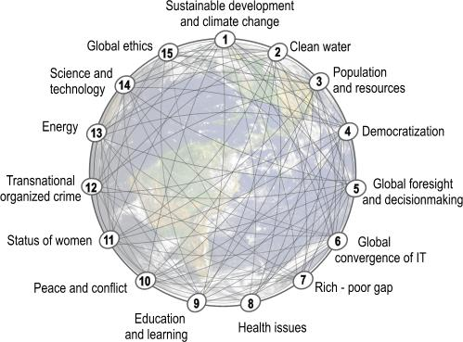
Note Adopted from The Millennium Project [25]

The questions about the links between education, science, technology and society are at multiple levels. Some of the methodological questions about the relationship between inputs and outputs are addressed within separate spheres of education, industry and government, where each sphere has a prescribed role. Universities carry the responsibility of knowledge creation and dissemination, while industry takes the responsibility of translation of this knowledge into commercial technological solutions. Government supervises this process of transfer, by supervising the regulatory environment that governs activities in industries and in universities.
The global Innovation Index launched in 2008 by INSEAD covers 143 economies around the world and is using 81 indicators. Although its methodology does not represent an innovation in itself, its reach to policy makers around the world is profound. Through harnessing the sponsorship of established global agencies such as the World Intellectual Property Organisation (WIPO), PwC Strategy Network, and major institutions in India, Brazil and USA, it is promoting a consistent platform for index-driven policy evaluation across all participating countries.
2.
Global Indexing of Innovation—History and Current State of Affairs
Most indices capture either innovation inputs or outputs. Although there are indices about the behavior of actors that translate inputs into outputs, currently there are no direct measures to reflect on the knowledge transfer process, or the impact of university-industry collaborations.
The first innovation metrics used since the 60s are: Research & Development (R&D) expenditure, Science & Technology (S&T) personnel employed, Capital invested, and Technological Intensity—as a measure of the relationship between inputs and outputs of R&D activity [16]. Four new measures were created in the 70s—to capture innovation outputs: patents, publications, new products introduced to the market and new quality enhanced processed introduced within firms. The 90s brought the awareness that innovation capacity is deeper than these input and output indicators, and requires some qualitative measures collected with innovation surveys. During the same period, innovation management theory introduced a number of tools and techniques for innovation indexing, benchmarking and measuring innovation capacity. All of these tools and techniques continue to be used at present—both at firm level and at the level of national innovation systems.
During this period and as one of the first efforts to establish a robust methodology that measures innovation and provides a framework for comparisons is the OECD publication of the Frascati Manual [17, 21], which enlists innovation indicators with clear definitions - how to obtain them. This manual, as well as its latest update [22] pose still a challenge for statistical authorities around the world.
At the turn of the 90s The World Bank launched its Knowledge Economy Index, which essentially built a measurement framework around four pillars: economic and institutional regime, education and skills, information and communication infrastructure and the innovation system as a whole [18]. There were three measurements of the global economy—in 1995, in 2008 and 2012, and the most recent efforts covers 83 structural and qualitative variables, applied to 140 countries, including 100 developing nations [30]. In this framework, there is a much stronger place for Government as the “Gardener of Innovation”, and a very clear position for education establishments, providing education and skills [27]. The three comparisons of the world economy have identified a dynamic picture of some countries rapidly advancing their position through the index and across a significant number of normalised indicators.
Among the newest developments in innovation metrics are the fourth generation of measures and ‘process indicators’ that were introduced at the turn of the 21st century, interrogating system-level environmental dimensions such as: business clusters and networks, knowledge and intangible assets of firms, the effect of market demand and ratios such as risks to returns, the critical impact of effective management techniques and the scale and scope of system dynamics [16]. All these concepts have proven difficult to integrate into established innovation indices, such as the Global Innovation Index and the European Innovation Scoreboard.

3.
The OECD Framework
The OECD framework puts a heavy weight on the industry, enlisting indicators under 4 categories: Business capabilities for innovation; Business innovation activities (including Acquisition of technology, Acquisition of knowledge and Training and development); Business innovation and Knowledge flows (measuring innovation adoption, diffusion, absorptive capacity and flow across firm boundaries through innovation surveys), and Objectives and outcomes of business innovation (mixing qualitative measures of innovation objectives and quantitative measure of innovation outcomes at firm level {markets, production, delivery, business organisation} and the level of economy, society and the environment {gender, health, quality of life, social inclusion}). All context specific factors, that relate to the activities of the knowledge sector (universities) and the policy and regulatory environment (government) are enlisted under External factors influencing innovation in firms (activities of customers, competitors and suppliers; labour market, legal, regulatory, competitive and economic conditions; and the supply of technological and other types of knowledge) [12].
Figure 2 describes the very broad scoping of the environment that influences the innovation activities and capacity of firms and indicates clearly that universities and education are not seen as deeply integrated into this process.
The OECD model put a heavy weight on industry and markets, where innovation is seen mainly driven by commercial establishments. The role of government is framed in terms of 5 categories—public policy, macroeconomic policies, regulation and tax incentives, direct and indirect government support and public infrastructure—all of which are framed as enables for the commercial sector. The university presence is disguised behind the spatial and location factors—as generic knowledge provider. Although knowledge flows and networks are considered, they are mainly viewed in terms of knowledge and technology transfer from Universities to industry, or across firms.

Fig. 2
Main elements of the external environment for business innovation.
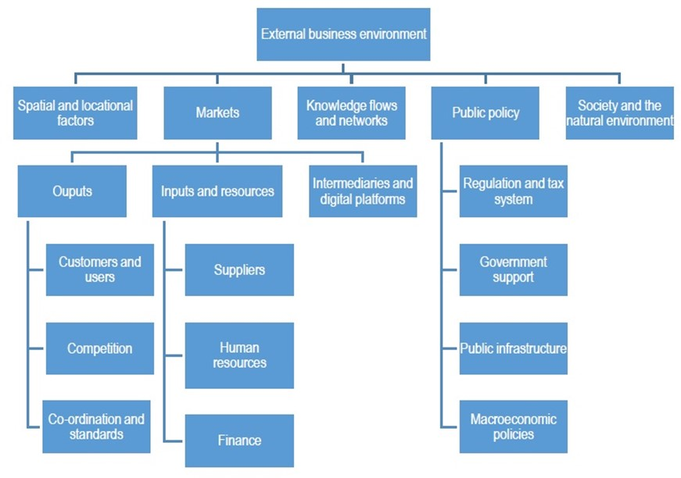
Note Adopted from OECD/Eurostat Oslo Manual [22], Fig. 7.1

There is no reflection on how the ‘government value’ is deployed and distributed, or how education and innovation policies can contribute beyond enabling the business sector. Although this model envisages contributions from all Triple Helix actors, it does not provide sufficient guidance on what types of interactions between government policies, market forces and knowledge creation are best suited to drive innovation for sustainable growth.
The new dimension of knowledge flows and knowledge networks aims to introduce some new categories, such as: the rate and scale of diffusion of innovation (measured by product/service adoption), the type of actors and the type of knowledge (i.e. existing, vs. prospective), inbound and outbound knowledge flows in open innovation, co-operation, collaboration and co-innovation. It even engages with the concept of knowledge capabilities but leaves short of acknowledging that dynamic capabilities involve learning, and absorptive capacity, which are beyond domestic and foreign inflows and outflows. The categories used in this dimension do not even address the complex interactions between universities, government and industry (or Triple Helix interactions) that trigger such flows, or the governance issues that emerge within knowledge networks [26].
In addition, the latest edition of the OECD Manual acknowledges that innovation occurs not only in the private sector, but also in the public sector, in non-governmental organisations and even if family households. The innovation, however, is still perceived as new products and services, and does not even question the innovation in processes, and system-level innovations, or what is acknowledged as ‘innovation-in-innovation’ [9].

4.
The World Bank Framework
The World Bank Knowledge Economy Index has proven that there are very insightful comparisons that can be made across developing and developed nations in terms of economic and institutional regimes, systems for deployment of education and skills, the outreach of communication and information infrastructure, and the overall elements of innovation systems.
The World Bank Knowledge Assessment Methodology (KAM) employed a range of robust indicators that demonstrate long-term trajectories underlying knowledge growth [3]. Since 1995, the World Bank programme on Knowledge for Development has promoted that Government is a “Gardener of Innovation”, managing both the university and the industry parts of the innovation system. The measurement methodology includes a number of indicators that capture government impact and education outputs [32]. The economic performance indicators introduced as a fifth pillar are used as an ultimate measure for growth. The index itself has evolved from basic performance indicators (i.e. average annual GDP growth (%) and Human Development Index), to a sophisticated portfolio of measures that capture how countries address their wider societal challenges, such as poverty and unemployment.
The systemic view of the knowledge economy also has evolved—from the three basic measures of patents, publications and royalty payments—to a complex measurement of foreign capital flows (as % of GDP), science and engineering enrolment of graduates, Ph.D. researchers employed in R&D, research collaborations between universities and industry, technology clusters and private sector spending for R&D. Such a broad systemic picture of the science and innovation systems enables to investigate the direct relationship between innovation inputs from government, industry and university actors—into innovation outputs (Fig. 3).

Fig. 3
Pillars and indicators of the knowledge economy.
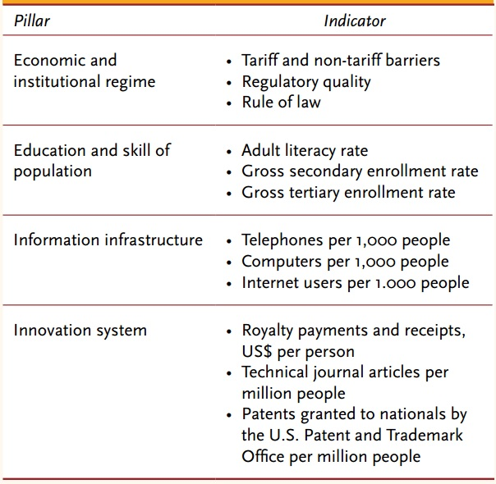
Note Adopted from World Bank Knowledge for Development Programme [31]

Although this is one of the most comprehensive frameworks for comparisons across the world, it is still short of determining the policy instruments that can enhance the innovation position of a country breaking from path-dependency and accelerating economic growth through all stakeholder mobilisation. World Bank recommendations spread across all comprehensive policy mixes of: economic reforms, investments in ‘entry points’ such as sectors and cities, removing obstacles for business development, managing the business environment (trade, finance, regulations), strengthening cluster policies, strengthening institutions and instruments of innovation policy, enhancing research and technology infrastructure, developing export sector policies, enhanced and holistic information and communication technology (ICT) policy, upgrading education, and overall putting the knowledge economy at the heart of development policies [27]. The World Bank view adopts the old static Triple Helix model, envisaging Government as orchestrator of innovation transformations in the economy and society, driving innovation through the public and the private sector [10]. In the entire portfolio of policy recommendations, the World Bank maintains this economic view of the supremacy of government. The only other force that rivals the role of government is the ICT revolution, and the profound impact of the internet and ICT technologies on bringing transformational changes to the society and the economy [1, 23].

5.
EU Innovation Union Scoreboard
The EU Innovation Union (IU) Scoreboard was launched to support the European 2020 Strategy, ‘Innovation for Growth’. The 2011 marked the first edition of the European Innovation Scoreboard, which has been strongly influenced by the OECD methodology, including the OECD measure for R&D intensity [Gross Domestic Expenditure on R&D (GERD) as % of Gross Domestic Product (GDP)] [11]. The IU Scoreboard offers over 10 years comparison of the innovation inputs and performance of all member states, using one of the most advanced resources for comparable metrics—the Eurostat.
The methodology of the EU Innovation scoreboard mixes the inputs and outputs in three distinctive categories—enablers, firm activities, and innovation outputs (see Fig. 4). The unique category of enablers combines measures of both public and private sector, including all institutions and actors that support the development of human capital, open and excellent research system, and finance and support. The role of government in this category of enables is reduced to public sector financing, and this leading role is shared with education establishments and venture capital [28].
The second group of indicators is focused on the industry and in particular—firm activities directed towards innovation, such as Firm’s investment in R&D, Linkages and entrepreneurship, and Intellectual assets of firms. Specific indicators in this category are the R&D expenditure of firms, contributions from the small and medium size firms, and intellectual assets, including community designs and trademarks, usually attributed to various social enterprises and not-for-profit organisations [28].
The final group of indicators refers to innovation outputs, where a strong emphasis is put on the agency of innovators and the economic effects, including entrepreneurship effects, growth of employment for innovators, and internationalisation of knowledge intensive services (Fig. 4). Using essentially similar to the OECD methodology, the EU Innovation scoreboard produces a substantially different picture, attributing much stronger role for universities and education providers, as well as small entrepreneurial firms and social enterprises.

Fig. 4
European Innovation Union Scoreboard indicators.
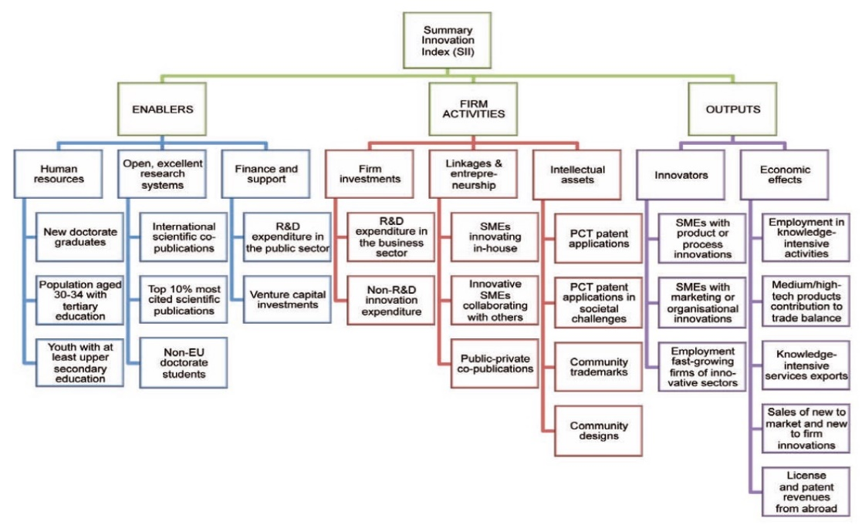
Note Adopted from EC report on Research and Innovation Performance in the EU (2014)

The index, however, remains short of measuring the impact of specific policy initiatives, or the interactions between government policies, university and industry contributions. Overall, the Triple Helix actors are included in the index, but their dynamic interactions that lead to specific outcomes remain hidden, and hence the explanatory power of the index is limited to a normalised score. The main advantage of this index is the quality of indicators used, which enables to explain individual country cases and their position in one of the four groups: innovation leaders, followers, moderate and modest innovators. Neither the scores and the position of individual countries, nor the contextual explanation of individual variables enables a substantive analysis of the strengths and weaknesses in each unique innovation system. What is visible from the country comparisons is that the weaknesses and strengths are usually across the board of all variables, or they capture a systemic strength or weakness.

6.
The Global Innovation Index (GII)
One of the great strengths of the GII is the structural simplification of measurement procedures. The index constitutes of two sub-indices for innovation input and innovation output. The Innovation Inputs sub-index combines the scores for all enablers: (1) Institutions, (2) Human capital and research, (3) Infrastructure, (4) Market sophistication, and (5) Business sophistication. The Innovation Outputs sub-index combines the scores for (6) Knowledge and technology outputs and (7) Creative outputs. The Innovation Efficiency Ratio—is calculated for each country as the ratio of the Output Sub-Index over the Input Sub-Index. It shows how much innovation output a given country is getting for its inputs [14].
This methodological approach enables cross-country comparability at multiple levels—the level of the overall ranking, the level of sub-indices, the level of input and output categories, and the level of individual indicators (Fig. 5). The first group of enablers (Institutions) broadly reflects on the activities of government in terms of political stability and shaping the regulatory and business environment for firms. The second enabler (Human capital and research) broadly represents activities of universities and the education providers, as well as public sector research and technology organisations (RTOs). The third group of enablers adopts the World Bank measures on ICT and infrastructure, with some modifications towards ecological sustainability.
The next two enablers represent the industry and are significant developments separating macro-economic measures of credit, investment, trade and competition (bundled as market sophistication) from micro-economic measures of firm level innovation (described as business sophistication). The business sophistication group comprises both static and dynamic variables, such as knowledge workers, innovation linkages and knowledge absorption [5, 6, 7].
Although the input sub-index contains measures of all tree of the helices—government, industry and university, there are no dynamic measures that reflect on the positive engagement between university-industry and government. Measuring individual helices remains a dominant position.

Fig. 5
INSEAD Global Innovation Index.
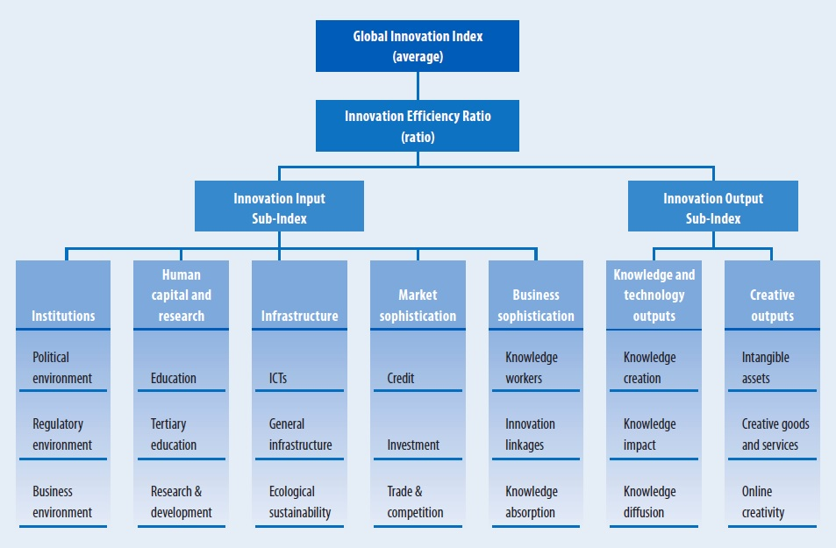
Note Adopted from Global Innovation Index [4]

There is also a confused grouping of indicators in the output sub-index—discriminating between knowledge and technology outputs (i.e. from Universities), such as knowledge creation, impact and diffusion, and creative outputs from industry (intangible assets, firm capabilities, creative goods and services and on-line creativity). Conceptually, this distinction is incorrect, although at aggregate level both groups give an emergent picture of innovation outputs.
There are also insufficient indicators to capture knowledge flows across the helices, as well as activities from positive overlaps between university, industry and government. The Triple Helix literature has been very clear about the distinction between positive overlap of helices (through mutual engagement and sharing), versus negative overlaps (through boundaries and lack of trust) [15].
Although the Global Innovation Index is a very authoritative publication and does not receive much criticism, it can be observed that it is not moving along with the wave of recognition that there is a fundamental need for government, industry and university to create a shared space of translated meaning into action and of mutually shared directions for innovation. Many global events, such as the World Economic Forum and the INSEAD Global Business Leaders Conference drive a new agenda for a stronger engagement between the government, the industry sector and the knowledge providers, as collective driving force for innovation and growth.

7.
Other International Institutions and Forums
The World Economic Forum has been established since 1971 as an international organisation for public-private cooperation, annually bringing together political and business leaders to discuss global challenges and to envisage solutions. For its existence over 48 year it has generated a wide range of institutionalised cooperation platforms and initiatives focused on innovation and metrics. Among these are: the Global Future Council (GFC) on New Metrics and the GFC on Innovation Ecosystems. The GFC on New Metrics is working to expand the availability of accepted actionable data from traditional and new data providers and analytic methodologies. The GFC on Innovation Ecosystems, on the other hand, is working on models for effective collaboration between startups, corporations, owners of private capital, governments, and academia.
A key map from the Mapping Global Transformations initiative indicated that the pivotal role of Innovation is played by System level design, the Role of Government, the Role of Science and Technology, Business Model Innovation, as well as Innovation for Social Benefit. Interestingly, this map, generated by the top world leaders does not reference any of the innovation metrics, which shows the information gap between the data providers and its users [29]. It looks like for the majority of world leaders, innovation metrics is not critical for shaping policy initiatives.

8.
Conclusions and Recommendations
The discussions on the Knowledge Economy continue to expand both the theoretical foundations and the empirical observations of our knowledge capacity and flows. The metrics, however, continue to expand with a focus on firms. Distinctions are made between existing and prospective knowledge, embedded and disembedded, material and intrinsic, generic and commercial knowledge—all of which is associated with commercial entities. The Universities remain at the periphery of this process, and knowledge transfer is not taken into account. Knowledge management is mostly seen in the context of enterprise activities, and even the creativity indicators are measuring firm outputs, largely ignoring University contributions to knowledge.
One of the main reasons for this state of affairs is the dominant paradigm that R&D is nested in the industry sector, and it feeds on investment capital and labour, while universities are merely ‘servants’ of the labour markets. The change in position of the ‘ivory towers’ of University knowledge has not happened yet, in spite of the accelerating discourse on entrepreneurial universities, and the impact of knowledge in general.
Knowledge flows are interpreted mainly as knowledge sourcing by firms and are discussed in 5 categories: product and client-oriented R&D; collaborative inter-firm R&D; science-based embedded knowledge sourcing (such as contract research); open process modernising (such as management innovations in firms); and wider innovations in the society (such as social entrepreneurship and community innovation) [19, 20]. All University-based innovations are measured in terms of publications and number of graduates, and entrepreneurial university metrics are still a voluntary self-assessment.
Although there is a theoretical understanding of the mechanisms behind knowledge exchange, there is a lack of a comprehensive policy framework in place that can enhance knowledge flows through effective disembodiment of knowledge, which occur in commercial transactions around intellectual property (IP), licencing, franchising, know-how contracts and non-disclosure agreements. Innovation policies cannot create direct incentives for embedded knowledge transactions, sourcing solutions, or co-development agreements—beyond transaction costs. This leaves the direction of innovation skewed towards firm performance, and very far away from altruistic and philanthropic innovations that address societal and economic challenges.
Innovation is in the Ninth Sustainable Development Goal (SDG) and it is bundled with Industry and infrastructure—driving development through resilient infrastructure and the promotion of inclusive and sustainable industrialization.
One of the most insightful metrics of the innovation indices is the calculation of the R&D Intensity as a ratio between innovation inputs and outputs. The new proposals are that R&D Intensity considers innovation outputs, based on four components chosen for their policy relevance, data quality, international availability, cross-country comparability and robustness of results. These output components are (1) technological innovation; (2) employment in knowledge-intensive activities (KIA); (3) competitiveness of knowledge-intensive goods and services; (4) employment in fast-growing firms of innovative sectors [22].
Based on the systematic collection of data across all European Union member states, the conclusions from the policy evaluation on innovation-driven growth and the impact of Horizon 2020, emphasize policy mixes that invest in people, in markets for the future, in high-growth firms, in solution-driven clusters, alliances and networks, and in lifting visible and invisible barriers for free movement of the factors of production within the Single Market [8]. This policy evaluation suggests that innovation performance is very much driven by context factors, rather than by direct policy measures, as it requires a complex mix and co-alignment of policy instruments in order to generate substantial effects.
In concurrence with this position, the UAE chapter of the Global Innovation Index for 2014 develops a clear framework for building a comprehensive innovation ecosystem. It highlights that under the Government Leadership, the country should enhance simultaneously the human capita, the technological capital, and the financial capital [2]. This is linked to the accelerated government spending for education as well as increased R&D expenditure [13]. Among the specific recommendations are to invest in innovation culture and in entrepreneurial mentorship.
Dubai Future Accelerators Program is clearly a strategic response in this direction—to create a collaborative environment for public and private stakeholders to engage in knowledge transfer, harnessing key challenges and opportunities for the 21st century. Observations of the first three cohorts show that participants from the government and the private sector are at the front line of engagement. The omission of university actors in the programme is an important fact that exhibits a weakness at a system level. University actors are essential players—not only to bring critical thinking, but to ensure sustainable knowledge flows across the public and the private domain.
The policy recommendations from the Abu Dhabi Innovation Index clearly point in this direction that the foundations of the knowledge economy require a broad range of knowledge capabilities for knowledge creation, accessing, anchoring, diffusion and exploitation [33]. Universities are critical players that drive the knowledge process and engagement with university actors is essential for the success of system level innovation.
It is at the university level, where knowledge and technology are intertwined—in a pre-commercial design and a post-commercial critical reflection and learning. Knowledge and technology exhibit complex pathways of mutual enhancement and acceleration that starts at a university level before it flows into the economy. Acquisition and implementation of technology can not be a substitute to a comprehensive knowledge linkages and spill over effects across the socio-economic sphere.
The University axis of the Triple Helix is essential to balance the system towards a sustainable growth through critical and reflexive evaluation of alternative scenarios and impacts. Moreover, the universities are the ‘glue’ in the Triple Helix system with the impartiality of knowledge and the future thinking of blue-sky research. It is not accidental that the countries that are among the highest in innovation performance have the strongest higher education sectors, whereby universities are critical strategic players in regional development [26].
Harnessing effective Triple Helix interactions is a guarantor for sustainability and strategic coalignment between the public and private sector. Multi-stakeholder solutions and collaborations are becoming best-practice cases, where observations and measurement of the process of collaboration can enhance both the process and the innovation outcomes. Comprehensive mapping of the actors within the Triple Helix, the linkages between then, the knowledge flows and sharing and the spill over effects from interactions can show the real value creation for the society and the economy.

Acknowledgements
This paper is based on the Key-Note presentation by Prof. Emanuela Todeva at the 2nd Triple Helix International Summit in Dubai, 10–13 November 2018, with the sponsorship of the British University of Dubai, Mohammed Bin Rashid School of Government, University of Dubai, Al-Maktoum College of Higher Education, American University of Ras Al Khaiman, Al Maktoum Foundation, Dubai Department of Tourism and Commerce Marketing, Dubai Supreme Council of Energy and Al Sahel Contracting Company.

References
1.
Arvis J-F, Ojala L, Wiederer C, Shepherd B, Raj A, Dairabayeva K, Kiiski T (2018) Connecting to compete: trade logistics in the global economy. World Bank, Washington, DC.

2.
Byat AB, O du Sultan (2014) The United Arab Emirates: fostering a unique innovation ecosystem for a knowledge-based economy. In: Global Innovation index. INSEAD, Fontainebleau, pp 101–111
3.
Chen D, Dahlman C (2005) The knowledge economy, the KAM methodology and world bank operations. World Bank, Washington, DC. http://documents.worldbank.org/curated/en/695211468153873436/The-knowledge-economy-the-KAM-methodology-and-World-Bank-operations
4.
Cornell University, INSEAD, WIPO (2014). The Global Innovation Index 2014: the human factor in innovation, Fontainebleau, Ithaca, and Geneva
5.
Cornell University, INSEAD, WIPO (2015). The Global Innovation Index 2015: effective innovation policies for development, Fontainebleau, Ithaca, and Geneva
6.
Cornell University, INSEAD, WIPO (2018) The Global Innovation Index 2018: energizing the world with innovation, Ithaca, Fontainebleau, and Geneva
7.
Cornell University, INSEAD, WIPO (World Intellectual Property Organization) (2013) The Global Innovation Index 2013. In: Dutta S, Lanvin B (eds) The local dynamics of innovation. Cornell, INSEAD, and WIPO, Geneva, Ithaca, and Fontainbleau

8.
EC (2013) Innovation Union Competitiveness Report, 2013 edn. Presentation by Pierre Vigier Head of Unit Economic Analysis and Indicators
9.
Etzkowitz Henry (2003) Innovation in innovation: the Triple Helix of university-industry-government relations. Soc Sci Inf 42(3):293–337
10.
Etzkowitz H, Leydesdorff L (2000) The dynamics of innovation: from national systems and “mode 2” to a Triple Helix of university–industry–government relations’. Res Policy 29:109–123
11.
European Commission (2014) Research and innovation performance in the EU: innovation union progress at country level. EC, DG for Research and Innovation, Brussels
12.
Eurostat and OECD (Organisation for Economic Co-operation and Development) (2005) Oslo manual: guidelines for collecting and interpreting innovation data, 3rd edn. OECD, Paris
13.
UAE Government (2015) Science, technology & innovation policy in the United Arab Emirates
14.
INSEAD (2011) The Global Innovation Index 2011. In: Dutta S (ed) Accelerating growth and development. INSEAD, Fontainebleau
15.
Leydesdorff L (2016) Triple Helix of university-industry-government relations. Transl Sci 2016:1844–1852
16.
Milbergs E, Vonortas N (2004) Innovation metrics: measurement to insight. Center for Accelerating Innovation and George Washington University, National Innovation Initiative 21st Century Working Group, p 22
17.
OECD (1992) Proposed guidelines for collecting and interpreting technological innovation data: Oslo Manual. OECD, Paris

18.
OECD (1996) The knowledge-based economy. Organisation for Economic Cooperation and Development, Paris
19.
OECD (2013) Knowledge networks and markets. OECD Science, Technology and Industry Policy Papers, No. 7, OECD Publishing, Paris. http://dx.doi.org/10.1787/5k44wzw9q5zv-en
20.
OECD (2013) OECD Science, Technology and Industry Scoreboard 2013. OECD, Paris
21.
OECD (2015) Frascati Manual 2015: guidelines for collecting and reporting data on research and experimental development. The measurement of scientific, technological and innovation activities. OECD Publishing, Paris, http://oe.cd/frascati
22.
OECD/Eurostat (2018) Oslo Manual 2018: guidelines for collecting, reporting and using data on innovation, 4th edn. The measurement of scientific, technological and innovation activities. OECD Publishing, Paris/Eurostat, Luxembourg. https://doi.org/10.1787/9789264304604-en
23.
Omole D (2012) Harnessing information and communication technologies (ICTs) to address urban poverty: emerging open policy lessons for the open knowledge economy. Inf Technol Dev 19(1):03–21
24.
Prime Minister’s Office at the UAE (2015) UAE National Innovation Strategy. Ministry of Cabinet Affairs
25.
The Millennium Project (2017) 15 global challenges. Accessed on the 27.01.2019 at http://www.millennium-project.org/projects/challenges/
26.
Todeva E (2013) Governance of innovation and intermediation in the Triple Helix interactions. Ind High Educ 27(4):263–278. https://doi.org/10.5367/ihe.2013.0161
27.
UNCTAD/UNDP (2010) Creative economy: Report 2010. UN, New York. Available at http://www.unctad.org/en/docs/ditctab20103_en.pdf
28.
Vigier, Pierre (2013) Innovation Union Competitiveness Report 2013. Presentation by Pierre Vigier, Head of Unit Economic Analysis and Indicators, European Commission
29.
WEF (2019) Mapping global transformations. Innovation. World Economic Forum. Accessed on the 27.01.2019 at https://toplink.weforum.org/knowledge/insight/a1Gb0000000LrSOEA0/explore/summary
30.
World Bank (2006) Knowledge assessment methodology (updated Mar 2006). http://www.worldbank.org/kam
31.
World Bank (2008) Measuring knowledge in the world’s economies: knowledge assessment methodology and knowledge economy index. Knowledge4Development Programme
32.
World Bank Institute (2007) Building knowledge economies: advanced strategies for development. The International Bank for Reconstruction and Development/The World Bank (WBI)
33.
UAE Department of Economic Development (no date) The Abu Dhabi Innovation Index

In: Ed. By Prof. Abid Abu-Tair, Proceedings of the II International Triple Helix Summit, Chapter 10, ISBN:978-3-030-23897-1

