Ul Haq, Naveed, Rahmat, Ullah, Todeva, Emanuela (2019) From R&D to Innovation and Economic Growth: An Empirical-Based Analysis from Top Five Most Innovative Countries of the World, Chapter 23, Proceedings of the II International Triple Helix Summit, ISBN: 978-3-030-23897-1.

Abstract
This study aims to explore the relationship between research and development, innovation and economic growth of most innovative countries of the world, where innovation and economic growth are dependent variables and R&D, skills, technological innovation and economic structure are the independent variables. The data analysis is conducted using GMM dynamic panel estimations for finding the relationships among variable of the study for the period of 1990–2016 of the top five most innovative countries of the world. The findings of this study show that larger spending in research and developments, more skilled labour, the efficient economic structure of a country having more employment in industry and services sectors, a rapid increase in the technological innovation are the key factors that boost the innovation and economic growth of these countries. The existence of the strength of the relationship is however contingent country-specific socio-economic characteristics, which affect overall capacity of the country to transform research and development investments into innovation and ultimately into the economic growth of a country. The findings of this study are helpful for other countries which are on the way of innovation. The factors identified by this study are very helpful for governments, researchers and policymakers to pay attention to it for the purpose of creating a country innovative and eventually boosting the economic growth of a country.

Keywords
R&D
Innovation
Economic growth
GMM
Innovative countries of the world

1.
Introduction
The contribution of research and development to innovation and economic growth of a country is well established in the literature of economic theoretically and practically [711]. Over the last few decades, governments of developed countries have pursued remarkable research and development policies with the aim of fostering the innovation and economic growth in their countries. The question arises that whether these innovation policies are paying off. In this regard, technological spillovers, the increasing trend of return to scale in research and development, the unavailability of socio-economic conditions and innovation culture seems to cast doubt on the returns of these innovation policies.
The linkage between innovation and economic growth of a country largely depends on the technology and technological advances of a country, for instance, Grossman and Helpman [4] observed that technology has been the real force behind the rising living standards. Generally, investment in research and development has been considered as one of the strategic keys to boosting the innovation and ultimately the economic growth of a country [15]. Similarly, Bilbao-Osorio and Rodríguez-Pose [2] have shown the relationship between research and development, innovation and economic growth, seems to show the path for the policymakers in order to boost the innovation in a country. The recent developments in the theoretical role of innovation and economic growth considered four kinds of innovation (learning by dong, human capital, research and development and public infrastructure) [1610]. It becomes difficult to generalize about the empirical approaches to the innovation taken by the studies to test the new growth theories.
The present study undertakes the world’s most innovative countries for finding the relationship between R&D, innovation and economic growth. According to the Global Innovative Index 2016 rankings, Switzerland is the most innovative country. Its capacity for innovation and quality of its research institutions are the two factors that have enabled this small alpine country to hold on the first position of being most innovative country. The major research area of Switzerland is “Robotics”, that’s why Forbes recently called it as the “Silicon Valley of Robotics”. Many multinational companies and emerging startups are conducting their researchers in Switzerland, such as Amazon, Microsoft, Apple, Google, IBM, Bosch etc.
Sweden is the second world’s most innovative country. A century ago, Sweden was among the poorest nations in Europe. But despite being a small country today, it is the world leader in innovation. There are several innovations which set the example of Sweden country to being an innovative country. The invention of the pacemaker was a great innovation of Sweden because millions of hearts around the world beat with the help of a pacemaker. Another one is candles that are lit with the help of safety matches. And finally the three-point seat belt, which can save innumerable lives. These are some examples of Swedish innovation that have made a difference [14]. Because innovation is closely linked with the research and development, one of the major reasons for being an innovative country is that Sweden is one of Europe top three spenders in research and development area. Sweden has strengths in terms of both input and output. The strong output of the country is demonstrated in many new published papers and registered patents. On the other hand, Sweden is also seen to have a good input basis, characterized by the stable political environment and high-quality education.
The United Kingdom is the third world’s most innovative country. The United Kingdom is the leader in scientific research, great ideas and innovativeness. The larger tendency in spending R&D leads the UK towards the innovative country. There are many examples of innovations of this country which are remarkable for example, surgical forceps, clinical thermometer, first blood pressure measurement and first cardiac catheterization, a battle tank and hydraulic press etc. The United States is the fourth most innovative country in the world and is prized for its history of individual creativity. The US has been and still at the forefront of cutting-edge science, technology and innovation. The culture of US that has graced this nation since encourages risk-taking. The US innovation is followed by risk-taking and thus got handsomely rewarded and failure if any is viewed properly as a tool for learning. The greatest innovations of US include hearing aid, traffic lights, microwave oven, laser, led lights and global navigation etc. Finally, Finland is the fifth most innovative country in the world. Finland is considered as modern West Country and achieves the economic miracle. The major reasons behind this change were investing in educations with free universities and other egalitarian educational policies. One of the massive consequences is the number of technologies Finns have created. According to the Finnish Invention Foundation, the population of six million people make around 15,000 inventions every year. The major inventions of Finns include Nokia mobile phone, SSH the universal tool for secure computer administration, Linux operating system, Erwise the first available graphical web browser etc.
Figure 1 shows the graphical presentation of research and development, innovation and economic growth of top five innovative countries as whole over the period from 1990 to 2016. We can see that the trend of spending in R&D activities in innovative countries is very high. They initially spend more in R&D and as a result of this innovation of these countries increases and ultimately economic growth also increases. The graph clearly shows that when spending in R&D decreases it suddenly effects the innovation and economic growth of these countries. Similarly, Figs. 2, 3, 4, 5 and 6 shows the trend of R&D, innovation and economic growth of innovative countries separately for the period of 1990–2016.

Fig. 1
Trend of R&D, innovation and economic growth of innovative countries for the period of 1990–2016
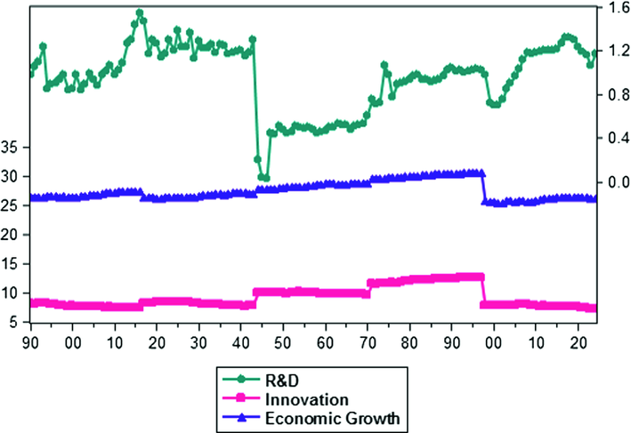

Fig. 2
Trend of R&D, innovation and economic growth of Switzerland for the period of 1990–2016
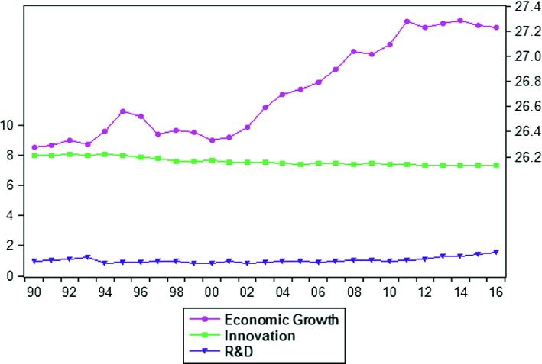

Fig. 3
Trend of R&D, innovation and economic growth of Sweden for the period of 1990–2016
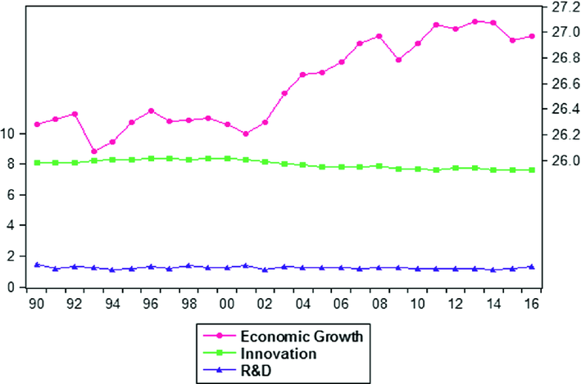
Fig. 4
Trend of R&D, innovation and economic growth of UK for the period of 1990–2016
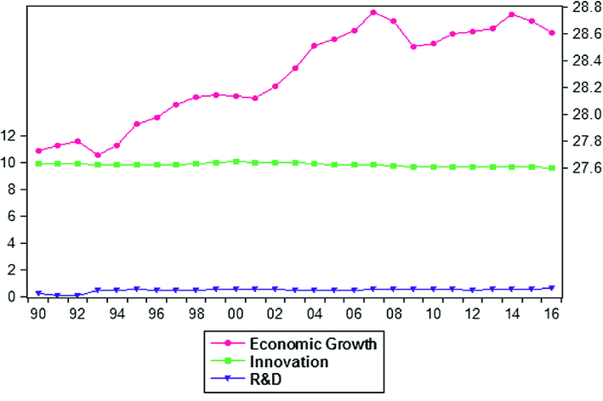

Fig. 5
Trend of R&D, innovation and economic growth of US for the period of 1990–2016
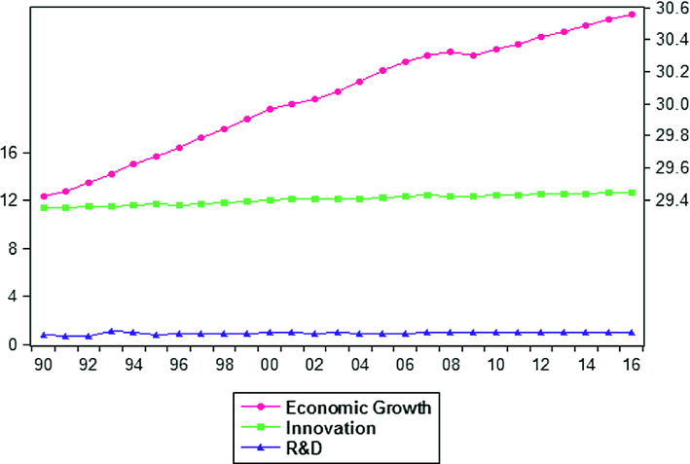
Fig. 6
Trend of R&D, innovation and economic growth of Finland for the period of 1990–2016
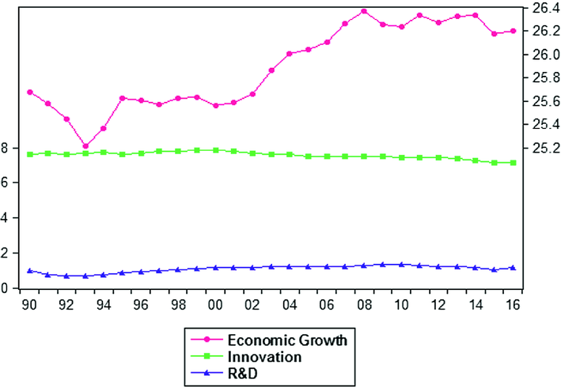
The technological change is a very important factor for the economic growth of a country. But in recent years after neglecting the study of technological change, many economists have shown a great interest in examining the relationship between research and development, innovation and economic growth. In this study, we have developed a dynamic panel data model of top five most innovative countries in the world to test the linkage between the research and development, innovation and economic growth. The present study is conducted to answer the following questions:
Q1: What is the relationship between research and development and innovation of most innovative countries of the world?
Q2: What is the relationship between innovation and economic growth of most innovative countries of the world?
To answer the research questions, we developed following research objectives:
1.
To investigate the linkage between research and development and innovation of most innovative countries of the world.
2.
To investigate the linkage between innovation and economic growth of most innovative countries of the world.
Section 2 of the study sheds lights on the literature of the research and development, innovation and economic growth of a country. The first part of the literature describes the studies that explore the relationship and contribution of the research and development to innovation and economic growth of a country. The second part of the literature theoretical and empirical literature linking to the innovation and economic growth of a country and consists of the development of a hypothesis. In Sect. 3, we describe the methodology and operational model of the study. The results and discussions are discussed in Sect. 4, and finally, Sect. 5 describes the conclusion and Sect. 6 presents the practical implications of the study for policy makers.

2.
Background of the Study
The neoclassical growth theory developed by Solow [13] presents the model in which the series of neoclassical assumptions are given for the growth path of any country. These neoclassical models assume the existence of perfect competition, no externalities, constant returns to scale, diminishing returns to inputs and maximizing behaviour. As a result of these assumptions, the growth path theory model predicts productivity growth as a result of it increases the amount of capital each worker is set to operate. Under these assumptions, the investments in developed countries become increasingly inefficient making the investment in a more attractive option. The growth path theory is challenged by the researchers such as Lucas Jr. [6]. They highlighted the need to introduce technology because technology is an endogenous factor affecting economic growth of a country.
The investments in research and development have a number of characteristics that make it different from the ordinary investments. One of the important features if investment in R&D is the degree of uncertainty which is associated with its output. This uncertainty has a tendency to be most noteworthy toward the start of an exploration program or venture, which suggests that an ideal R&D technique has alternatives like character and ought not by any means be examined in a static structure. Research and development ventures with little probabilities of extraordinary accomplishment, later on, might be worth proceeding regardless of whether they don’t pass a normal rate of return test. The vulnerability here can be outrageous and not a basic matter of an all-around determined circulation with a mean and variance.
The importance of skill in the way to innovation process can never be denied. Pavitt [8] explained that technological and scientific knowledge requires an extensive learning process. The labour market is another factor that may influence on the innovation process of a country because the low-level activities and employment in the country are the key characteristics of the innovation averse societies [9]. The economic structure of a country also plays a vital role in the genesis and assimilation of innovation [12]. A transcendently agricultural region is more averse to produce expansive quantities of patents, as agriculture and particularly traditional agriculture does not have a tendency to be as creative as different sectors. Alternately, certain sub-divisions inside the manufacturing and service sectors might be more inclined to foster the innovation. Specifically, the countries which rely on the technology their sub-sectors have greater tendency to achieve the higher rate of innovation.
The greater increase in the technological innovation intensity leads to the economic growth of a country. The neoclassical and endogenous growth models of economic growth acknowledge the importance of the technological innovation in the way of economic growth of a country [10]. A large body of researchers has explained the rationale behind technological progress and innovation [3]. These studies have contributed significantly the economic growth of a country. The high technology exports of a country increase due to the increase in technological innovation. The general findings in the developed countries are that the larger exporting firms have higher productivity than non-exporters because the tendency of innovation seems to be higher in exporters firms.
Figure 1 the conceptual framework of this study. The study is estimated the linkage between R&D, innovation and economic growth with some economic factors. In first step the innovation is dependent variable and R&D, skill and technological innovation intensity are the independent variables followed by first four hypotheses. Then in second step for finding the linkage between innovation and economic growth we us economic growth as dependent variable and innovation, growth in innovation, skills and economic structure are the independent variables followed by hypotheses 4–7.

Fig. 7
Conceptual framework of R&D and innovation
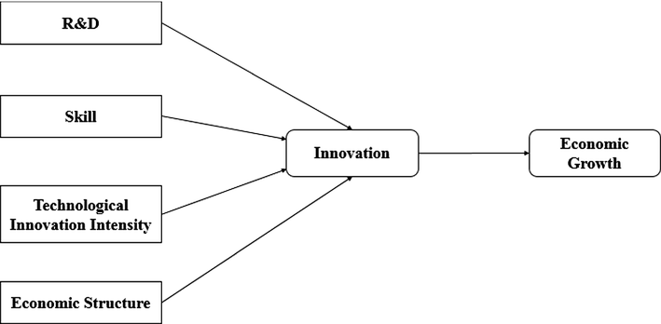

The present study has following research hypothesis:
H1: There is a relationship exists between research and development and innovation
H2: There is a relationship exists between skills and innovation
H3: There is a relationship exists between technological innovation intensity and innovation
H4: There is a relationship exists between innovation and economic growth
H5: There is a relationship exists between growth in innovation and economic growth
H6: There is a relationship exists between skills and economic growth
H7: There is a relationship exists between economic structure and economic growth.

3.
Data and Methodology
This study uses an international sample of top five most innovative countries in the world. Top five most innovative countries are according to the Global Innovative Index 2016. Table 1 shows the ranking of top five most innovative countries in the world. Global Innovative Index provides matrices about the innovative performance of 127 countries and economies from all over the world. The index has 81 indicators for exploring the broad vision of innovation of a country. The data used in this research is the secondary type and collected from World Bank Database for the period of 1990–2016.
Table 1
Global innovative index 2016 rankings
Country/economy | Score | Rank | Income
Switzerland | 66.28 | 1 | HI
Sweden | 63.57 | 2 | HI
United Kingdom | 61.93 | 3 | HI
United States | 61.4 | 4 | HI
Finland | 59.9 | 5 | HI
The study uses dynamic panel data model, GMM (Generalized Methods of Movements) estimations for the purpose of achieving the objectives of the study. Generally, in panel data, we have to face some econometric issues i.e. unobserved heterogeneity, omitted variables bias and the problem of endogeneity. The GMM estimations developed by Hansen [5], provides most accurate estimations of panel data and deals with endogeneity and unobserved heterogeneity. The dependent variables of the study such as innovation and economic growth of a country, are dependent on the various factors and also effects from its past performance, so the problem of endogeneity might occur [16].
Equations (1) and (2) are the operational model of the study under GMM estimations. In the first equation innovation is the dependent variable and research and development, skills and technological innovation intensity are the independent variables. Whereas, in the second equation, economic growth is dependent and innovation, growth in innovation, skills and economic structure are the independent variables. In the dynamic panel data model where i is the country at time t. INNOV_{i,t} is explained by its lagged values and a set of exogenous explanatory variables. Here α_{i} is individual specific effects and λ_{t} represents the time-specific effects. Table 2 presents the measurement of the variables used in the study.
Table 2
Variables explanation
Variable name | Abbreviation | Measurement
Innovation | INNOV | No. of patent application
Growth in innovation | G_INNOV | Percentage change in innovation
Research and development | R&D | Research and development expenditure as a percentage of GDP
Skill | Skill | Total labour force
Economic structure | ECO_STR | Percentage of employees working in industry + Percentage of employees working in the services sector
Technological innovation intensity | TECH_INNO_INT | No. of patent applications/GDP
Economic growth | EG | Measured as gross domestic product (GDP) current US $

4.
Results and Discussions
Table 3 shows the results of descriptive statistics of the whole sample data. The sample size is 135 observations. Descriptive statistics analysis is used to describe the various features of the dataset. In general, as compared to inferential statistics, the descriptive statistics are not based on the probability theory. These types of analysis are normally presented to describe the central tendency and variability of the dataset. Measures of central tendency include mean, median and mode whereas measures of variability include standard deviation, range, variance, maximum and minimum values in the data. Using this type of analysis is necessary before running any econometrics model because it provides the overall first look at the data and also the extreme values that are included in the dataset.
Table 3
Summary statistics of the whole sample
Variables | Mean | Std. dev | Minimum | Maximum | N
R&D | 0.946 | 0.305 | 0.023 | 1.543 | 135
INNOV | 8.998 | 1.765 | 7.139 | 12.596 | 135
G_INNOV | 7.995 | 1.775 | 5.979 | 11.598 | 135
EG | 27.505 | 1.539 | 25.215 | 30.555 | 135
SKILL | 16.288 | 1.519 | 14.715 | 18.907 | 135
TECH_INNO_INT | 1.078 | 5.405 | 2.090 | 2.430 | 135
ECO_STR | 4.572 | 0.020 | 4.478 | 4.594 | 135

The mean value of R&D expenditures is 0.946 with a standard deviation of 0.305, minimum value 0.023 and a maximum value of 1.543. Similarly, innovation has a mean value of 8.998 and a standard deviation of 1.765. Similarly, all variables show normality of the data. The technological innovation intensity has a larger variation in the dataset which is 5.405 with a minimum value of 2.090 and a maximum value of 2.430.
Tables 4 and 5 shows the correlation matrix of our operational models. Correlation analysis is also called the bivariate analysis. It measures the strength of the association among variables of the study. The correlation matrix provides the correlation information about dependent variable with each independent variable and among each independent variable also. The value of correlation computed by the correlation matrix ranges from −1 to +1. The positive correlation shows that when two variables move in the same direction, on the other hand, an inverse relationship is shown by negative correlation. The correlation matrix provides us information about the multicollinearity in the variables. The problem of multicollinearity occurs when the correlation between two variables is high. The correlated variables generate biased results or insignificant estimations. In order to run a regression analysis, we have to ensure that there is multicollinearity among variables. Both tables confirm that there is no such problem of multicollinearity among independent variables in the models. All variables in the model have correlation values less than 0.7 which confirms that model is free from multicollinearity.
Table 4
Correlation matrix of model 1
Variables | R&D |  | SKILL |  | TECH_INNO_INT |  |  | COUNTRY |  | YEAR
R&D | 1 |  | – |  | – |  |  | – |  | –
SKILL | 0.526 |  | 1 |  | – |  |  | – |  | –
TECH_INNO_INT | −0.281 |  | −0.492 |  | 1 |  |  | – |  | –
COUNTRY | 0.161 |  | 0.163 |  | −0.627 |  |  | 1 |  | –
YEAR | −0.395 |  | −0.469 |  | −0.566 |  |  | −0.472 |  | 1
Table 5
Correlation matrix of model 2
Variables | INNOV | G_INNOV |  | SKILL |  | ECO_STR | COUNTRY |  | YEAR
INNOV | 1 | – |  | – |  | – | – |  | –
G_INNOV | −0.665 | 1 |  | – |  | – | – |  | –
SKILL | −0.233 | 0.044 |  | 1 |  | – | – |  | –
ECO_STR | 0.388 | −0.378 |  | −0.261 |  | 1 | – |  | –
COUNTRY | 0.069 | −0.146 |  | 0.238 |  | 0.552 | 1 |  | –
YEAR | −0.145 | 0.202 |  | −0.168 |  | −0.562 | −0.445 |  | 1

5.
Results of GMM Dynamic Panel Estimation
Table 6 shows the results of the model 1 of the study under Generalized Methods of Movements (GMM) estimations of the whole sample. The overall results of the model show a clear picture of innovation and economic growth of innovative countries having significant relationships. The model 1 of the study captures the relationship between research and development and innovation with other economic variables of the country. The dependent variable is innovation and independent variables are research and development, skills, technological innovation intensity. To measure the country effect and time effect we use country and year dummies in our operational models. The GMM estimations include the lagged value of the dependent variable as the independent variable and also the country dummy for measuring the country effect. The model results indicate that lagged innovation has a positive significant impact on the innovation of years ahead.
Table 6
Model 1 results of GMM estimations on R&D and innovation of the whole sample
Dependent variable: INNOV
Independent variables | Coefficient | Std. error | Prob.
LAG_INNOV | 0.8499 | 0.0250 | 0.000***
R&D | 0.0695 | 0.0327 | 0.034**
SKILL | 0.1695 | 0.0274 | 0.000***
TECH_INNO_INT | 1.2707 | 0.2177 | 0.000***
COUNTRY_DUMMY | 0.0115 | 0.0096 | 0.231
YEAR_DUMMY | 0.0010 | 0.0955 | 0.303
CONSTANT | −1.6681 | 0.2545 | 0.000***
*p < 0.10, **p < 0.05, ***p < 0.01
To test the hypothesis from H₁ to H₃ we run model 1 under GMM dynamic panel estimations. The first hypothesis of the study states the relationship between R&D and innovation. We find the evidence in support of this hypothesis and that are; H₁ (β = 0.0695, p < 0.05), states that there is a positive significant relationship exists between R&D and innovation of innovative countries of the world. The more a country invests in the R&D activities the greater the innovation will be. The Skill; H₂ (β = 0.1696, p < 0.01), states that there is positive significant relationship exists between skills and innovation of innovative countries, leading to accept the second hypothesis of the study. Similarly H₃ (β = 1.2707, p < 0.01), states that technological innovation intensity has a positive significant impact on the innovation of innovative countries, thus leading to accept the third hypothesis of the study. Moreover country and year do not have a significant impact on the dependent variable innovation.
Table 7 shows the results of model 2 of the study to explain the linkage between innovation and economic growth of innovation countries. To the hypothesis H₄ to H₇, we run Eq. (2) under GMM estimation. The H₄ of the study states the relationship between innovation and economic growth. The H₄ (β = 1.1885, p < 0.1), proves the existence of a positive relationship between growth in innovation and economic growth of innovative countries. The H₅ (β = 1.1780, p > 0.1), states that there is a significant positive relationship between growth in innovation and economic growth of innovative countries. This states that when the country achieves significant growth in innovation activities then it has a significant impact on its economic growth. The H₆ (β = 0.1764, p < 0.01) and H₇ (β = 0.5936, p < 0.05), provides the evidence that there is significant positive relationship between skills, economic structure and economic growth of innovative counties.
Table 7
Results of GMM estimations on innovation and economic growth of whole sample
Dependent variable: EG
Independent variables | Coefficient | Std. error | Prob.
LAG_EG | 0.8129 | 0.0368 | 0.000***
INNOV | 1.1885 | 0.6808 | 0.081*
G_INNOV | 1.1780 | 0.6787 | 0.083*
SKILL | 0.1764 | 0.0420 | 0.000***
ECO_STR | 0.5936 | 0.6053 | 0.049**
COUNTRY_DUMMY | −0.0126 | 0.0072 | 0.083*
YEAR_DUMMY | 0.0059 | 0.0017 | 0.001***
CONSTANT | −1.7319 | 2.8305 | 0.541
*p < 0.10, **p < 0.05, ***p < 0.01

6.
Conclusion
This study is an attempt to shed some lights on the importance of research and development in innovation and innovation ultimately on economic growth of most innovative countries of the world. The study begins with the importance of R&D in innovation and economic growth of the country, then discussed the top five innovative countries of the world. The primary objective of this study is to find the linkage between R&D, innovation and economic growth of innovative countries with the support of some socio-economic variables of the economy so that we can find out the characteristics of the innovative countries. We also observed the linkage between R&D, innovation and economic growth of innovative countries individually.
We began by estimating model 1 of the study for finding the dynamic relationship between research and development and innovation using GMM estimations and found a significant positive relationship in innovative countries as a whole. The reason for a positive linear relationship because these countries have larger tendency to invest in R&D activities. Furthermore, other factors such as labour skills, the economic structure of a country and technological innovation also found to be significant and show a positive relationship with the innovation of innovative countries of the world. Most of the variables found to significant in innovative counties individually such as R&D expenditures, skills, economic structure and technological innovation. In Switzerland and the strength of the relationship between technological innovation and innovation is strong. The findings of the study are consistent with [2]. The model 2 of the study estimated the linkage between innovation and economic growth of innovative countries and results supports the literature on innovation and economic growth. The significant and positive relationship states that innovation leads to the ultimate economic growth of a country. The other economic factors found to be positive and significant such as growth in innovation, skills and technological innovation. The individual country-wise results show that economic structure of Switzerland and Finland is supportive for innovation and shows a higher value of coefficient thus states the strong relationship between them. This might be the reason that Switzerland holds a top position as an innovative country in the world.

7.
Proposals for Policy Makers
As a whole, this study has emphasized the multifaceted relationship between R&D, innovation and economic growth of innovative countries of the world. The R&D, skills and technological innovation are the significant factors that we found in the innovative countries that leads them towards the direction from R&D to innovation and economic growth. The policymakers must focus on the R&D based strategies to generate the innovation and consequently the economic growth of a country. Although research and development is the base for innovation, the economic structure of a country is very much essential to implement the R&D strategies in that country. The governments of developing countries must put efforts for increasing the percentage of employment in industry and service sectors for strengthening its economic structure. The findings of the study provide useful guidelines for policymakers of the less innovative countries to invest in R&D activities, strengthen their economic structures and consider other significant factors to increase the innovation and for securing the position for being innovative countries of the world.

References
1.
Aghion P, Harris C, Howitt P, Vickers J (2001) Competition, imitation and growth with step-by-step innovation. Rev Econ Stud 68(3):467–492
2.
Bilbao-Osorio B, Rodríguez-Pose A (2004) From R&D to innovation and economic growth in the EU. Growth Change 35(4):434–455
3.
Griliches Z (1990) Patent statistics as economic indicators. J Econ
4.
Grossman GM, Helpman E (1994) Endogenous innovation in the theory of growth. J Econ Perspect 8(1):23–44
5.
Hansen LP (1982) Large sample properties of generalized method of moments estimators. Econ J Econ Soc 1029–1054
6.
Lucas RE Jr (1988) On the mechanics of economic development. J Monet Econ 22(1):3–42
7.
Nadiri MI (1993) Innovations and technological spillovers. National Bureau of Economic Research
8.
Pavitt K (1991) Key characteristics of the large innovating firm. Br J Manag 2(1):41–50
9.
Rodríguez-Pose A (1999) Innovation prone and innovation averse societies: economic performance in Europe. Growth Change 30(1):75–105
10.
Romer PM (1986) Increasing returns and long-run growth. J Polit Econ 94(5):1002–1037
11.
Romer PM (1990) Endogenous technological change. J Polit Econ 98(5, Part 2):S71–S102
12.
Roper S, Hewitt-Dundas N, Love JH (2004) An ex ante evaluation framework for the regional benefits of publicly supported R&D projects. Res Policy 33(3):487–509
13.
Solow RM (1956) A contribution to the theory of economic growth. Q J Econ 70(1):65–94
14.
Sverige S (2017) Inventing tomorrow’s world. https://sweden.se/business/innovation-in-sweden/
15.
Trajtenberg M (1990) A penny for your quotes: patent citations and the value of innovations. Rand J Econ 172–187
16.
Wintoki MB, Linck JS, Netter JM (2012) Endogeneity and the dynamics of internal corporate governance. J Financ Econ 105(3):581–606

