**The impact of signposting and group support pathways on a community-based physical activity intervention grounded in motivational interviewing.**

Wade, M.1,2, Brown, N.1, Steele, J.2,3, Mann, S.4, Dancy, B.1, Winter, S.1, Majumdar, A.1

Dr Matthew Wade – PhD student, St Mary’s University; Head of Research, ukactive Research Institute

Dr Nicola Brown – Reader in Female Health, St Mary’s University

Dr James Steele – Principle Investigator, ukactive Research Institute; Associate Professor – Sport and Exercise Science, Solent University

Dr Steven Mann – Director, 4Global

Dr Bernadette Dancy – Health and Exercise Consultant

Dr Stacy Winter - Senior Lecturer in Applied Sport Psychology, St Mary’s University

Dr Anne Majumdar - Senior Lecturer in Nutrition and Chronic Disease, St Mary’s University

1 Faculty of Sport, Allied Health and Performance Sciences, St Mary’s University, Twickenham, TW1 4SX, UK

2 ukactive Research Institute, London, WC1A 2SL, UK

3 School of Sport, Health, and Social Sciences, Solent University, Southampton, UK

4 4Global, Chiswick, W4 5YG, UK

*Corresponding author:* Matthew Wade - [matthewwade@ukactive.org.uk](mailto:matthewwade@ukactive.org.uk)

**ABSTRACT**

**Background:** Brief advice is recommended to increase physical activity (PA) within primary care. This study assessed change in PA levels and mental wellbeing after a motivational interviewing (MI) community-based PA intervention and the impact of signposting [SP] and Social Action [SA] (i.e. weekly group support) pathways. **Methods:** Participants (n=2084) took part in a community-based, primary care PA programme using MI techniques. Self-reported PA and mental wellbeing data were collected at baseline (following an initial 30-minute MI appointment), 12-weeks, six-months, and 12-months. Participants were assigned based upon the surgery they attended to the SP or SA pathway. Multilevel models derived point estimates and 95%CIs for outcomes at each time point and change scores. **Results:** Participants increased PA and mental wellbeing at each follow-up time point through both participant pathways and with little difference between pathways. Retention was similar between pathways at 12-weeks, but the SP pathway retained more participants at six-months and 12-months. **Conclusions:** Both pathways produced similar improvements in PA and mental wellbeing, however the addition of a control would have provided further insight as to the effectiveness. Due to lower resources yet similar effects, the SP pathway could be incorporated to support PA in primary care settings.

## INTRODUCTION

Primary care settings are well placed to promote physical activity (PA) as a high proportion of the population visiting a General Practitioner (GP) each year1. The benefits of participating in regular PA are well documented and include management and prevention of over 20 chronic conditions2. The Chief Medical Officers’ PA guidelines recommend moderate and vigorous intensity PA for the greatest health benefits however these benefits may be achieved from lower activity intensities, volumes and frequencies3. Light intensity PA has been associated with improved health benefits although to a lesser extent than moderate-to-vigorous PA4. Continuous or accumulated PA produce similar health benefits suggesting the importance of promoting walking that can be incorporated into daily living alongside moderate and vigorous intensity activities5. To increase PA levels, the National Institute for Health and Care Excellence6 recommend motivational interviewing (MI); a form of brief advice to elicit positive behaviour change.

MI is a client centred direct approach to increase, guide, elicit, and strengthen intrinsic motivation to change, while exploring and resolving ambivalence7,8. MI was seen as an alternative to more directive and confrontational counselling9 with client-cantered principles and techniques10. MI has been used to promote positive behaviour change in a number of domains and is one of few theory based interventions supported by evidence11. However, findings regarding PA improvement through MI interventions have been mixed12–15. More recently, O’Halloran et al.16 reported a small effect for MI increasing PA levels amongst individuals with chronic health conditions, whilst Morton et al.17 reported positive effects on PA in half of the 22 MI based interventions included in their systematic review. Furthermore, MI based interventions for PA may also elicit improvements in other health parameters, such as mental wellbeing18 (e.g. anxiety and depression) however, evidence regarding this is limited and thus research is warranted to explore the wider benefits associated with MI interventions.

Group-based interventions have been extensively used for health related behaviour change19. These groups provide efficiency in time and resource as well as participant interaction and through social support20,21. To reinforce PA behaviour, social support groups are another common strategy to build networks especially in community settings22. However, previously they have not been typically incorporated into MI interventions for PA improvement. Individuals with chronic illnesses often join support groups to help with their emotional and practical challenges23–26. Group sessions may maximise opportunities for members to change behaviours27; thus, they are an increasingly popular method for health improvement28. Indeed, the evidence for health improvement through group delivery settings has been presented in a number of systematic reviews for specific lifestyle behaviours such as type 2 diabetes29 and obesity30, that mainly focus on individual behaviour change28.

Considering the evidence supporting both MI and promotion of social action through group support to elicit behaviour change and impact positively upon health, their combination may enhance the effectiveness of a community-based PA intervention grounded in MI. Therefore, the current study aimed to firstly examine the overall effectiveness of a community-based PA intervention grounded in MI on PA and mental wellbeing, and secondly whether the addition of novel weekly support groups would impact effectiveness.

## METHOD

## Population

Data were collected across three-years (June 2015 – September 2018) from 2,084 participants (representing a 77.3% uptake of the 2,697 who booked an initial appointment) participating in a community-based PA programme that utilised MI techniques (Let’s Get Moving). The programme was delivered across the county of Essex, UK and participants were invited to take part if their GP records stated they were 18-74 years of age with a body mass index (BMI) between 28-35kg.m-2.

**Intervention**

All participants attended an initial appointment with a Community Exercise Professional (CEP) trained in MI, where data were collected and a motivational interview appointment took place. Each motivational interview session lasted for at least 30 minutes. Participant pathways were allocated to each surgery in a non-random fashion. Allocation was determined based upon the local surgery resources available to deliver the group support sessions, and engagement of the surgeries with the project team. Thus, at the end of each participant’s baseline appointment they were informed of their allocated pathway depending on their GP surgery. The participant pathways were; (1) signposting to local PA provisions only, and (2), signposting and a ‘Social Action’ (SA) group support pathway. The participant journey through the study including contact point, example activities and data collection is highlighted in Figure 1. The weekly SA group support sessions lasted for 12-weeks, run in groups of up to 25 with the CEP in local community centres; the sessions involved learning about, and discussing, a range of topics to help individuals lead a healthy lifestyle. Participants did not take part in any PA *during* these sessions.

All participants provided written informed consent and institutional ethical approval (SMEC_2016-17_085) was obtained for this research in addition to intervention ethical approval from the London – Hampstead Research Ethics Committee (REC reference 14/LO/1822).



Figure 1. Intervention pathway flow diagram. *Pathway allocation occurred non-randomly at the surgery level.

## Measures

Demographic data collected included sex, age, ethnicity, and disability or medical condition using predetermined categories. Ethnicity was categorised into five ethnic groups in accordance with the Office of National Statistics31 guidance on measuring equality. Disabilities were collected in 14 predetermined categories used as part of the intervention reporting; where a response was missing, it was considered to indicate that a participant had no known disability or medical condition. Self-reported PA levels were collected using The short-form International Physical Activity Questionnaire32. The Short Warwick-Edinburgh Mental Wellbeing Scale (SWEMWBS) was used to measure mental wellbeing33. Physical activity and mental wellbeing data were collected face-to-face during the baseline and 12-week appointments, and via telephone at six-month and 12-month follow up (Figure 1).

## Statistical Analysis

Data were recorded and securely stored using Lumeon (1.90.18.dev, Lumeon, London, UK) before being anonymously exported for processing. Processing and analysis was conducted using R (version 3.6.1; R Core Team, 2019) and RStudio (version 1.2.1335; RStudio Team, 2018). IPAQ 34, reported as Metabolic Equivalent (MET) minutes per week, and SWEMWBS 35 processing was conducted in accordance with published guidelines. Multilevel mixed modelling was conducted using the ‘lme4’ package36 due to the hierarchical structure of the data, which included ‘surgery’ as a level three variable, ‘participants’ as a level two variable, and ‘time’ as a level one variable. Dependent variables included vigorous, moderate, walking, and total PA, as well as mental wellbeing. The fixed effects of the participant ‘pathway’, ‘time’, and ‘pathway x time’ (modelled as an interaction) were examined with ‘time’ also included as a repeated effect. Random intercepts by participant were included. Due to the inclusion of both fixed and random effects Restricted Maximum Likelihood estimation was used 37,38. Estimated marginal means and 95% Confidence Intervals (CIs) were calculated using the ‘emmeans’ package and presented with comparisons made using post hoc Bonferonni adjustments. An estimation based approach was utilised for this analysis as opposed to null hypothesis statistical testing 39; we consider the implications of all results compatible with the data, from the lower limit to the upper limit of the confidence intervals, with the greatest interpretive emphasis placed on the point estimate.

## RESULTS

Baseline appointments were attended by 2,084 participants (Table 1). Retention, defined as returning for the 12-week appointment or providing PA data (due to being collected throughout the intervention) at six-months and 12-months, was 59.5% at 12-weeks, reducing to 46.0% at six-months and 36.7% at 12-months for the whole intervention. The SP and SA pathways had similar retention at 12-weeks (SP=60.1%, SA=59.2%), however, the SA group retention reduced to 42.3% at six-months and to 30.0% at 12-months, whilst the SP pathways retention remained above 50.0% (six-months=53.8%, 12-months=50.4%).

Table 1. Age, sex, ethnicity, and disability or medical condition at baseline for all participants and within each pathway.

|  |  |  |  |  |  |  |
| --- | --- | --- | --- | --- | --- | --- |
|  | **All participants** | | **SP pathway** | | **SA pathway** | |
|  | **n** | **%** | **n** | **%** | **n** | **%** |
| **Age** |  |  |  |  |  |  |
| Under 20 | 1 | 0.0 | 1 | 0.1 | 0 | 0.0 |
| 21-30 | 35 | 1.7 | 10 | 1.5 | 25 | 1.8 |
| 31-40 | 102 | 4.9 | 35 | 5.2 | 67 | 4.8 |
| 41-50 | 247 | 11.9 | 100 | 14.9 | 147 | 10.5 |
| 51-60 | 433 | 20.9 | 166 | 24.7 | 267 | 19.1 |
| 61-70 | 721 | 34.8 | 200 | 29.7 | 521 | 37.3 |
| 71-80 | 529 | 25.6 | 160 | 23.8 | 369 | 26.4 |
| 81-90 | 2 | 0.1 | 1 | 0.1 | 1 | 0.1 |
| **Sex** |  |  |  |  |  |  |
| Male | 717 | 39.1 | 259 | 38.9 | 458 | 39.2 |
| Female | 1,117 | 60.9 | 406 | 61.1 | 711 | 60.8 |
| **Ethnicity** |  |  |  |  |  |  |
| White or White British | 1,780 | 95.1 | 540 | 92.3 | 1,240 | 96.3 |
| Black or Black British | 38 | 2.0 | 22 | 3.8 | 16 | 2.7 |
| Asian or Asian British | 41 | 2.2 | 16 | 2.7 | 25 | 4.3 |
| Mixed | 6 | 0.3 | 4 | 0.7 | 2 | 0.3 |
| Other | 0 | 0.0 | 0 | 0.0 | 0 | 0.0 |
| Prefer not to say | 7 | 0.4 | 3 | 0.5 | 4 | 0.7 |
| **Disability or medical condition\*** |  |  |  |  |  |  |
| Musculoskeletal disorders | 671 | 28.7 | 175 | 30.6 | 496 | 28.1 |
| High blood pressure | 277 | 11.8 | 43 | 7.5 | 234 | 13.2 |
| Cardiovascular system disorders | 252 | 10.8 | 71 | 12.4 | 181 | 10.2 |
| Respiratory disorders | 200 | 8.5 | 44 | 7.7 | 156 | 8.8 |
| Diabetes | 187 | 8.0 | 53 | 9.3 | 134 | 7.6 |
| Cancer | 129 | 5.5 | 29 | 5.1 | 100 | 5.7 |
| Neurological disorders | 128 | 5.5 | 51 | 8.9 | 77 | 4.4 |
| Mental health conditions | 114 | 4.9 | 27 | 4.7 | 87 | 4.9 |
| Endocrine system disorders | 111 | 4.7 | 18 | 3.1 | 93 | 5.3 |
| Sensory impairment | 79 | 3.4 | 20 | 3.5 | 59 | 3.3 |
| Digestive system disorders | 54 | 2.3 | 9 | 1.6 | 45 | 2.5 |
| Autoimmune disorders | 36 | 1.5 | 10 | 1.7 | 26 | 1.5 |
| Learning disability | 10 | 0.4 | 5 | 0.9 | 5 | 0.3 |
| Other | 92 | 3.9 | 17 | 3.0 | 75 | 4.2 |

*Participants may have more than one disability. This indicates the frequency of disabilities reported.

## Overall intervention PA levels

Point estimates and 95%CIs for PA levels at each time point are presented in Figure 2A for walking, moderate intensity PA, vigorous intensity PA, and in Figure 2b for total PA. Baseline PA levels indicate that participants were taking part in some form of PA before the interventions, with the majority of this PA being walking or moderate intensity exercise.

A

B

A

B

B

A

Figure 2. Point estimates and precision (95% CIs) for MET-min/week in each PA intensity (a) and for total PA (b) within the mixed model.

When examining change in PA between time points, each PA intensity and total PA improved between baseline and 12-weeks, with continued improvement between 12-weeks and six-months for vigorous and moderate intensity PA and total PA, but not walking (Table 2). Continued improvements between six-months and 12-months for any PA intensity or total PA (Table 2) were less evident. Comparing change from baseline to each follow up time point revealed improvements in PA across all intensities at each time point (Table 2).

Table 2. Point estimates and 95% precision (95% CIs) change in PA (MET-min/week) from baseline to 12-weeks, 12-weeks to six-months, six-months to 12-months, and from baseline to six-months and 12-months.

|  |  |  |  |  |
| --- | --- | --- | --- | --- |
| **Change between**  **time points** | **PA intensity** | **Mean change**  **(MET-min/week)** | **95% CI**  **(MET-min/week)** | |
| Baseline to 12-weeks | Vigorous | 58 | 10 | 106 |
| n=1,239 | Moderate | 206 | 129 | 283 |
|  | Walking | 221 | 164 | 278 |
|  | Total | 486 | 378 | 595 |
|  |  |  |  |  |
| Baseline to six-months | Vigorous | 175 | 122 | 227 |
| n=959 | Moderate | 613 | 528 | 698 |
|  | Walk | 226 | 163 | 289 |
|  | Total | 1,011 | 891 | 1130 |
|  |  |  |  |  |
| Baseline to 12-months | Vigorous | 115 | 57 | 172 |
| n=764 | Moderate | 672 | 578 | 765 |
|  | Walk | 195 | 126 | 264 |
|  | Total | 977 | 846 | 1109 |
|  |  |  |  |  |
| 12-weeks to six-months | Vigorous | 117 | 60 | 174 |
| n=729 | Moderate | 407 | 314 | 500 |
|  | Walking | 5 | -63 | 74 |
|  | Total | 524 | 394 | 655 |
|  |  |  |  |  |
| Six-months to 12-months | Vigorous | -60 | -125 | 4 |
| n=548 | Moderate | 59 | -46 | 164 |
|  | Walking | -31 | -109 | 46 |
|  | Total | -33 | -180 | 113 |

## Note: Sample sizes differ due to the number of participants providing data at each time point to calculate change.

## Overall intervention mental wellbeing

Baseline data reveals point estimates and 95%CIs mental wellbeing scores of 24.7 (95%CI=24.2-25.2); Table 3. Mental wellbeing significantly increased between baseline and 12-weeks (1.96, 95%CI= 1.59 to 2.32; Table 3) to a mean of 26.7 (95%CI=26.2-27.2; Table 3). No further significant changes were observed at six-months and 12-months suggesting maintenance from the previous time point. At each follow up time point mental wellbeing was significantly higher compared to baseline, with a mean increase of 2.80 (95%CI=2.30 to 3.29; Table 3) at 12-months.

Table 3. Point estimates and 95% precision (95% CIs) SWEMWBS scores at each time point and change between time points.

|  |  |  |  |  |
| --- | --- | --- | --- | --- |
| **Time point** | **Mean (SWEMWBS)** | **95% CI**  **(SWEMWBS)** | | |
| Baseline (n=1,358) | 24.7 | 24.2 | 25.2 | |
| 12-weeks (n=728) | 26.7 | 26.2 | 27.2 | |
| 6-months (n=397) | 27.3 | 26.7 | 27.8 | |
| 12-months (n=353) | 27.5 | 27.0 | 28.1 | |
|  |  |  |  | |
| **Change between**  **time points** | **Mean change**  **(SWEMWBS)** | **95% CI**  **(SWEMWBS)** | | |
| Baseline to 12-weeks (n=717) | 1.96 | 1.59 | | 2.32 |
| Baseline to 6-months (n=373) | 2.54 | 2.07 | | 3.01 |
| Baseline to 12-months (n=323) | 2.80 | 2.30 | | 3.29 |
| 12-weeks to 6-months (n=283) | 0.58 | 0.08 | | 1.08 |
| 6-months to 12-months (n=149) | 0.26 | -0.34 | | 0.85 |

Note: Sample sizes differ due to the number of participants providing data at each time point to calculate change. SWEMWBS - Short Warwick-Edinburgh Mental Wellbeing Scale

## Comparison of PA by pathway

At each timepoint both participant pathways had similar levels of total PA and PA intensities (vigorous, moderate, and walking) (Figure 3). The only apparent difference occurred at six-months where moderate intensity PA in the SA group was higher (SP: 844, 95%CI= 672 to 1016; SA: 1244, 95%CI= 1103 to 1285; Figure 3B).

Comparing the change in PA for both pathways from baseline to each follow up time point revealed increases across all PA intensities and total PA (Figure 4). The only exception was for vigorous PA change in the SP pathway between baseline and 12-weeks which did not change (Figure 4A). The only apparent difference between the pathways revealed that the SA pathway had greater PA compared to the SP pathway for moderate (SP: 438, 95%CI= 298 to 577; SA: 718, 95%CI= 611 to 825; Figure 4B) and total PA (SP: 745, 95%CI= 549 to 941; SA: 1167, 95%CI= 1017 to 1318; Figure 4D) between baseline and six-months. Between 12-weeks and six-months moderate, vigorous and total PA significantly increased in both pathways, but there was no change for either pathway for walking. Between six-months and 12-months the only apparent change was seen for vigorous PA which significantly decreased for the SA pathway (-87 95%CI= -172 to -2; Figure 5B). There were no clear differences between the pathways between 12-weeks and six-months and six-months and 12-months.

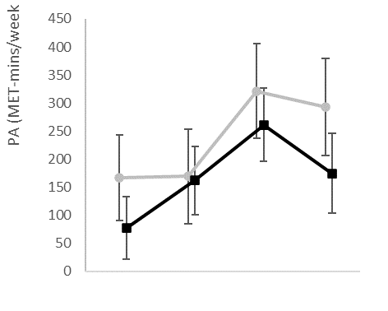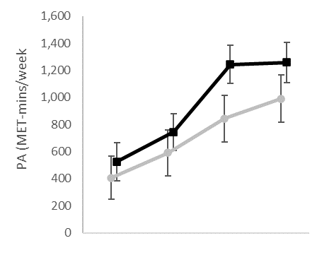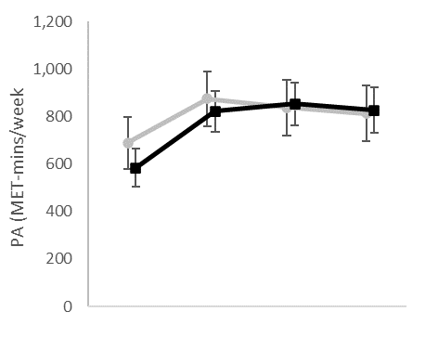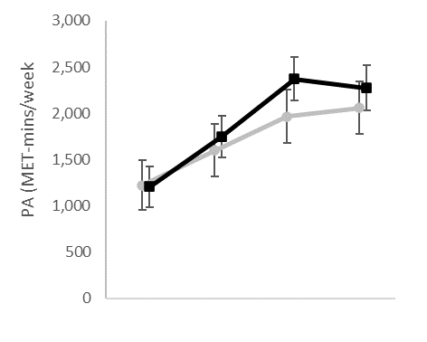

A

B

C

D

Baseline 12-weeks 6-months 12-months

Baseline 12-weeks 6-months 12-months

Baseline 12-weeks 6-months 12-months

Baseline 12-weeks 6-months 12-months

Figure 3. PA level point estimates and 95% precision (95% CIs) at each time point, for each activity intensity by participant pathway. A – Vigorous PA; B – Moderate PA; C – Walking PA; D – Total PA. SP= Signposting pathway, SA= Social Action group pathway.

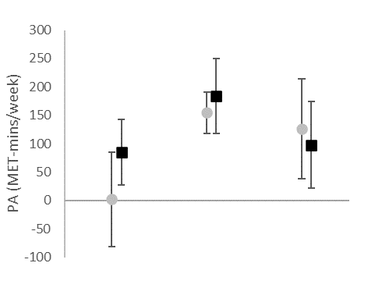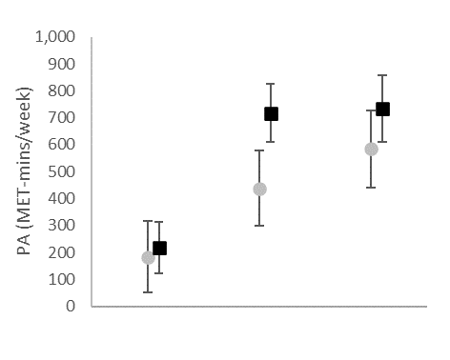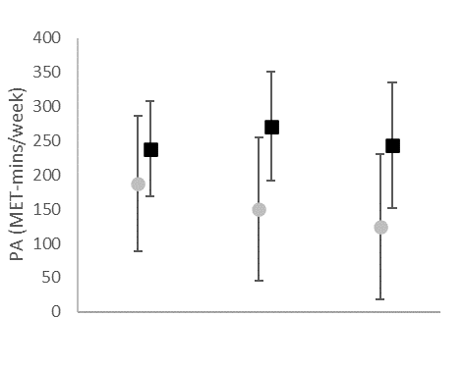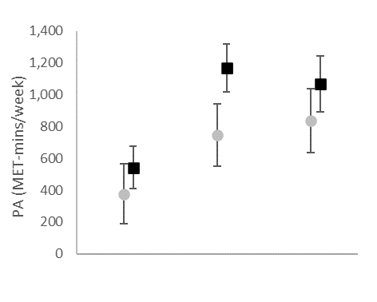

A

B

C

D

Baseline – 12-weeks

Baseline – six-months

Baseline – 12-months

Baseline – 12-weeks

Baseline – six-months

Baseline – 12-months

Baseline – 12-weeks

Baseline – six-months

Baseline – 12-months

Baseline – 12-weeks

Baseline – six-months

Baseline – 12-months

Figure 4. Point estimates and 95% precision (95% CIs) changes in PA levels from baseline to each follow-up time point, for each activity intensity by participant pathway. A – Vigorous PA change; B – Moderate PA change; C – Walking PA change; D – Total PA change. SP= Signposting pathway, SA= Social Action group pathway.

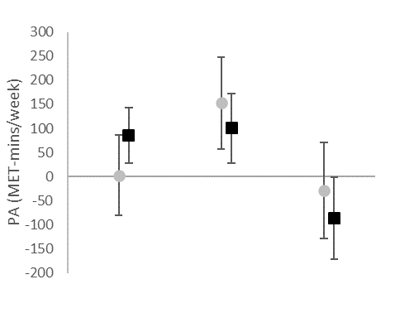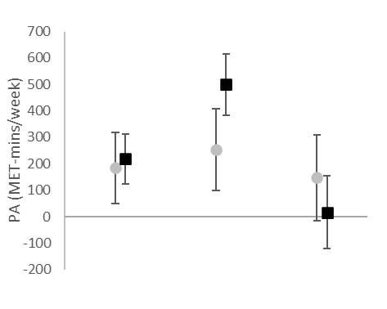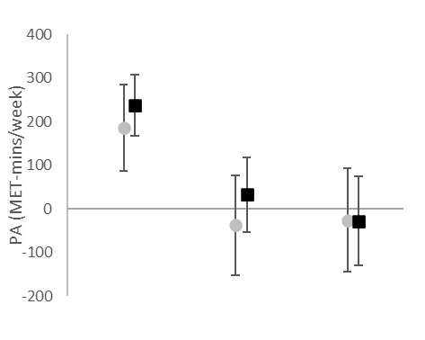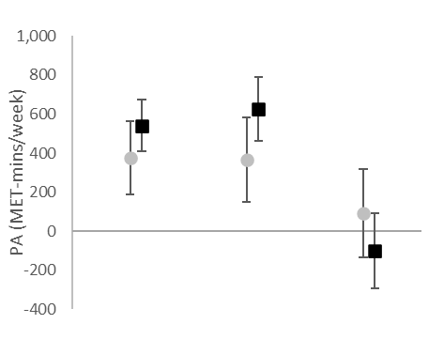

A

B

Baseline – 12-weeks

12-weeks – six-months

Six-month – 12-months

Baseline – 12-weeks

12-weeks – six-months

Six-month – 12-months

Baseline – 12-weeks

12-weeks – six-months

Six-month – 12-months

Baseline – 12-weeks

12-weeks – six-months

Six-month – 12-months

C

D



Figure 5. Point estimates and 95% precision (95% CIs) changes in PA levels between each time point, for each activity intensity by participant pathway. A – Vigorous PA change; B – Moderate PA change; C – Walking PA change; D – Total PA change.

#### Comparison of mental wellbeing by pathway

Point estimates and 95%CIs for mental wellbeing showed an increase in mental wellbeing through to 12-months for both pathways, and little difference between the pathways (Figure 6). Comparing change between time points revealed that between baseline and each follow up time point mental wellbeing increased (Figure 7A). From 12-weeks to six-months there was only clear improvement observed in the SA pathway (0.64, 95%CI= 0.1 to 1.2; Figure 7B), although this was minimal. From six-months to 12-months there was little change for either pathway. There was no apparent difference for the change in mental wellbeing between the pathways at any time point.

Figure 6. Point estimates and 95% precision (95% CIs) SWEMWBS results for each pathway at each time point.

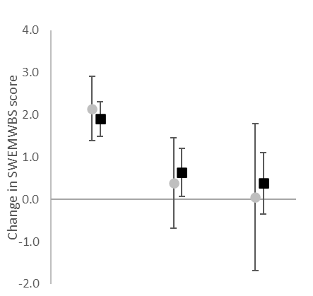

Baseline – 12-weeks

12-weeks – six-months

Six-months – 12-months

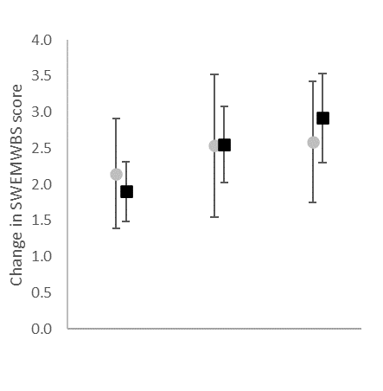

Baseline – 12-weeks

Baseline – six-months

Baseline – 12-months

A

B

Figure 7. Point estimates and 95% precision (95% CIs) changes in SWEMWBS score by participant pathway. A - from baseline to each follow-up time point; B - between each time point.

## DISCUSSION

**Main findings of the study**

This study assessed whether a community-based PA intervention grounded in MI improved PA and mental wellbeing, and if the impact differed between the SP and SA participant pathways. Overall, PA and mental wellbeing were increased at 12-weeks, six-months, and 12-months compared to baseline. The only apparent difference between pathways was that the SA pathway produced greater change in moderate and total PA between baseline and six-months; however, both pathways appear effective. The greatest improvements across the 12-months were in moderate intensity PA, whereas vigorous intensity PA only had slight improvements. Walking plateaued after an initial increase at 12-weeks. These results present practical implications for MI based PA interventions as the SP pathway produced similar outcomes with less resources required.

**What is already known on this topic**

The improvements from baseline reported in the current study build upon recent literature 16,17. The greatest improvements in this study were achieved in the first six-months, except for walking which only improved to 12-weeks. It could be that walking did not continually improve as more intensive PA displaced it over time, increasing overall improvements. Hardcastle et al.40 also reported significant changes in walking from baseline at six and 18-months, but is unclear if this plateaued from 12-weeks as found in the present study. Overall, PA levels were improved such that participants would be classified as having ‘high’ activity levels after 12-weeks, and this was maintained post six-months though without further improvement. Compared to exercise referral schemes comparable changes in physical activity have been seen over 12-weeks41, however participants in the present study started with a higher baseline. In the present study, the six-month appointment was via telephone, not face-to-face, and did not include MI for the first time. This could be a critical time point. If this follow-up included MI, or delivery was face-to-face, positive improvements may have continued. The delivery of follow-up MI may help continued improvement in PA however, if this happened, from a practical perspective it is not clear where this support should stop and is certainly not feasible for MI to be provided *ad infinitum.* It may be there is a point at which further support will no longer elicit positive change and maintenance through implementing minimal resources becomes more advantageous. Further longitudinal investigation into different approaches including a return on investment analysis may aid understanding and provide additional practical guidance.

The current study also showed improved mental wellbeing following an MI based intervention, supporting previous findings18, and suggests there may be a wider impact of improving PA through MI. Compared to the Health Survey for England 2010-2013, the baseline SWEMWBS score in this study (24.7) was just above the norm data for males (23.7) and females (23.6)42. Furthermore, the significant increase at six-months from baseline meant participants were in the 85th percentile42. The threshold of clinically meaningful change (±2.77)43 was met for the change from baseline to 12-months, although the lower limit of the 95% CIs fell below the clinically meaningful value (2.80, 95%CI= 2.30 to 3.29). Estimates from exercise referral schemes show a similar point and interval estimate for mental wellbeing change though supporting the present findings44.

To understand the role of group support, the intervention incorporated a novel pathway approach: the SA group pathway. Minimal difference was seen between the SP and SA pathways in any of the PA intensities or mental wellbeing. Considering social group support has been shown to reinforce PA behaviour22 and maximise behaviour change opportunities for group members27 it was anticipated that this would enhance the effectiveness of the MI intervention. However, this study suggests that the MI and signposting to relevant activities alone, were enough to support and promote positive behaviour change; therefore, these should be preferentially recommended, saving cost and resources. That being said, the current study has only investigated PA and mental wellbeing outcomes. There may be other health and wellbeing outcomes that have not been measured here that could be impacted by social group support such as loneliness.

In addition to improved PA and mental wellbeing outcomes, the current study had a higher retention at 12-weeks (59.5%) compared to traditional exercise referral pathways (12-42%45, 49%46) and only reduced to 46.0% at six-months. Although retention here is comparable to similar interventions 40.5% of participants still dropped out by 12-weeks. Previous work has been undertaken to identify those most likely of dropout47 however early identification and support these participants. The MI appointment received by all participants here compared to traditional pathways may have supported longer term behaviour change and influenced the higher retention rates at six-months. However, between pathways there was a considerable difference at 12-months. This was higher for the SP pathway who had received no structured support. The retention differences seen may have impacted the outcome results of either pathway and could have potentially produced differences in the outcome measures between the pathways however the extent of this is unknown. Further investigation is required to fully determine the impact of retention on the outcomes and the reasons that retention differed between pathways.

**What this study adds**

Recently there has been an increase in the popularity and promotion of social prescribing48. There are similarities between the intervention utilised and social prescribing which links primary care with a range of social activities and community support pathways to promote improvements in health and wellbeing across a range of factors49,50. Similarities extend beyond improving the health of participants to intervention set up, delivery, and utilising expertise within primary care to provide participants tailored support. This support aims to identify local provision suitable for the participants to improve health. The CEP involved in the present intervention focused on PA; however, social prescribing link workers provide more holistic support to improve health and wellbeing. The present intervention’s structure could be incorporated within social prescribing with the findings recommended to inform the PA element social prescribing.

Utilising MI to elicit positive health behaviour changes is still an emerging area of research within real-world settings. The findings from this study provide evidence as to the effectiveness of MI to promote PA and mental wellbeing improvements in primary care settings. It is recommended that commissioners, deliverers, and decision makers use MI and signpost participants to relevant local activities to promote improvements in PA levels and mental wellbeing. However, group support may elicit improvements in variables not measured here so should not be wholly discounted. The results demonstrate the SA group support was effective but future research could investigate a more targeted approach such as participants with specific conditions to elicit greater improvements in the desired outcomes. Additionally, in light of the COVID-19 pandemic there is likely to be an emphasis on the importance of regular PA with this intervention and MI to be an approach to support such initiatives. Future research should capture data on the activities participated in (not captured in the present study) and data to account for confounding variables (i.e. living in an area of deprivation, occupation, or marital status). This will support the refinement and implementation of PA based interventions routinely in primary care.

## Limitations of this study

This study did not collect data on what activities participants engaged in. Data on attendance at signposted activities or to the SA group meetings, through to activity volume and intensity data could have helped contextualise the improvements seen. Furthermore, analysis could have investigated if different activities, intensities, or attendance influenced the PA and mental wellbeing outcomes. Practically this may not be feasible given the additional resource required. It is also possible that direct and indirect effects exist between PA and mental wellbeing and these may even be bidirectional however an analysis model was not proposed *a priori* and therefore dependant variables were treated as equally independent. Further, the absence of a control does not allow for the improvements to be compared to not receiving either pathway and limits the effectiveness conclusions that can be drawn. All CEPs received MI training and support, however the MI delivery fidelity was not monitored meaning conclusions of the impact of MI must be interpreted considering this. Including MI appointments elicited positive improvements, however if the fidelity of MI delivered had been measured further understanding could have been generated.

## Conclusion

This study found that both the SP and SA group pathways were similarly effective in producing improvements in PA and mental wellbeing. However, the addition of a control would have provided further insight as to the effectiveness of these pathways. Considering the lesser resources required, SP should currently be recommended over SA to improve overall PA levels and mental wellbeing. Furthermore, the community-based physical activity intervention grounded in motivational interviewing utilised here, and specifically the SP pathway, could be incorporated as a PA element of the NHS backed social prescribing, although further assessment of the effectiveness is required.

**ACKNOWLEDGEMENTS**

The authors thank Essex County Council and Nesta for their funding and support in the delivery of this intervention. Specific thanks go to the project co-ordinators and Community Exercise Professionals, and of course the participants.

**COMPETING INTERESTS**

None declared.

**DATA AVAILABILITY**

The data underlying this article will be shared on reasonable request to the corresponding author.

**FUNDING**

The authors have not declared a specific grant for this research from any funding agency in the public, commercial or not-for-profit sectors.

**REFERENCES**

1. Williams NH. Promoting physical activity in primary care. *BMJ*. 2011;343(d6615):973. doi:10.1136/bmj.d6615

2. WHO. *Global Recommendations on Physical Activity for Health*. Switzerland; 2010.

3. Department of Health and Social Care. *UK Chief Medical Officers’ Physical Activity Guidelines*.; 2019. https://www.gov.uk/government/publications/physical-activity-guidelines-uk-chief-medical-officers-report. Accessed October 13, 2020.

4. Saint-Maurice PF, Troiano RP, Berrigan D, Kraus WE, Matthews CE. Volume of Light Versus Moderate-to-Vigorous Physical Activity: Similar Benefits for All-Cause Mortality? doi:10.1161/JAHA

5. Murphy MH, Lahart I, Carlin A, Murtagh E. The Effects of Continuous Compared to Accumulated Exercise on Health: A Meta-Analytic Review. *Sport Med*. 2019;49(10):1585-1607. doi:10.1007/s40279-019-01145-2

6. NICE. Physical activity: exercise referral schemes. https://www.nice.org.uk/guidance/ph54. Published 2014.

7. Miller WR, Rollnick S. *Motivational Interviewing*. 2nd ed. New York: Guilford Press; 2002.

8. Miller WR, Rollnick S. Ten Things that Motivational Interviewing Is Not. *Behav Cogn Psychother*. 2009;37:129-140. doi:10.1017/S1352465809005128

9. Miller WR, Rose GS. Toward a Theory of Motivational Interviewing. *Am Psychol*. 2009;64(6):527-537. doi:10.1037/a0016830

10. Resnicow K, McMaster F. Motivational Interviewing: Moving from why to how with autonomy support. *Int J Behav Nutr Phys Act*. 2012;9. doi:10.1186/1479-5868-9-19

11. Dalgetty R, Miller CB, Dombrowski SU. Examining the theory-effectiveness hypothesis: A systematic review of systematic reviews. *Br J Health Psychol*. 2019;24(2):334-356. doi:10.1111/bjhp.12356

12. Burke BL, Arkowitz H, Menchola M. The Efficacy of Motivational Interviewing: A Meta-Analysis of Controlled Clinical Trials. *J Consult Clin Psychol*. 2003;71(5):843-861. doi:10.1037/0022-006X.71.5.843

13. Dunn C, Deroo L, Rivara F. Use of brief interventions adapted from motivational interviewing across behavioural domains: a systematic review. *Addiction*. 2001;96(12):1725-1742. doi:10.1080/09652140120089481

14. Hettema J, Steele J, Miller WR. Motivational Interviewing. *Annu Rev Clin Psychol*. 2005;1(1):91-111. doi:10.1146/annurev.clinpsy.1.102803.143833

15. Lundahl BW, Kunz C, Brownell C, Tollefson D, Burke BL. A Meta-Analysis of Motivational Interviewing: Twenty-Five Years of Empirical Studies. *Res Soc Work Pract*. 2010;20(2):137-160. doi:10.1177/1049731509347850

16. O’Halloran PD, Blackstock F, Shields N, et al. Motivational interviewing to increase physical activity in people with chronic health conditions: a systematic review and meta-analysis. *Clin Rehabil*. 2014;28(2812):1159-1171. doi:10.1177/0269215514536210

17. Morton K, Beauchamp M, Prothero A, et al. The effectiveness of motivational interviewing for health behaviour change in primary care settings: a systematic review. *Health Psychol Rev*. 2014;9(2):205-223. doi:10.1080/17437199.2014.882006

18. O’Halloran PD, Shields N, Blackstock F, Wintle E, Taylor NF. Motivational interviewing increases physical activity and self-efficacy in people living in the community after hip fracture: a randomized controlled trial. *Clin Rehabil*. 2016;30(11):1108-1119. doi:10.1177/0269215515617814

19. Borek AJ, Abraham C, Greaves CJ, et al. Identifying change processes in group-based health behaviour-change interventions: development of the mechanisms of action in group-based interventions (MAGI) framework. *Health Psychol Rev*. 2019;13(3):227-247. doi:10.1080/17437199.2019.1625282

20. Borek AJ, Abraham C. How do Small Groups Promote Behaviour Change? An Integrative Conceptual Review of Explanatory Mechanisms. *Appl Psychol Heal Well-Being*. 2018;10(1):30-61. doi:10.1111/aphw.12120

21. Greaves CJ, Campbell JL. Supporting self-care in general practice. *Br J Gen Pract*. 2007;57(543):814-821. doi:10.3399/096016407782605018SGULAuthors:Kerry,SallyMargaretOakeshott,Philippa

22. Heath GW, Parra DC, Sarmiento OL, et al. Evidence-based intervention in physical activity: Lessons from around the world. *Lancet*. 2012;380(9838):272-281. doi:10.1016/S0140-6736(12)60816-2

23. Lieberman MA, Winzelberg A, Golant M, et al. Online Support Groups for Parkinson’s Patients. *Soc Work Health Care*. 2006;42(2):23-38. doi:10.1300/j010v42n02_02

24. Barg FK, Gullatte MM. Cancer support groups: Meeting the needs of African Americans with cancer. *Semin Oncol Nurs*. 2001;17(3):171-178. doi:10.1053/sonu.2001.25946

25. Davison KP, Pennebaker JW, Dickerson SS. Who talks? The social psychology of illness support groups. *Am Psychol*. 2000;55(2):205-217. doi:10.1037/0003-066X.55.2.205

26. Delisle VC, Körner A, El-Baalbaki G, et al. Effect of support group peer facilitator training programmes on peer facilitator and support group member outcomes: a systematic review. *BMJ Open*. 2016;6(11):1-7. doi:10.1136/bmjopen-2016-013325

27. Miller WR, Rollnick S. *Motivational Interviewing: Helping People Change*. New York: Guilford Press; 2013.

28. Hoddinott P, Allan K, Avenell A, Britten J. Group interventions to improve health outcomes: A framework for their design and delivery. *BMC Public Health*. 2010;10:800. doi:10.1186/1471-2458-10-800

29. Deakin T, McShane CE, Cade JE, Williams RDRR. Group based training for self-management strategies in people with type 2 diabetes mellitus. *Cochrane database Syst Rev*. 2005;(2):CD003417. doi:10.1002/14651858.CD003417.pub2

30. Paul-Ebhohimhen V, Avenell A. A systematic review of the effectiveness of group versus individual treatments for adult obesity. *Obes Facts*. 2009;2(1):17-24. doi:10.1159/000186144

31. Office for National Statistics. [ARCHIVED CONTENT] Presentation of Ethnic Group Data - ONS. The National Archives. http://webarchive.nationalarchives.gov.uk/20160108194238/http://www.ons.gov.uk/ons/guide-method/measuring-equality/equality/ethnic-nat-identity-religion/ethnic-group/presentation-of-ethnic-group-data.html. Published 2016.

32. IPAQ. Downloadable questionnaires - International Physical Activity Questionnaire. n.d. https://sites.google.com/site/theipaq/questionnaire_links. Accessed April 2, 2019.

33. Stewart-Brown S, Tennant A, Tennant R, et al. Internal construct validity of the Warwick-Edinburgh Mental Well-being Scale (WEMWBS): a Rasch analysis using data from the Scottish Health Education Population Survey. *Health Qual Life Outcomes*. 2009;7(7). doi:10.1186/1477-7525-7-15

34. IPAQ. *Guidelines for Data Processing and Analysis of the International Physical Activity Questionnaire (IPAQ): Short and Long Forms*.; 2005.

35. Warwick Medical School. SWEMWBS. https://warwick.ac.uk/fac/sci/med/research/platform/wemwbs/development/swemwbs/. Published 2013.

36. Bates D, Mächler M, Bolker BM, Walker SC. Fitting linear mixed-effects models using lme4. *J Stat Softw*. 2015;67(1):1-48. doi:10.18637/jss.v067.i01

37. Lininger M, Spybrook J, Cheatham CC. Hierarchical linear model: Thinking outside the traditional repeated-measures analysis-of-variance box. *J Athl Train*. 2015;50(4):438-441. doi:10.4085/1062-6050-49.5.09

38. Raudenbush S, Bryk A. *Hierarchical Linear Models: Applications and Data Analysis Methods*. 2nd Editio. London: SAGE Publications; 2002.

39. Cumming G. The New Statistics: Why and How. *Psychol Sci*. 2014;25(1):7-29. doi:10.1177/0956797613504966

40. Hardcastle S, Taylor AH, Bailey MP, Harley RA, Hagger MS. Effectiveness of a motivational interviewing intervention on weight loss, physical activity and cardiovascular disease risk factors: A randomised controlled trial with a 12-month post-intervention follow-up. *Int J Behav Nutr Phys Act*. 2013;10(1):40. doi:10.1186/1479-5868-10-40

41. Rowley N, Steele J, Wade M, et al. Are Exercise Referral Schemes Associated With an Increase in Physical Activity? Observational Findings Using Individual Patient Data Meta-Analysis From the National Referral Database. *J Phys Act Heal*. 2020;17(6):621-631. doi:10.1123/jpah.2019-0435

42. Ng Fat L, Scholes S, Boniface S, Mindell J, Stewart-Brown S. Evaluating and establishing national norms for mental wellbeing using the short Warwick–Edinburgh Mental Well-being Scale (SWEMWBS): findings from the Health Survey for England. *Qual Life Res*. 2017;26(5):1129-1144. doi:10.1007/s11136-016-1454-8

43. Maheswaran H, Weich S, Powell J, et al. Evaluating the responsiveness of the Warwick Edinburgh Mental Well-Being Scale (WEMWBS): Group and individual level analysis. *Health Qual Life Outcomes*. 2012;10(1):156. doi:https://doi.org/10.1186/1477-7525-10-156

44. Wade M, Mann S, Copeland RJ, Steele J. Effect of exercise referral schemes upon health and well-being: Initial observational insights using individual patient data meta-analysis from the National Referral Database. *J Epidemiol Community Health*. 2020;74(1):32-41. doi:10.1136/jech-2019-212674

45. Williams NH, Hendry M, France B, Lewis R, Wilkinson C. Effectiveness of exercise-referral schemes to promote physical activity in adults: Systematic review. *Br J Gen Pract*. 2007;57(545):979-986. doi:10.3399/096016407782604866

46. Pavey TG, Taylor A, Hillsdon M, et al. Levels and predictors of exercise referral scheme uptake and adherence: a systematic review. *J Epidemiol Community Health*. 2012;66(8):737-744. doi:10.1136/jech-2011-200354

47. Wade M, Brown N, Dancy B, Mann S, Gissane C, Majumdar A. Identification of dropout predictors to a community-based physical activity programme that uses motivational interviewing. *J Public Heal (United Kingdom)*. 2020;42(1):3-11. doi:10.1093/pubmed/fdy206

48. Husk K, Elston J, Gradinger F, Callaghan L, Asthana S. Social prescribing: Where is the evidence? *Br J Gen Pract*. 2019;69(678):6-7. doi:10.3399/bjgp19X700325

49. Bickerdike L, Booth A, Wilson PM, Farley K, Wright K. Social prescribing: Less rhetoric and more reality. A systematic review of the evidence. *BMJ Open*. 2017;7(4):e013384. doi:10.1136/bmjopen-2016-013384

50. Drinkwater C, Wildman J, Moffatt S. Social prescribing. *BMJ*. 2019;364:1285. doi:10.1136/bmj.l1285