Day type and start time may influence sleep in adolescent professional football players
Original investigation submission
Luke Edinborough^{1,2} * (Orcid: 0000-0002-2806-9478)
Stewart Bruce-Low³ (Orcid: 0000-0002-4178-1160)
Jessica Hill¹ (Orcid: 0000-0001-9720-3469)
Jonathan Woodhouse¹
Mark Jarvis¹
Charles R Pedlar^{1,4} (Orcid: 0000-0002-3075-9101)
1. Faculty of Sport, Allied Health and Performance Sciences, St Mary's University, Twickenham, UK
2. Southampton Football Club, Southampton, UK
3. School of Health Sport & Bioscience, University of East London, London, UK
4. Institute of Sport, Exercise and Health, Division of Surgery and Interventional Science, University College London (UCL), London, UK
* Corresponding Author (luke.edinborough@saintsfc.co.uk, OrcID: 0000-0002-2806-9478)
Word-count (excluding tables and figures): 3482
Preferred running head: Day type, start time and sleep in U18 footballers
Key words: Chronotype, wrist-accelerometery, start time, workload, adolescent

Abstract
This study assessed if scheduling (start time and day type) and workload variables influenced sleep markers (activity monitor) in professional academy footballers (n=11; 17.3±0.7yrs) over a 10-week in-season period. Separate linear mixed regressions were used to describe the effect of start time on the previous nights sleep, and the effect of day type (matchday, matchday+1) and workload on subsequent sleep. Workload variables were modelled by day (day), 7-day (acute), and 28-day (chronic) periods. Sleep duration following matchday+1 (400mins; 95%CI:368—432) was significantly reduced compared to all other day types (p<0.001). Sleep onset time following matchday (00:35; CI:00:04—01:12) and wake time on matchday+1 (09:00; CI:08:37—09:23) were also significantly later compared to all other day types (p<0.001). Sleep duration (19.1mins; CI:9.4–28.79), wake time (18mins; CI:9.3–26.6), and time in bed (16.8mins; CI:2.0–31.5) were significantly increased per hour delay in start time. When no activity was scheduled sleep duration (37mins; CI:18.1—55.9), sleep onset (42.1mins; CI:28.8–56.2), and wake times (86mins; CI:72–100) were significantly extended, relative to a 09:00 start time. Day, acute, and chronic workloads were associated with sleep onset and wake times only. Scheduled start times were associated with changes in sleep duration, therefore, delaying start times may increase sleep in this population.

Introduction
Sleep monitoring methodologies in observational studies have highlighted several factors that may influence sleep in professional football players. Notwithstanding the significant inter/intra-individual variation [1], studies have also reported differences according to day type (eg: matchday (MD), MD+1) [1], and reduced sleep quality or quantity after night matches [2,3], and travel [4,5]. Consequently, there is growing evidence to suggest that competitive scheduling contributes to sleep disruption in footballers. As biological chronotype (the intrinsic entrainment of an individual’s circadian system to a 24-hour cycle) approaches peak lateness during late adolescence, approximately 104 mins later than the lifetime average [6], it follows that scheduling considerations for adolescents and senior players should differ.
Start time (ST; the time players are scheduled to arrive for training or competition) is a consideration that coaches arguably have more control over than other scheduling elements. This could be particularly pertinent for professional academy players whose chronotype may support a delayed start time [6,7]. In adolescent students in the USA (13 to 18yrs), later school STs have been associated with longer sleep durations, reduced daytime sleepiness, and improved academic performance [6,7]. Professional academy players commitments vary compared to the general population, consequently, the influence start time has on professional academy footballers sleep is not known.
Workload may also influence sleep [1], with both workload [8] and suboptimal sleep [9] linked to increased injury risk. However, reports investigating the impact of workload on subsequent sleep are equivocal. In professional rugby league players, higher acceleration/deceleration counts resulted in greater sleep efficiency [10], whereas intensified training in endurance athletes resulted in reduced sleep duration and efficiency [11]. However, in football a substantial relationship is yet to be presented. In English Premier League (EPL) players, no significant link was revealed between total distance covered above >4m·s⁻¹ and subsequent perceived sleep quality [12,13], and, while another study [1] did observe a significant relationship between distance high speed running (>5.5 m·s⁻¹; HSR) and sleep duration, effect sizes were trivial.
Therefore, the aims of this study were to 1) assess how start time may influence sleep the night before, and how day type may influence subsequent sleep; and 2) assess how workload may influence subsequent sleep in 18year old (U18) professional footballers.

Materials and methods.

Participants
Eleven male U18 outfield professional (full-time, contracted) footballers playing for a category 1 EPL academy participated in this study (17.3±0.7yrs; 178.6±7.4cm, 74.8±8.4kg). Players were excluded if they had previously self-reported any clinical sleep issues to the club’s medical team. Fourteen players were initially recruited but 3 were excluded from the analysis due to lack of adherence (n=2), and technology failure (n=1). All players were living at home or with host families throughout the duration of the study and travelled to training via their own means or a minibus service provided by the club. Informed participant and parental consent were obtained before data collection and this study was approved by the ethics committee at St Mary’s University, Twickenham.

Experimental design
This was a longitudinal, observational study which spanned a 10-week in-season period during the 20/21 season and, therefore, subject to National and Football Association COVID-19 regulations. However, players continued their normal uninterrupted competitive schedule throughout the study. The study included 9 matches (66.7% home) and all kick-offs were before 1300. A typical training week is described in supplementary 1. Player sleep was monitored objectively using activity monitors (ReadiBand, Fatigue Science, Vancouver BC, Canada). Data were then categorised by day type (activity of the day, relative to match day, eg MD, MD+1) and start time (the time players were scheduled to arrive at the training ground). Throughout training and matches players workload was quantified using the Global positioning system (GPS) and accelerometry (Viper V.2, StatSports, Ireland) data routinely collected by the club. Periods of injury/illness were excluded.

Sleep monitoring
Players wore activity monitors on their non-dominant wrists. Nocturnal movements were then used to estimate time-in-bed, sleep duration, sleep quality, wake after sleep onset (WASO), sleep latency and sleep onset time. ReadiBands have demonstrated good inter-device reliability and accuracy compared to polysomnography [14,15]. The devices were synced to cloud-based software by training staff who also requested and logged information on naps. Activity monitors can interpret sedentary periods (eg. travel) as sleep, therefore, any periods where the device registered sleep before 21:30 were removed after self-reported naps were accounted for. Activity monitors were worn for an average of 52% of nights that they were requested to be worn (Table 1). Forgetfulness was most often cited for non-adherence. Players who wore the devices for less than 14 days were excluded (n= 2).
Table 1: Total number of observations per linear mixed model
Variable | Number of observations | Observations per participant (mean ± SD, min, max)
Day type | 402 | 36.5 ± 11.7, 18, 56
TD | 265
MD-1 | 52
MD | 33
MD+1 | 52
Start time (categorical) | 402 | 36.5 ± 11.7, 18, 56
08:00 | 10
08:15 | 7
09:00* | 244
09:30 | 28
10:00 | 67
11:15 | 8
NSA | 38
Start time (continuous) | 364 | 33.1 ± 10.1, 16, 49
08:00 | 10
08:15 | 7
09:00 | 244
09:30 | 28
10:00 | 67
11:15 | 8
Workload | 250 | 22.7 ± 7.8. 14, 38
TD (training day)
MD (match day)
NSA (no scheduled activity)
* Used as reference start time

Start time and day type
Separate statistical models were generated for start time and day type. The day types were training day (TD, a normal training day), match day (MD, a day in which a competitive fixture is played), pre-match training day (MD-1, a normal training day the day before a MD) and post-match day (MD+1, the day after MD). As the players scheduled day off, no start time was available for MD+1. Therefore, to elucidate the complete influence of start time on sleep metrics, two separate start time models were generated. First, start time was coded as a categorical variable with no scheduled activity (NSA) imputed as the start time for MD+1. Start time was then analysed under the following categories: 08:00, 08:15, 09:00, 09:30, 10:00, 11:15, NSA. Data were compared against a 09:00 start time as the most frequent start time. Second, NSA was excluded from the dataset and start time was modelled continuously.
An individual’s chronotype can be quantified through their mid-sleep point on work-free days [6]. As MD+1 had no scheduled activity, it was assumed that players were more likely to initiate sleep on MD and wake on MD+1 without any influence from scheduling demands [6]. The authors accept that an accurate chronotype may not be calculated due to the effects of MD exertion on sleep drivers, nevertheless, the lack of scheduling on MD+1 provides a proxy for when sleep is supposed to occur naturally to estimate chronotype. Consequently, for reference purposes only, chronotype was calculated as the midpoint between sleep onset on MD and the wake time on MD+1 [6].

External load
GPS data were used to quantify workload during training and matches. The players donned a vest that placed a GPS and accelerometry unit between the scapulae. The unit sampled GPS and accelerometry data at 10 Hz and 100 Hz, respectively, and was downloaded using specialist software (Statsports APEX). To assess the influence of workload on sleep metrics, HSR distance (total distance (m) covered at running speeds >5.5m·s⁻¹; HSR) was used as a global measure of external load, as per previous research [1,12,13] and due to its association with injury occurrence in U18 footballers [8]. Additionally, high-speed decelerations (a decrease in speed for at least half a second with maximum deceleration in the period of at least 0.5m·s⁻², DEC), and high-speed accelerations (an increase in speed for at least half a second with maximum deceleration in the period of at least 0.5m·s⁻²; ACC) were included due to their links with muscle damage and possible pain that may disrupt sleep during nocturnal movements [16]. Each variable was sampled by day (day), accumulated 7day (acute), and accumulated 28day (chronic). High chronic (relative risk (RR): 2.14; p=0.003) and acute (RR:1.73; p=0.029) HSR has been associated with increased overall injury risk in a similar cohort (U18 footballers, 17.3±0.9yrs) [8]. HSR is reported per 100m. DEC and ACC are reported per 10 actions.

Statistical analysis
Linear mixed modelling (LMM) were performed for all analysis with activity monitor-derived sleep metrics imputed as the dependant variable and random slopes and intercepts generated for each individual [17]. To assess differences in sleep according to day type, a regression was performed with Bonferroni post hoc. The mid-point of sleep between MD sleep onset and MD+1 wake time was derived from this model. Separate regressions were performed for start time viewed continuously (excluding NSA), and categorically. Finally, the influence of DEC, ACC, and HSR was assessed through separate multiple regressions with day, acute, and chronic workloads as the predictor variables. All data were analysed using the R statistical environment (The R Foundation for Statistical Computing) in Rstudio (Boston, USA) (supplementary 2). All data are presented with estimates and 95% confidence intervals (CI), and P<0.05 was considered statistically significant.

Results
Data from 402 nights were collected. Multiple regressions require data from all predictor variables to be available. This reduced the data available for the workload models (Table 1).

Day type and start time
Sleep duration (p<0.001) was significantly reduced following MD+1 (400mins, CI:368—432) compared to all other day types (TD: 430mins, CI:400—459, p=0.007; MD: 456mins, CI:422—490, p<0.001; MD-1:433mins, CI:401—465, p=0.03). Time-in-bed was significantly longer (p=0.009) following MD (570mins, CI:535—605mins) compared to MD+1 (506, CI:476—537mins; p=0.005) and TD (529, CI:505—552; p=0.047). Sleep onset time was significantly later (p<0.001) following MD (00:35, CI:00:04—01:12) compared with all other day types (MD-1: 23:47, CI:23:17—00:14, p<0.001; MD+1:00:03, CI:23:33—00:29, p=0.009; TD: 23:56, CI:23:27—00:29, p<0.001). Wake time was significantly later on MD+1 (09:00, CI:08:37—09:23mins) compared with all other day types (TD: 07:44, CI:07:26—08:01, p<0.001; MD-1: 07:38, CI:07:16—07:58, p<0.001; MD: 07:42, CI:07:20:38—08:04, p<0.001) (Figure 1). Based on the available data from MD (n=33), mid-sleep point (chronotype) is estimated at 04:46 ± 00:44, (CI: 04:19–05:13).
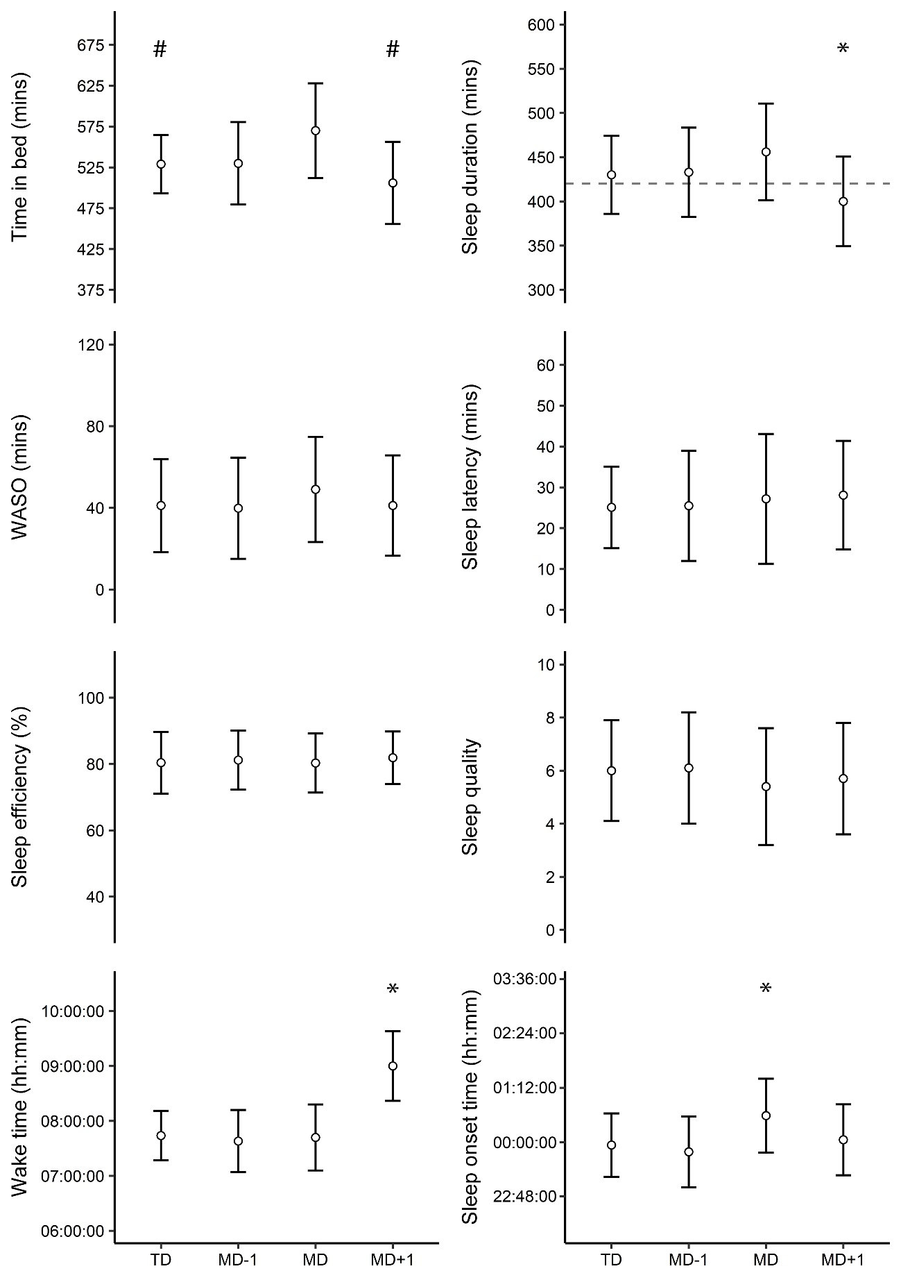
Figure 1: Estimated marginal means ± 95% confidence intervals for activity monitor derived sleep metrics across the 4-day types. For reference, the dashed line on sleep duration represents 420 mins. Training day (TD), Matchday (MD), the day before MD (MD-1), day after MD (MD+1), time awake after sleep onset (WASO). Number of observations: TD (265), MD-1 (52), MD (33), MD+1 (52). *Significantly different from all other day types (p<0.05). #significantly different from MD (p<0.05)

When start time was analysed continuously, time in bed (16.8mins, CI:2–31.5; p=0.026), sleep duration (19.1mins, CI:9.4–28.79; p<0.001), and wake time (18mins, CI:9.3–26.6; p<0.001) significantly increased per hour delay in start time. Relative to a 09:00 start time, sleep duration was extended during the night preceding all other start times, with the exception of a 11:15 start time (09:30: 31.7mins, CI: 9.51–53.96, p= 0.0052; 10:00: 17.7mins, CI: 2.72 – 32.67, p=0.0198; and NSA: 37mins, CI: 18.1–55.9, p<0.001). Compared to the reference 09:00 start time, wake time was later than on all other start times, with the exception of 11:15 (09:30: 38mins, CI: 14–62, p<0.001; 10:00: 22min, CI: 14–0.30, p=0.001; and NSA 86mins, CI:72–100, p<0.001). Sleep onset time was also significantly later the night before NSA (42mins, CI:29–55; p<0.001) compared to all other STs. Time-in-bed (45mins, CI:17–73; p=0.002) and WASO (7.4mins, CI:0.2–14.6; p=0.044) the night before NSA were significantly greater than on 09:00 start time days. Sleep latency on 10:00 start time days (-8.5mins, CI: -14.5– -2.6; p=0.006) was significantly reduced compared to 09:00 start time days (Figure 2 and 3, supplementary 3).
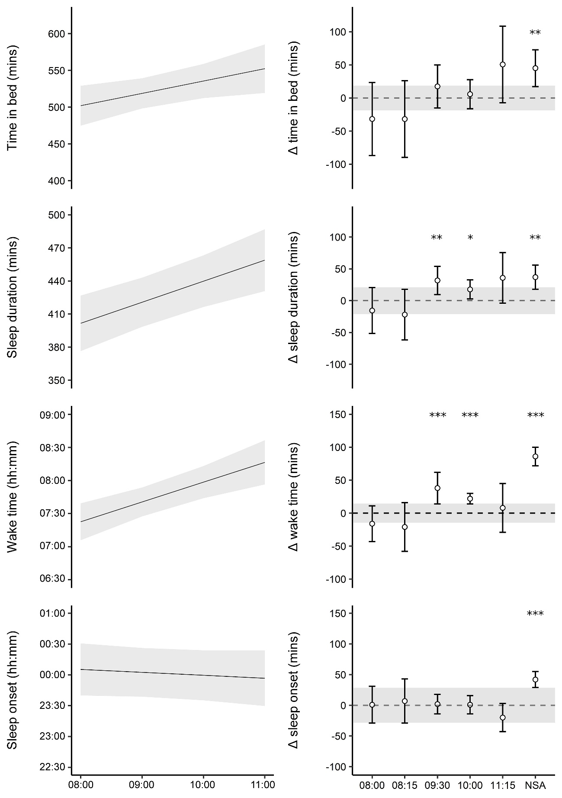
Figure 2: Data visualisation for the continuous start time model (left) and categorical start time model (right) for time in bed, sleep duration, wake time, and sleep onset. Data are presented as beta estimates ± 95% confidence intervals (grey area). No scheduled activity (NSA). 08:00 (10), 08:15 (7), 09:00 (244), 09:30 (28), 10:00 (67), 11:15 (8), NSA (38). * p<0.05 ** p<0.01 *** p<0.001

Workload
Each 100m increase in Day HSR resulted in a 4.48 min (CI:2.78–6.58min; p<.001) later sleep onset time and a 3.38min (CI:1.27–5.5mins; p=0.002) later wake time the following morning. Contrastingly, each 100m increase in acute HSR accounted for a 1.22min (CI:-2.27– -0.17; p=0.024) earlier sleep onset time. Each 100m increase in chronic HSR also accounted for a 2.58mins (CI:-4.87–-0.3; p=0.027) earlier sleep onset time and a 4.13mins (CI:-6.58– -1.68; p=0.001) earlier wake time. For every 10 DEC and 10 ACC, modelling revealed that sleep onset time was 0.9min (CI:-1.7– -0.1; p=0.004) and 1.32min (CI:-2.2– -0.42; p=0.026) earlier, respectively (Table 2). There was no significant change in sleep duration as a result of workload.
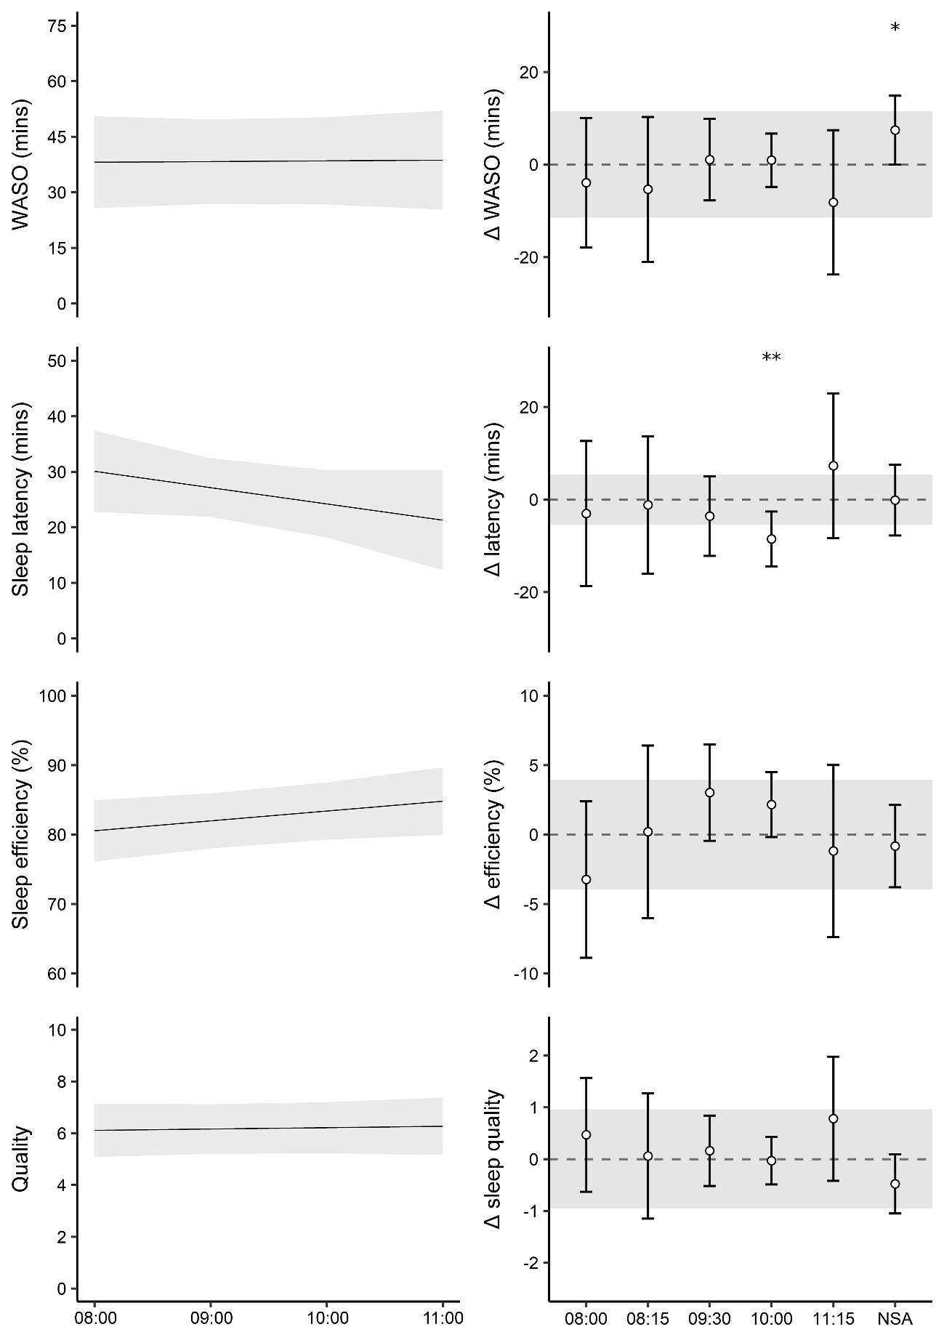
Figure 3: Data visualisation for the continuous start time model (left) and categorical start time model (right) for wake after sleep onset (WASO), sleep latency, sleep efficiency, and quality. Data are presented as beta estimates ± 95% confidence intervals (grey area). No scheduled activity (NSA). 08:00 (10), 08:15 (7), 09:00 (244), 09:30 (28), 10:00 (67), 11:15 (8), NSA (38). * p<0.05 ** p<0.01 *** p<0.001

Table 2: Results from the linear mixed multiple regression models for each activity monitor derived sleep metric with day (1 day workload), acute (accumulated 7 day workload), chronic (accumulated 28 day workload), workloads for high-speed distance, high-speed accelerations, and high-speed deceleration as the predictor variables. Beta values represent the estimated outcome change per unit change of the predictor and are presented with 95% confidence intervals.
 | Latency (mins) | WASO (mins) | Quality | Time in bed (mins) | Sleep duration (mins) | Efficiency (%) | Sleep Onset time  (mins) | Wake time  (mins)
Predictor | High-speed running (100m)
Day | -0.64 | -0.16 | 0.03 | -2.27 | -1.37 | 0.10 | 4.68*** | 3.38**
 | (-1.62 – 0.33) | (-1.25– 0.94) | (-0.06– 0.12) | (-5.92 – 1.38) | (-4.14– 1.40) | (-0.30 – 0.50) | (2.78– 6.58) | (1.27–5.5)
Acute | 0.24 | -0.04 | -0.01 | -0.17 | 0.31 | 0.10 | -1.22* | -0.15
 | (-0.28 – 0.76) | (-0.66 – 0.57) | (-0.06– 0.04) | (-2.17 – 1.83) | (-1.22 – 1.84) | (-0.12 – 0.32) | (-2.27– -0.17) | (-1.32–1.27)
Chronic | -0.14 | 0.54 | -0.09 | 2.45 | -1.71 | -0.43 | -2.58* | -4.13***
 | (-1.18 – 0.90) | (-0.81 – 1.88) | (-0.20– 0.02) | (-1.46– 6.36) | (-4.96 – 1.54) | (-0.91 – 0.05) | (-4.87– -0.3) | (-6.58– -1.68)
 | High-speed accelerations (10 occurrences)
Day | -0.05 | -0.04 | -0.04 | -1.32 | -2.35 | -0.22 | -0.4 | -2.65
 | (-1.34 – 1.24) | (-1.47 – 1.39) | (-0.16 – 0.07) | (-6.28 – 3.64) | (-6.07 – 1.37) | (-0.76 – 0.33) | (-3.13–2.32) | (-5.67–0.38)
Acute | 0.16 | 0.31 | -0.02 | 0.07 | 0.2 | 0.05 | -0.9* | -0.65
 | (-0.21 – 0.52) | (-0.11 – 0.74) | (-0.05 – 0.01) | (-1.35 – 1.48) | (-0.88 – 1.28) | (-0.11 – 0.21) | (-1.7– -0.1) | (-1.32–0.22)
Chronic | -0.23 | -0.21 | 0.02 | -0.64 | -0.74 | 0.04 | 0.23 | -0.97
 | (-0.84 – 0.38) | (-0.93 – 0.51) | (-0.04 – 0.08) | (-2.86 – 1.58) | (-2.56 – 1.07) | (-0.23 – 0.31) | (-1.12–1.58) | (-2.4– 0.47)
 | High-speed decelerations (10 occurrences)
Day | -0.05 | -0.04 | -0.04 | -1.32 | -2.35 | -0.22 | 1.67 | -1.47
 | (-1.34 – 1.24) | (-1.47 – 1.39) | (-0.16 – 0.07) | (-6.28 – 3.64) | (-6.07 – 1.37) | (-0.76 – 0.33) | (-1.38–4.71) | (-4.9– 1.97)
Acute | 0.16 | 0.31 | -0.02 | 0.07 | 0.2 | 0.05 | -1.32** | -0.72
 | (-0.21 – 0.52) | (-0.11 – 0.74) | (-0.05 – 0.01) | (-1.35 – 1.48) | (-0.88 – 1.28) | (-0.11 – 0.21) | (-2.2– -0.42) | (-1.72–0.27)
Chronic | -0.23 | -0.21 | 0.02 | -0.64 | -0.74 | 0.04 | 0.68 | -0.57
 | (-0.84 – 0.38) | (-0.93 – 0.51) | (-0.04 – 0.08) | (-2.86 – 1.58) | (-2.56 – 1.07) | (-0.23 – 0.31) | (-0.6– 1.98) | (-1.97– 0.85)
Day (1 day workload), acute (accumulated 7 day workload), chronic (accumulated 28 day workload), Wake after sleep onset (WASO).
* p<0.05, ** p<0.01, *** p<0.001.

Discussion
This explorative longitudinal study assessed whether day type, start time, and workload accounted for any variability in activity monitor-derived sleep metrics in U18 professional footballers.
To the author's knowledge, this is the first study to examine the influence of start time on sleep variables in this population. Analysis suggests that start time is a significant factor in the amount of sleep achieved by U18 footballers, with an estimated sleep extension of 19.1mins (CI: 9.4–28.79) per hour delay in start time. This also occurred in tandem with later wake times (18mins, CI:9.3–26.6), with no significant change to sleep onset times (p>0.05). To some extent, start time is likely to be related to day type, for example, the scheduled start time on MDs may depend on travel or kick-off time, however, start time is still a manipulatable variable, notably on TDs where coaches may have greater control.
Despite sleep extensions, it is not clear to what magnitude start time would have to be manipulated to produce a meaningful well-being or performance benefit. Whilst sleep extension protocols in athletes are limited to the collegiate level, studies have demonstrated improvements in daytime sleepiness and performance. However, extensions of ≥90mins were used [18]. The required magnitude of start time manipulation to generate synonymous levels of sleep extension may be unfeasible. Nevertheless, similar levels of sleep extension have also been reported in a cross-sectional study in American High Schools (13 to 18yrs) where each 30mins delay in school start time yielded 12mins of additional sleep [19]. Further studies have linked extensions to school start time with reductions in daytime sleepiness and improved academic performance [7]. Therefore, delaying start time may support adolescent footballers by increasing the available window for sleep. This may also be strengthened by encouraging earlier sleep onset times, although, this may not be supported by their intrinsic chronotype [6].
The players studied (17.3±0.7yrs) presented with a similar mid-sleep point (04:46 ± 00:44) as a similarly aged non-athletic population (17yrs, n=458, 04:35 ± 02:14)[6]. Whilst it is acknowledged that the chronotype calculation cannot be robust due to the unknown inference of MD, it does follow that the players may benefit from a later start time [6].
Coaches should also be aware that player sleep habits may differ as a result of days off. In the present study, sleep onset time was later on the nights preceding NSA (42.1mins, CI:28.8–56.2), occurring alongside later wake times (86mins, CI:72–100) and an extended sleep duration start time (37mins, CI: 18.1–55.9), relative to a 09:00, on NSA. The change may be due to players electing to use their free time to engage in social activities and/or delay sleep in anticipation of their day off. Regardless, the change may generate circadian misalignment as players subsequently readjust sleep behaviour to coincide with training schedules; a phenomenon termed social jetlag [20].
WASO on NSA days was also longer (7.4min, CI:0—14.8) compared to a 09:00 start time. The reasoning is not clear; however, this may be due to increased electronic device use or social jetlag [20,21]. Sleep latency the night before a 10:00 start time was also lower with no obvious explanation. It may be related to pre-MD nerves with a 10:00 start more likely associated with MD, rather than TD. Later STs may have exhibited a similar trend if a greater number of data points were available (11:15, n=8).
Sleep duration was shorter following MD+1 in comparison to all other day types. These findings are in line with other results in similarly aged footballing cohorts [1]. The reduction may be a result of reduced workload on MD+1 as a rest day. However, we were unable to monitor workload on MD+1 as it was exclusively the players day off (i.e. they did not train or play), so this cannot be assessed. Alternatively, without the presence of scheduling pressures, players may have chosen to modulate their sleep and social activities resulting in circadian misalignment [1,20] and reduced sleep on MD+1 [1].
Only sleep onset and wake times were associated with workload, however, results are conflicting. We report that for every 100m increase in day HSR, sleep onset and wake time are extended by 4.68min (CI:2.78—6.58mins) and 3.38mins (CI: 1.27—5.5mins), respectively. Yet, chronic HSR appeared to have the opposite effect, with every 100m increase resulting in an earlier sleep on onset time (-2.58mins, CI: -4.87— -0.3mins) and waketime (-4.13mins, CI:-6.58— -1.68mins). This may suggest a different interaction between day and chronic workloads on subsequent sleep, however, sleep duration was not affected. The current study, however, does not rule out any influence of workload on sleep. Activity monitors interpret nocturnal movements to infer sleep metrics [14,15]. Polysomnography studies in footballers would be needed to conclusively determine if workload affects sleep architecture. Results are not dissimilar to other studies. In English Premier League players, 1, 2, 3, and 4-day accumulated high-intensity running (classified as total distance >4m·s⁻¹) were notassociated with perceived sleep quality [12,13]. However, in professional youth players, Whitworth-Turner et al [1] reported a significant relationship between total HSR (>5.5 m·s⁻¹) and subsequent objective sleep metrics. While differences in how workload was classified, and how sleep was measured, may account for discrepancies between studies, Whitworth-Turner et al [1] still reported only trivial increases in WASO, time in bed, and sleep duration per every 100m increase in HSR.
This study is limited by players' adherence to wearing their devices, as results may be biased against periods of non-adherence. Furthermore, this study was completed during the COVID-19 pandemic. Whilst data collection was not interrupted by lockdowns there may have been a latent effect of lockdowns on behaviour and chronotype [22]. This study also did not record any subjective measures; thus, it is unclear if participants perceived an effect to the investigated variables. This data may also not reflect the sleep behaviours of other academy cohorts or senior players with differing schedules and pressures.
In conclusion, start time appeared to influence the total sleep duration that the U18 professional footballers obtained, in tandem with changes in wake times. Further interventional studies are needed to determine any effect on performance or well-being. Day type was also associated with sleep, with MD+1 exhibiting reduced sleep duration, and this may be attributable to a form of social jetlag. Commensurate with previous reports, there was little evidence to suggest that workload affected activity monitor-derived sleep metrics.

References
[1] Whitworth-Turner CM, di Michele R, Muir I, et al. Training load and schedule are important determinants of sleep behaviours in youth-soccer players. Eur J Sport Sci 2019; 19: 576–584. doi:10.1080/17461391.2018.1536171
[2] Nédélec M, Dawson B, Dupont G. Influence of night soccer matches on sleep in elite players. J Strength Cond Res 2019; 33: 174–179. doi:10.1519/JSC.0000000000002906
[3] Carrico S, Skorski S, Duffield R, et al. Post-match sleeping behavior based on match scheduling over a season in elite football players. Sci Med Footb 2018; 2: 9–15. doi:10.1080/24733938.2017.1403036
[4] Fullagar HHK, Duffield R, Skorski S, et al. Sleep, travel, and recovery responses of national footballers during and after long-haul international air travel. Int J Sports Physiol Perform 2016; 11: 86–95
[5] Lastella M, Roach GD, Sargent C. Travel fatigue and sleep/wake behaviors of professional soccer players during international competition. Sleep Health 2019; 5: 141–147. doi:10.1016/j.sleh.2018.10.013
[6] Fischer D, Lombardi DA, Marucci-Wellman H, et al. Chronotypes in the US – Influence of age and sex. PLoS One 2017; 12: e0178782. doi:10.1371/JOURNAL.PONE.0178782
[7] Morgenthaler TI, Hashmi S, Croft JB, et al. High School Start Times and the Impact on High School Students: What We Know, and What We Hope to Learn. J Clin Sleep Med 2016; 12: 1681. doi:10.5664/JCSM.6358
[8] Bowen L, Gross AS, Gimpel M, et al. Accumulated workloads and the acute: Chronic workload ratio relate to injury risk in elite youth football players. Br J Sports Med 2017; 51: 452–459. doi:10.1136/bjsports-2015-095820
[9] Silva A, Narciso F v., Soalheiro I, et al. Poor sleep quality’s association with soccer injuries: Preliminary data. Int J Sports Physiol Perform 2020; 15: 671–676. doi:10.1123/ijspp.2019-0185
[10] Thornton HR, Delaney JA, Duthie GM, et al. Effects of Preseason Training on the Sleep Characteristics of Professional Rugby League Players. Int J Sports Physiol Perform 2018; 13: 176–182. doi:10.1123/IJSPP.2017-0119
[11] Hausswirth C, Louis J, Aubry A, et al. Evidence of disturbed sleep and increased illness in overreached endurance athletes. Sports Med Health Sci 2014; 46: 1036–1045. doi:10.1249/MSS.0000000000000177
[12] Thorpe RT, Strudwick AJ, Buchheit M, et al. Monitoring Fatigue During the In-Season Competitive Phase in Elite Soccer Players. Int J Sports Physiol Perform 2015; 10: 958–964. doi:10.1123/ijspp.2015-0004
[13] Thorpe RT, Strudwick AJ, Buchheit M, et al. The Influence of Changes in Acute Training Load on Daily Sensitivity of Morning-Measured Fatigue Variables in Elite Soccer Players. Int J Sports Physiol Perform 2017; 12: S2107–S2113. doi:10.1123/ijspp.2016-0433
[14] Driller M, McQuillan J, O’Donnell S. Inter-device reliability of an automatic-scoring actigraph for measuring sleep in healthy adults. Sleep Science 2016; 9: 198–201. doi:10.1016/j.slsci.2016.08.003
[15] Chinoy ED, Cuellar JA, Huwa KE, et al. Performance of seven consumer sleep-tracking devices compared with polysomnography. Sleep 2021; 44. doi:10.1093/SLEEP/ZSAA291
[16] Owens DJ, Twist C, Cobley JN, et al. Exercise-induced muscle damage: What is it, what causes it and what are the nutritional solutions? Eur J Sport Sci 2019; 19: 71–85
[17] Bates D, Maechler M, Bolker B, et al. Package „lme4“. 2020
[18] Schwartz, Simon. Sleep extension improves serving accuracy: A study with college varsity tennis players. Physiol Behav 2015; 151: 541–544. doi:10.1016/J.PHYSBEH.2015.08.035
[19] Paksarian D, Rudolph KE, He JP, et al. School Start Time and Adolescent Sleep Patterns: Results From the US National Comorbidity Survey—Adolescent Supplement. Am J Public Health 2015; 105: 1351. doi:10.2105/AJPH.2015.302619
[20] Wittmann, Dinich, Merrow, et al. Social jetlag: misalignment of biological and social time. Chronobiol Int 2006; 23: 497–509. doi:10.1080/07420520500545979
[21] Hysing M, Pallesen S, Stormark KM, et al. Sleep and use of electronic devices in adolescence: Results from a large population-based study. BMJ Open 2015; 5: e006748. doi:10.1136/bmjopen-2014-006748
[22] Romdhani M, Rae DE, Nedelec M, et al. COVID-19 Lockdowns: A Worldwide Survey of Circadian Rhythms and Sleep Quality in 3911 Athletes from 49 Countries, with Data-Driven Recommendations. Sports Med 2021; doi:10.1007/s40279-021-01601-y

Supplementary

Supplementary material 1: Typical in-season week for the U18 footballers involved in this study
Typical in-season week for the U18 footballers involved in this study
Day | AM | PM
Monday (TD) | Education | Training
Tuesday (TD) | Training | Gym training/ Injury prevention/ technical skills training/ analysis
Wednesday (TD) | Gym training/ Injury prevention, technical skills training/ analysis | Education
Thursday (TD) | Education | Training
Friday (MD-1) | Training | Team meeting
Saturday (MD) |  | Matchday
Sunday (MD+1) | Off/ rest day
Training day (TD)
Matchday minus one (MD-1)
Matchday plus one (MD+1)
Matchday (MD)

Supplementary material 2: blank code for linear mixed model analysis

## Key ##
#df dataframe
## packages
{library(readxl)
library(emmeans)
library(sjstats)
library(lme4)
library(lmerTest)
library(MuMIn)
library(sjPlot)
options(scipen = 999)}

## linear mixed model anova, repeat for each sleep variable ##
LMM_ANOVA <- lmer(df$sleep_variable ~ as.factor(df$day_type) + (1|df$ID)) ###linear model DV predicted by the IV
summary(LMM_ANOVA) ### summary of model
anova(LMM_ANOVA) ###show model as anova
eta_sq(LMM_ANOVA, partial = TRUE) ### partial eta sq
r.squaredGLMM(LMM_ANOVA) ### Rsq
emmeans(LMM_ANOVA, list(pairwise ~ day_type), adjust = "bonferroni") ###post hoc

## Linear mixed model multiple regression for external work load ##
LMM_mRegression <- lmer(df$sleep_variable ~ df$acute+ df$chronic + as.numeric (df$Ratio) + (1| df$ID)) ### linear model
summary (LMM_mRegression) ### summary of model
tab_model(LMM_mRegression) ### out put model as HTML table

## Linear mixed model multiple regression for start time ###
##### set factors #####
df$Start_time <- factor(df$Start_time,
levels = c("09:00:00",
"08:00:00",
"08:15:00",
"09:30:00",
"10:00:00",
"11:15:00",
"NSA"
##### contrasts and dummy coding ######
`08:00 vs 09:00`<- c(0,1,0,0,0,0,0)
`08:15 vs 09:00`<- c(0,0,1,0,0,0,0)
`09:30 vs 09:00`<- c(0,0,0,1,0,0,0)
`10:00 vs 09:00`<- c(0,0,0,0,1,0,0)
`11:15 vs 09:00`<- c(0,0,0,0,0,1,0)
`NSA vs 09:00`<- c(0,0,0,0,0,0,1)

contrasts(df$Start_time) <-
cbind(`08:00 vs 09:00`,
`08:15 vs 09:00`,
`09:30 vs 09:00`,
`10:00 vs 09:00`,
`11:15 vs 09:00`,
`NSA vs 09:00`)
##### regression #####
LMMstart_time <-
lmer(df$Sleep_variable ~ df$Start_time + (1|ID))
summary (LMMstart_time)
tab_model(LMMstart_time)

Supplementary 3: Complete results for both start time models
Supplementary 3: Complete results for both start time models
 | Latency (mins) | WASO (mins) | Quality | Time in bed (mins) | Sleep Duration (mins) | Efficiency (%) | Sleep onset (mins) | Wake time (mins)
 | ST as a categorical variable (presented as change from 09:00 ST)
08:00 | -3.0 | -3.9 | 0.5 | -31.8 | -15.5 | -3.2 | 1.0 | -15.5
 | (-18.8–12.7) | (-18–10.1) | (-0.6–1.6) | (-87–23.5) | (-51.5–20.6) | (-8.9–2.4) | (-25.8–27.8) | (-48.3–17.3)
08:15 | -1.2 | -5.4 | 0.1 | -31.8 | -21.9 | 0.2 | 7.0 | -21.5
 | (-16.–13.7) | (-21.1–10.3) | (-1.2–1.3) | (-90–26.4) | (-61.7–18) | (-6–6.4) | (-22.6–36.5) | (-57.70–14.8)
09:30 | -3.6 | 1.1 | 0.2 | 17.5 | 31.7** | 3.0 | 1.5 | 38.1***
 | (-12.2–5) | (-7.8– 9.9) | (-0.5–0.8) | (-15.1–50) | (9.5–54) | (-0.5–6.5) | (-15–18.1) | (17.8–58.3)
11:00 | -8.5** | 0.9 | 0.0 | 5.8 | 17.7* | 2.2 | 0.8 | 22.5***
 | (-14.5–-2.6) | (-4.8–6.7) | (-0.5–0.4) | (-16.2–27.7) | (2.7–32.7) | (-0.2–4.5) | (-10.3–11.8) | (8.9–37.10)
11:15 | 7.3 | -8.2 | 0.8 | 50.7 | 35.8 | -1.2 | -20.0 | 8.6
 | (-8.4–23) | (-23.8–7.5) | (-0.4–2) | (-7.4–108.8) | (-3.9–75.6) | (-7.4– 5) | (-49.3–9.4) | (-27.6–44.7)
NSA | -0.1 | 7.4* | -0.5 | 45.1** | 37.0** | -0.8 | 42.1*** | 86.4***
 | (-7.1–7.5) | (0.2–14.6) | (-1.1–0.1) | (17.1–73) | (18–55.9) | (-3.8–2.1) | (28.8–56.2) | (69.2–103.6)
 | ST as a continuous variable
Change per unit ST (1hr) | -2.9 | 0.2 | 0.1 | 16.8* | 19.1*** | 1.4 | -2.9 | 18.0***
 | (-7.1–1.3) | (-3.8–4.2) | (-0.3–0.4) | (2–31.5) | (9.4–28.8) | (-0.2–3) | (-10.3–4.6) | (9.3–26.6)
Wake after sleep onset (WASO),
Start time (ST)
* p<0.05, ** p<0.01, *** p<0.001

