Systematic Video Analysis of ACL injuries in Male Basketball Players: Injury Mechanisms, Situational patterns, and Biomechanics on 36 consecutive cases

ABSTRACT
Background: ACL injuries represent a significant burden to basketball players. Improving our understanding of the situations and biomechanics which result in ACL injury may support the design of more effective injury risk mitigation programs.
Purpose: To describe with video analysis the mechanisms, situational patterns, and gross biomechanics (kinematics) of ACL injuries in professional basketball matches.
Study design: Case series.
Methods: Thirty-eight ACL injuries across six consecutive seasons of professional male European basketball were identified. Thirty-six (95%) injury videos were analyzed for injury mechanism and situational pattern, whilst biomechanical analysis was possible on 32 cases. Three independent reviewers evaluated each video. ACL injury timing during the match and location on the court was also reported.
Results: More injuries occurred whilst attacking (n=25, 69%), than defending (n=11, 31%). One (3%) injury was direct contact, 21 (58%) indirect contact and 14 (39%) non-contact. Most injuries (83%) occurred during three main situational patterns: 1) offensive cut (n=17, 47%); 2) landing from jump (n=8, 22%) and 3) defensive cut (n=5, 14%). Injuries generally involved a knee flexion strategy (with minimal hip/trunk flexion and reduced plantar flexion) in the sagittal plane and knee valgus loading in most cases (75%). A similar number of injuries occurred across first (53%) and second (47%) halves, with a higher prevalence in the second (37%) and fourth (34%) quarters. A third and half of injuries occurred during the first 5 and 10 minutes of effective match-time (the number of minutes the player actually played prior to the injury as opposed to the match minute), respectively. More injuries occurred in Guards (58%) and 73% of all injuries occurred in the scoring zone.
Conclusion: Indirect contact as opposed to non-contact, is the main ACL injury mechanism in male professional basketball players. Three main situational patterns were described, with offensive cut being the most prevalent. Biomechanical analysis confirms a multiplanar mechanism, with knee loading patterning in the sagittal plane accompanied with dynamic valgus. More injuries occurred in the first 10 minutes of a player’s effective playing time, within the attacking zone and amongst Guards.
Clinical relevance: A complete comprehension of injury causation may aid to better exercise programs design for both primary and secondary reduction of ACL injuries in male basketball.

Key terms: Injury prevention, ACL injury, injury mechanism, biomechanics

What is known about the subject:
- Several video-analysis studies of ACL injuries have been undertaken across different sports, but only one on elite level basketball players
- Non-contact ACL injuries are the most common in basketball, with landing being often addressed as the main pattern
- ACL injuries involve multiplanar kinematics

What this study adds to existing knowledge:
- Three main situational patterns describe ACL injuries in elite male basketball players including offensive cut (being the most represented), landing from jump and defensive cut.
- Biomechanical analysis confirms a multiplanar mechanism, with a predominance to knee loading patterning in the sagittal plane accompanied with dynamic valgus. Reduced ankle acceptance occurs during cutting, but not landing ACL injuries.
- Guards were injured more, in which most injuries occurred in the attacking scoring zone during the first minutes of a player’s effective playing time.

INTRODUCTION
Anterior cruciate ligament (ACL) injury is a severe and concerning health issue for the professional basketball player causing long layoff time (~10 months).^{28,34} Whilst return to play rates are high in elite basketball players (84-89%),^{17,20,26,28} the risk of early knee osteoarthritis onset^{19,29} and reduced career length and performance,²⁰ are serious concerns.
Understanding the mechanisms and situations that lead to ACL injuries is key for the effective design of specific exercise programs to reduce ACL injury incidence.^{3,35} Although many approaches are available to support an increased understanding of ACL injury mechanisms,⁵ video analysis is a frequently used and valid tool to investigate injury mechanisms, playing situations and gross biomechanics preceding and during actual injuries.⁵ Several ACL injury video analysis studies have been performed across different sports.^{7,11,13,18,24,37} Regarding elite male basketball, just one paper has been published to date,²¹ more than 15 years ago. Whilst a valuable study to the field, there were limitations and biases in that study design, such as lack of systematic assessment, inclusion of different playing levels and mixed genders. There is a need for further research in a systematic larger cohort to better understand ACL injury causation in basketball. A clear definition of the differences between indirect and non-contact injuries is needed, given the importance of mechanical perturbation in ACL injuries, recently reported in other team sports.^{11,13,18} In addition, there is a need to better understand injuries according to timing within the match, location on the court and according to team positional role, as well as kinematics immediately prior to and at the time of injury.
The primary purpose of this study was to describe the mechanisms, situational patterns, and kinematics of ACL injury in male professional basketball players. The secondary purpose was to document the ACL injuries distribution across the match and court location and according to team positional role. In doing so, we aim to support practitioners in more effective design of primary and secondary ACL injury risk mitigation programs.

METHODS
Injury identification
A systematic search of online database resources was performed across seven consecutive seasons (from 2013/2014 to 2019/2020) to identify ACL injuries occurring during matches in players of Italian first (Lega Basket A) and second league (Lega A2), Spanish first league (Liga ACB), Euroleague and Eurocup professional basketball teams.
To identify ACL injuries, each season and team roster were extracted from online databases (legabasket.it; legapallacanestro.com/a2; acb.com; euroleague.net; eurocupbasketball.com). Then, each name player was searched on google.com matching with the English, Italian and Spanish keywords “Anterior cruciate ligament injury”, “Lesione del legamento crociato anteriore”, “Lesion de ligamento cruzado anterior”. When a result related to a likely episode of ACL injury in a professional basketball male player was detected, a new and more targeted search was performed in national and local media to find details on the specific episode. Finally, injuries were included only when we were able to track an official publicly available communication of the medical staff of the team stating the nature of the injury (complete ACL injury) suffered by the player. Through similar methods (publicly available sources), ACL reconstructions underwent by all players were also tracked.

Video extraction and processing
Videos of matches were obtained from an online digital platform (synergysportstech.com; Atrium Sports, Inc.). Videos were then downloaded to a personal computer and cut using a video analysis editing software (Dartfish Pro S; Dartfish, Fribourg, Switzerland). Each video was cut to 10-12 seconds before and 3-5 seconds after the estimated ACL injury frame (IF) to accurately evaluate the playing situation which preceded the injury and injury mechanism. Additionally, all available replays from the television broadcast (in slow motion and from different angles) were added to the video.

Video evaluation
Video evaluation was performed independently by three reviewers (FT, MB, FDV), with experience in sports medicine and orthopedic rehabilitation and team sports injury video analysis research. Video evaluation was performed according to two predetermined checklists (see supplementary Tables 1 and 2). Each ACL injury video was downloaded on a personal computer, opened using an online software (Kinovea; KinoveaInk), and analyzed using an evaluation flow adapted to basketball from previous research.^{11-13,24} In brief, each reviewer evaluated the original video to define the injury situation, defensive or offensive, which was categorized based on ball possession and specific playing situation. The injured leg was determined based on injury history information gathered as well as match video data. Leg loading was established as, if on the injured, un-injured or both limbs. Subsequently, the intensity of action was determined based on estimated horizontal and vertical velocities (zero, low, moderate and high). Then, a series of views were used to determine the injury mechanism and situational pattern. Three categories of injury mechanism were used according to our previous research¹¹: (1) non-contact, defined as an injury occurring without any contact (at the knee or any other level) prior or at IF; (2) indirect contact, defined as an injury resulting from an external force applied to the player, but not directly to the injured knee and (3) direct contact, defined as an external force directly applied to the injured knee. When estimating the distance between initial contact (IC) and estimated IF, reviewers based the decision on current knowledge and previous works.²³ Time between IC and estimated IF in our analysis was a median of 67 (interquartile range, 40) ms.
Following independent analysis, all reviewers met for a one-day comprehensive discussion about the main injury mechanism and situational patterns to establish consensus. If no complete agreement was reached between reviewers, problems were solved with a collegiate decision, as in previous research.^{11,13} Consensus agreement on all the items, including IC and IF, was reached during the meeting. Prior to the meeting, the intraclass correlation index for the IC between the reviewers was 0.99.

Biomechanical analysis (kinematics)
Biomechanical/kinematic analysis was performed on indirect and non-contact injuries when a frontal and/or sagittal view of sufficient quality was available. The analysis was performed to estimate intersegmental relationship and joint angles according to frontal and sagittal plane alignment at IC and IF. When more than one view was available, composite videos were created by manual synchronization using visual clues (eg, IC).^{11,27} Four videos had four camera views, seven videos had three camera views, 15 videos had two camera views, whilst 10 videos had one camera view.
Sagittal and frontal (trunk tilt) plane angles were estimated to the nearest 5º using a custom-made software (GPEM Screen Editor, GPEM, Genova, Italy) at IC and IF. The remaining frontal and coronal plane estimated joint positions were categorized according to appearance at IC and IF. Foot strike was evaluated according to a previous methodology¹¹ at IC and IF. Evaluated items are listed in table 3 and 4.

Match and field distribution
For each available injury video, a list of data regarding the match and field distribution was gathered through systematic web revision and analysis of videos in relation to the position of the injured player. We considered (1) phase of the match when ACL injury occurred (minute and half, and the number of minutes actually played by the player, correcting for substitutions) and (2) court location. The court location was determined based on zones with dimension in square meters (m²) calculated considering the official FIBA court dimensions stated in the official regulation (28 by 15 m) (www.fiba.basketball). The court was further divided into six zone (see figure 6).

Ethical considerations
All the videos we accessed are publicly available, data were anonymized, and no personal player information was accessed and published. Therefore, ethical approval was not required.

Statistical analysis
Continuous variables are presented as mean and standard deviation or median and range as appropriate according to the distribution of variables. Discrete variables were presented as absolute numbers and as percentage of the total number of observations. A Chi-squared test was performed to inspect the statistical difference in ACL injury distribution among the quarters (2x4 contingency table). Microsoft Excel 2016 and Stata 12 (StataCorp) were used for these analyses.

RESULTS
Thirty-eight ACL injuries were tracked and included. Of these, 10 each occurred in Italian Serie A and A2 matches, three in Spanish Liga ACB matches, 11 in international competitions (Euroleague, Eurocup and BCL), two during friendly national matches, and one each during the Turkish National Cup and Acropolis Tournament. The mean age of the injured players was 26.2±4.4 years. All ACL injuries were primary injuries with 23 (61%) injuries to the right and 15 (40%) injuries to the left ACLs. A detailed study flow chart is shown in Figure 1.
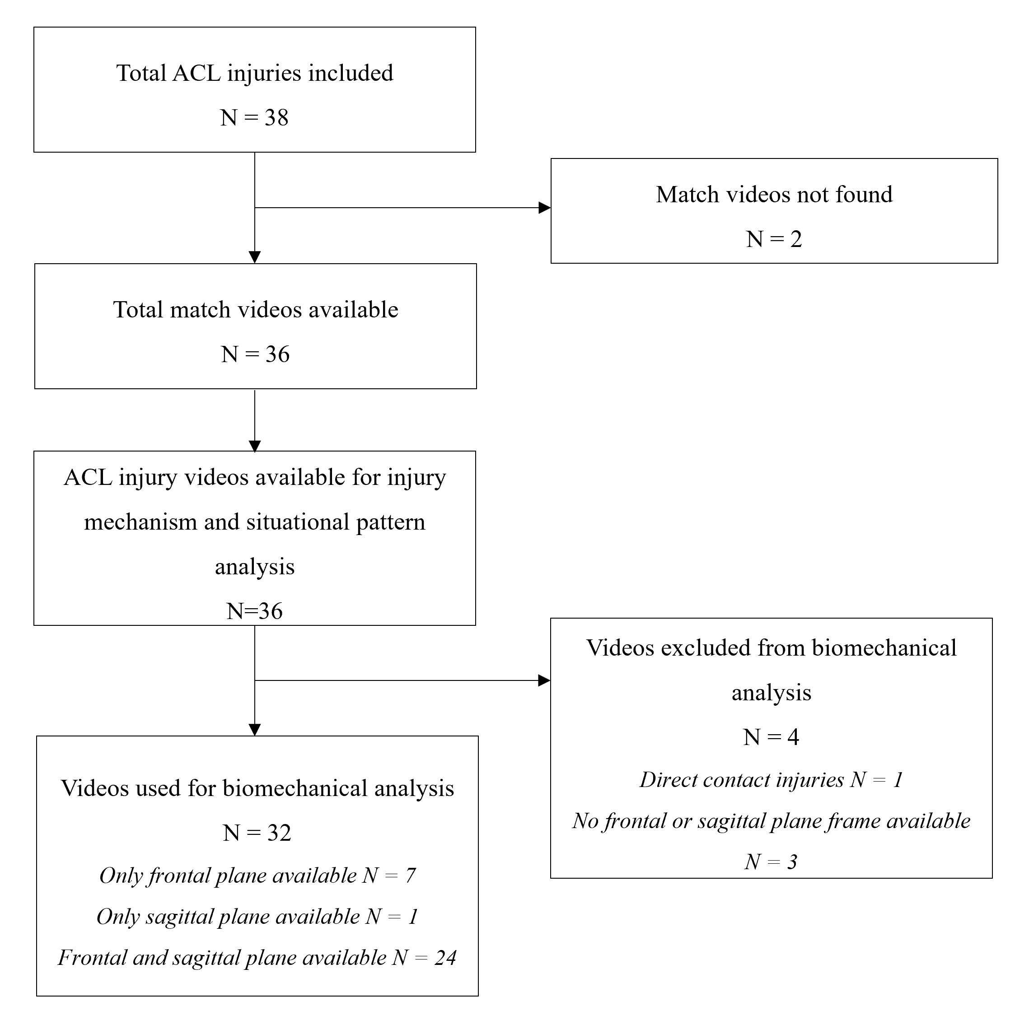
Figure 1. Detailed flowchart of the study. ACL, anterior cruciate ligament
Injury Mechanism Analysis
Video footage was available and identifiable for injury mechanism and situational pattern in 36 cases (95%). More injuries occurred whilst attacking (n=25, 69%) than defending (n=11, 31%). Most injuries (n=35; 97%) involved loading of the injured leg, with single limb loading on the ground frequently observed (n=29; 81%). We categorized one (3%) direct contact, 21 (58%) indirect contact and 14 (39%) non-contact injuries. A large proportion of injuries involved high or moderate horizontal speeds (72% of cases), whilst few (22% of cases) involved high or moderate vertical speeds at the time of injury (Table 1).

Table 1 Details of injury mechanisms of anterior cruciate ligament injuries in professional male basketball players (n=36).
Variables | Results
Playing phase before the injury | Offensive (n=25), defensive (n=11),
Field location at the time of injury | Zone 1 (n=3), zone 2 (n=3), zone 3 (n=5), zone 4 (n=4), zone 5 (n=18), zone 6 (n=3)
Player contact preceding injury | Yes (n=20), no (n=16)
If contact, where? | Upper body (n= 20)
Player contact at IF | Yes (n=14), no (n=22)
If indirect contact at IF, where? | Upper body (n=13)
Injury classification | Direct contact (n=1), indirect contact (n=21), non-contact (n=14)
How many feet were on the ground | One (n=29), two (n=7)
Leg loading at IF | Injured leg (n=35), both legs (n=1)
Horizontal speed | Zero (n=5), low (n=5), moderate (n=12), high (n=14)
Vertical speed | Zero (n=26), low (n=2), moderate (n=1), high (n=7)
Distance from the ball (meters) | 0-1 (n=30), 1-2 (n=4), 2-3 (n=2)
IF, injury frame.

Situational patterns of indirect and non-contact ACL injuries
Three main situational patterns were identified accounting for 83% of injuries. Offensive cut injuries were the most common, accounting for nearly half of all injuries (n=17, 47%). These injuries involved ball possession, with the injured player typically trying to overcome an opponent with the intention to drive towards the basket. Seven (41%) of these injuries occurred without any contact (Figure 2a), whilst ten (59%) involved indirect contact to the upper body, prior to or at estimated IF (Figure 2b), generally resulting in an ipsilateral trunk tilt at IC (Table 5).
Landing from a jump was the second most common situation, accounting for more than one in five injuries (n=8, 22%). These typically occurred after rebounding, blocking, boxing-out or a lay-up. Most involved indirect contact (88%) and single leg landing mechanism (88%) (Figure 3).
Defensive cut was the third situational pattern identified accounting for one in seven injuries (n=5, 14%) and involved a defensive pressing situation (Figure 3). The other five injuries involved dribbling, pivoting, rebounding or during a duel for the ball. See table 2 for additional details.

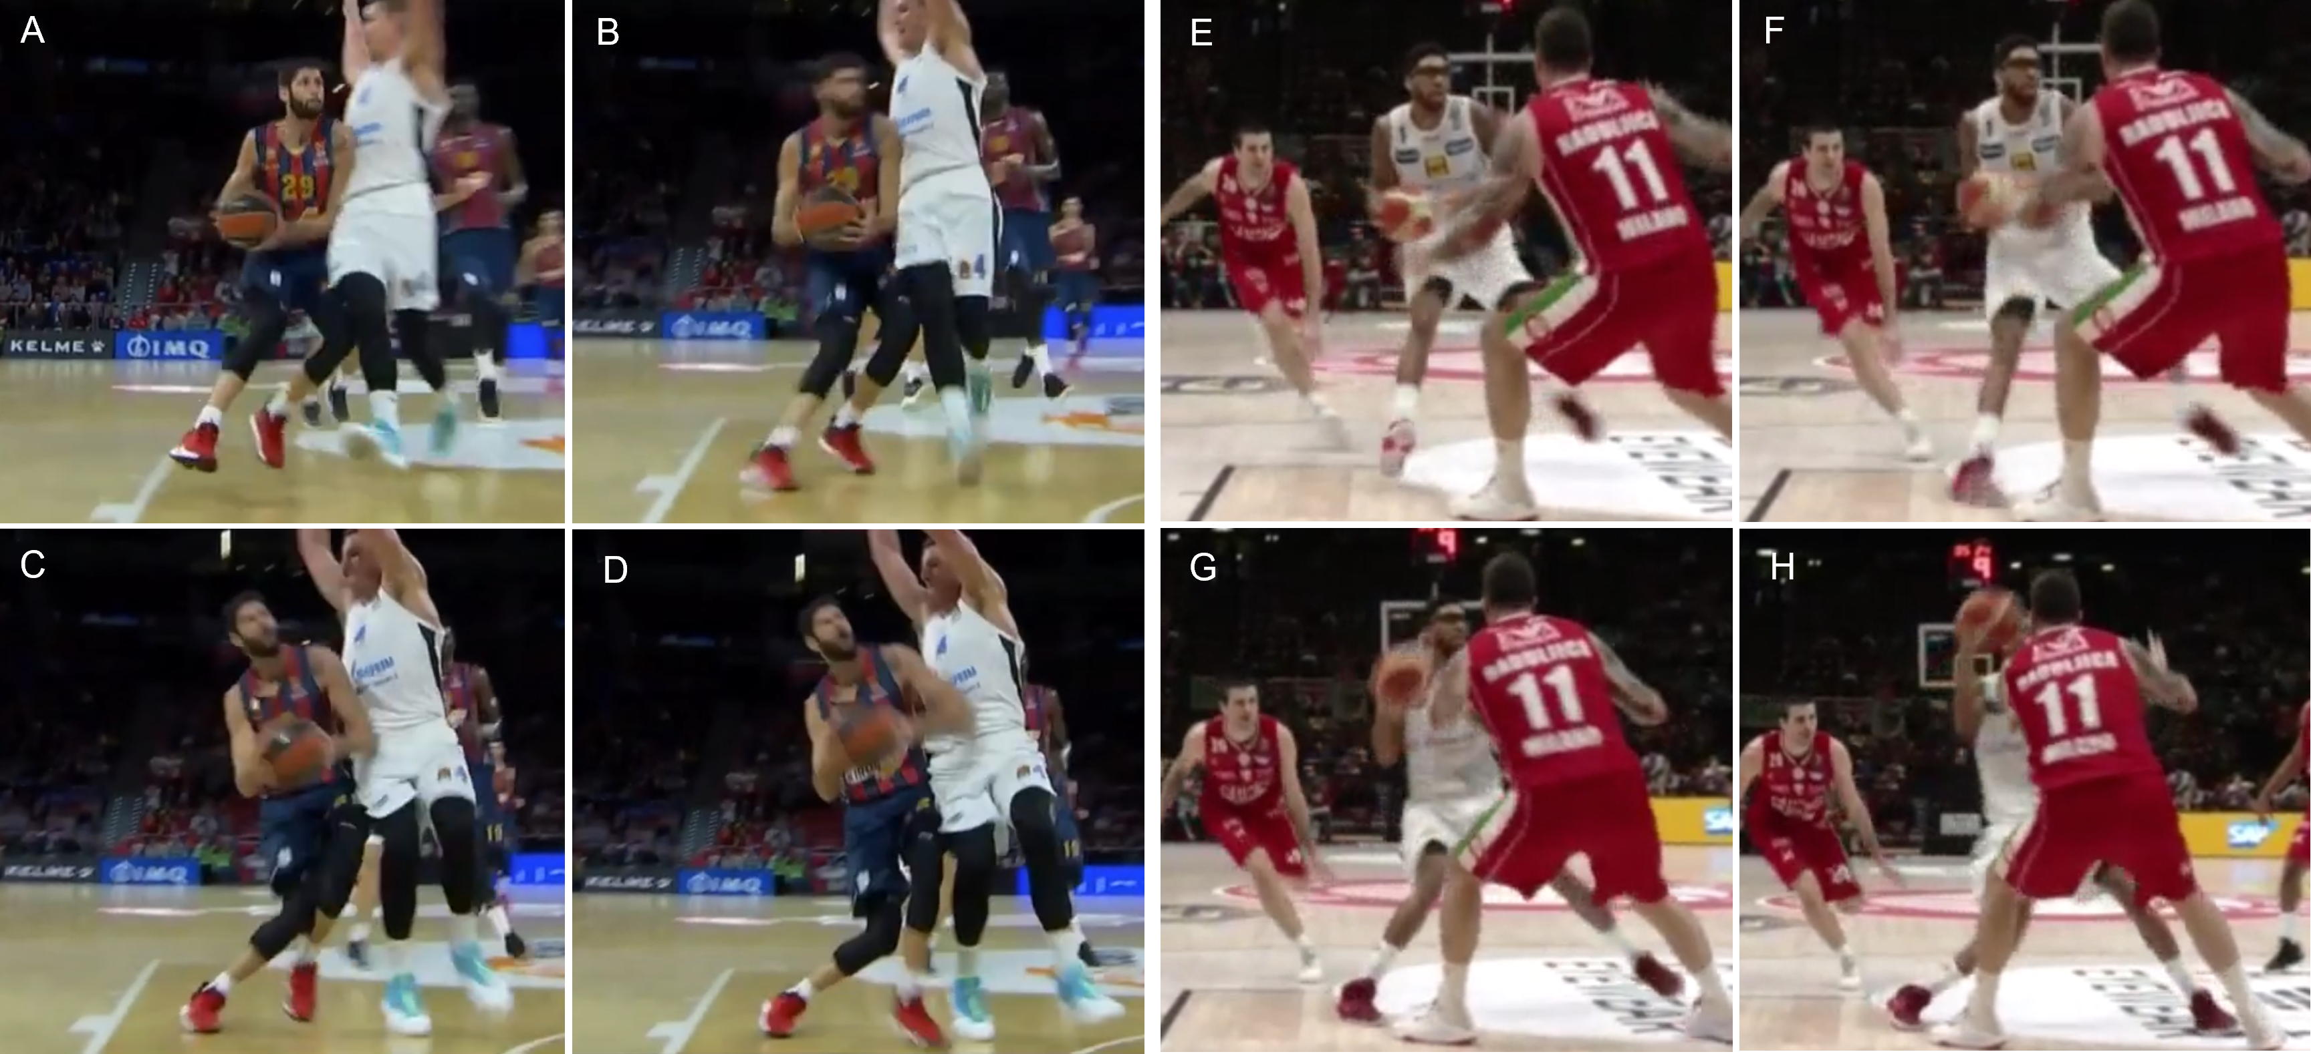
Figure 2. Two examples of “offensive cut” situational pattern for ACL injuries in basketball. A to D Indirect contact injury of player in blue and red stripes (jersey number 29, right ACL injury) in ball possession. A: before contact the ground upper body perturbation. B: initial contact. C: estimated injury frame. D: complete knee valgus collapse. E to G, right ACL noncontact injury of player in the white kit in ball possession. E: player approaching the cut with ball possession. F: initial contact. G: estimated injury frame. H: post-injury.
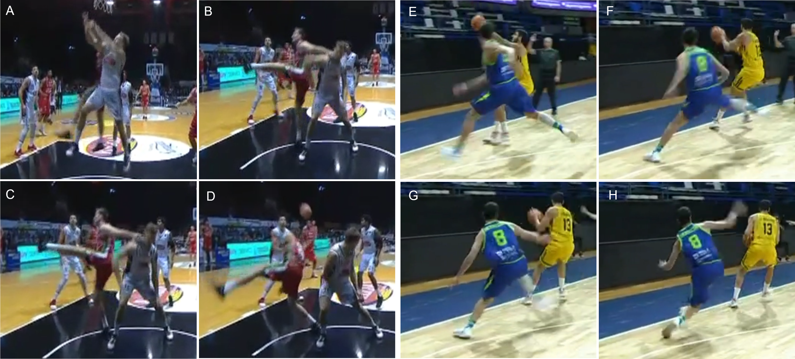
Figure 3. Examples of landing and defensive cut situational patterns. A to D, landing from jump (player in the red kit, right ACL injury). A: duel for the ball. B: initial contact. C: estimated injury frame. D: loss of balance after injury. E to G, defensive cut of player in the blue kit (jersey number 8, left ACL injury). E: neurocognitive perturbation (opponent reach the ball) pre-contact. F: initial contact. G: estimated injury frame. H: loss of balance.

Table 2 Details of situational patterns of ACL injuries in professional male basketball players (n=36 injuries).
Pattern | Playing phase | Injury mechanism | Horizontal velocity | Vertical velocity | Field location
Offensive cut (n=17, 47%) | 17 (100%) Offensive | 10 (59%) Indirect contact  7 (41%) Non-contact | 1 (6%) Zero  6 (35%) Moderate  10 (59%) High | 17 (100%) Zero | 2 (12%) Zone 4  11 (65%) Zone 5  4 (23%) Zone 6
Landing (n=8, 22%)  Bilateral (n=1)  Unilateral (n=7) | 5 (63%) Offensive  3 (38%) Defensive | 1 (12%) Non-contact  7 (88%) Indirect contact | 2 (25%) Zero  3 (38%) Moderate  3 (38%) High | 1 (13%) Moderate  7 (88%) High | 2 (25%) Zone 1  1 (13%) Zone 2  4 (50%) Zone 5
Defensive cut (n=5, 14%) | 5 (100%) Defensive | 4 (80%) Non-contact  1 (20%) Indirect contact | 1 (20%) Zero  2 (40%) Moderate  2 (40%) High | 2 (40%) Low  2 (40%) Moderate  1 (20%) High | 5 (100%) Zone 3
Others (n=6, 17%)  dribbling (n=2)  pivoting(n=1)  rebounding (n=2)  duel for ball (n=1) | 3 (50%) Offensive  3 (50%) Defensive | 2 (33%) Non-contact  3 (50%) Indirect contact  1 (17%) Direct contact | 2 (33%) Zero  3 (50%) Low  1 (17%) Moderate  0 (0%) High | 6 (100%) Zero  0 (0%) Low  0 (0%) Moderate  0 (0%) High | 3 (50%) Zone 1  1 (17%) Zone 3  2 (33%) Zone 4

Biomechanical analysis
Biomechanical analysis was possible in 32 cases, with 22 cases having both frontal and sagittal plane images, nine with frontal plane only and one with sagittal plane only (foot strike analysis was possible on 31 injury videos).
At IC, in the sagittal plane, players displayed a minimally flexed trunk (median, 6°), a moderately flexed hip (median, 32°), shallow flexed knee (median, 24°), plantar flexed ankle (median, 13°) and flat foot (42% of cases). On the frontal plane at IC, the trunk was tilted ipsilaterally (median, 11°) and either neutral (44% of cases) or rotated towards the injured leg (25% of cases), with the hip generally abducted (75% of the cases), the knee typically neutral (50% of cases) or in valgus (22% of cases) and the foot often externally rotated (44% of cases).
At estimated IF, the trunk remained minimally flexed (median, 4°), the hip similarly flexed (median, 30°), the knee more flexed (+22°, median, 46°) and the ankle now slightly dorsiflexed (+22°, median, 7°), with the foot predominantly planted flat (83% of cases). On the frontal plane at IF, the trunk remained tilted ipsilaterally (median, 13°) with a prevalence of trunk rotation towards the uninjured side (44%). The hip remained abducted in most cases (64% of cases), with greater prevalence of knee valgus (75% of cases), and externally rotated foot (50% of cases).
Knee valgus loading was frequently observed, and a significant visually identifiable increase in hip internal rotation and/or adduction from IC to IF was seen in most cases (75% of cases), whilst valgus collapse occurred in 22% of cases. The most common intersegmental body positions in the two most common situational patterns, offensive cut, and landing, are shown in Figure 4. See tables 3 and 4 for more details about biomechanics.

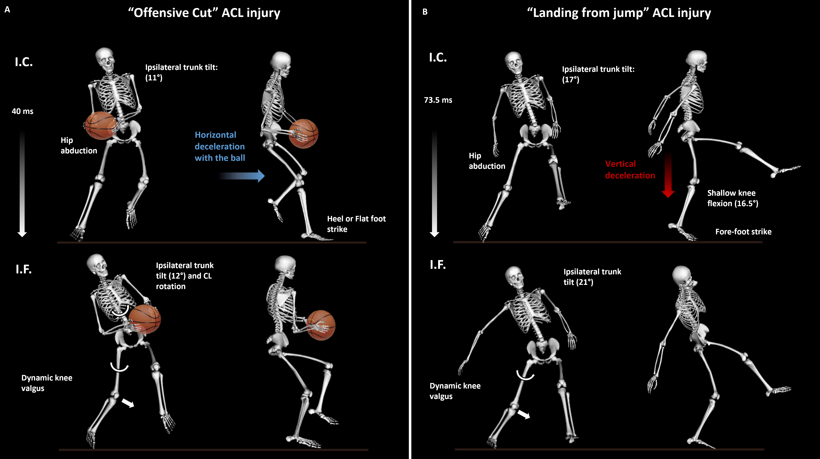
Figure 4. Biomechanics (kinematics) of the two most frequent pattens for ACL injuries in male professional basketball players. A: offensive cut; B: landing from jump.
Table 3. Sagittal plane metrics of ACL injuries (complete analysis on 23 cases with foot strike data available for 32 cases). Data are reported as median (min, max) or count (%).
Variables | Total |  |  |  | Offensive cut | Landing from  jump | Defensive cut | Other
Flexion angle (°)
Trunk at IC | 6 (-20, 30) |  |  |  | 9 (-7, 23) | -1 (-16, 20) | 7.5 (0, 30) | -10 (-20, 0)
Trunk at IF | 4 (-22, 26) |  |  |  | 11 (2, 24) | 1 (-22, 23) | 9 (-5, 26) | -8 (-16, 0)
Hip at IC | 32 (2, 59) |  |  |  | 49 (32, 59) | 7 (2, 20) | 22 (12, 32) | 34 (18, 49)
Hip at IF | 30 (8, 66) |  |  |  | 52 (29, 66) | 22 (8, 29) | 27 (17, 40) | 36 (29, 43)
Knee at IC | 24 (10, 55) |  |  |  | 25 (10, 55) | 16.5 (10, 24) | 36 (23,42) | 43 (35, 50)
Knee at IF | 46 (-19, 88) |  |  |  | 45 (-19, 88) | 45 (27, 53) | 55 (40, 70) | 57 (53, 60)
Ankle at IC | -13 (-45, 28) |  |  |  | -13 (-30, 28) | -25 (-32, 5) | -5 (-10,15) | -29 (-45, -12)
Ankle at IF | 7 (-50, 40) |  |  |  | 4.5 (-50, 30) | 20 (-16, 25) | 15 (2,40) | 20 (8, 32)
Foot strike appearance at IC
Heel | 9 (28%) |  |  |  | 7 (44%) | 0 (0%) | 2 (40%) | 0 (0%)
Flat | 15 (47%) |  |  |  | 8 (50%) | 2 (29%) | 3 (60%) | 2 (50%)
Toe | 7 (22%) |  |  |  | 1 (6%) | 5 (71%) | 0 (0%) | 1 (25%)
Unsure | 1 (3%) |  |  |  | 0 (0%) | 0 (0%) | 0 (0%) | 1 (25%)
Foot strike appearance at IF
Heel | 0 (0%) |  |  |  | 0 (0%) | 0 (0%) | 0 (0%) | 0 (0%)
Flat | 30 (94%) |  |  |  | 16 (100%) | 6 (75%) | 5 (100%) | 3 (75%)
Toe | 1 (3%) |  |  |  | 0 (0%) | 1 (25%) | 0 (0%) | 0 (0%)
Unsure | 1 (3%) |  |  |  | 0 (6%) | 0 (13%) | 0 (0%) | 1 (25%)
IC, initial contact; IF, injury frame.
Table 4. Frontal and transverse plane metrics of ACL injuries, stratified according to main situational patterns (data on 31 cases). Data are reported as median (min, max) or count (%).
Variables | Total |  |  |  |  | Offensive cut | Landing from jump | Defensive cut | Other
Trunk tilt at IC (°)  (+ipsilateral, -contralateral) | 11 (3, 27) |  |  |  |  | 11 (4, 27) | 17 (8, 21) | 12 (10, 20) | 10 (3, 16)
Trunk tilt IF (°)  (+ipsilateral, -contralateral) | 13 (1, 33) |  |  |  |  | 12 (1, 22) | 21 (10, 30) | 15 (10, 16) | 33 (2, 33)
Trunk rotation at IC
Towards injured | 9 (25%) |  |  |  |  | 5 (29%) | 1 (13%) | 2 (40%) | 1 (25%)
Neutral | 16 (44%) |  |  |  |  | 7 (41%) | 5 (63%) | 1 (20% | 3 (75%)
Towards uninjured | 6 (17%) |  |  |  |  | 4 (24%) | 0 (0%) | 2 (40%) | 0 (0%)
Unsure | 5 (14%) |  |  |  |  | 1 (6%) | 2 (25%) | 0 (0%) | 0 (0%)
Trunk rotation at IF
Towards injured | 7 (20%) |  |  |  |  | 3 (18%) | 3 (38%) | 0 (0%) | 1 (25%)
Neutral | 8 (22%) |  |  |  |  | 5 (29%) | 1 (13%) | 1 (20%) | 1 (25%)
Towards uninjured | 16 (44%) |  |  |  |  | 8 (47%) | 2 (25%) | 4 (80%) | 62 (50%)
Unsure | 5 (14%) |  |  |  |  | 1 (6%) | 2 (25%) | 0 (0%) | 0 (0%)
Frontal plane hip alignment at IC
Abduction | 27 (75%) |  |  |  |  | 13 (76%) | 6 (75%) | 5 (100%) | 3 (75%)
Neutral | 2 (6%) |  |  |  |  | 2 (12%) | 0 (0%) | 0 (0%) | 0 (0%)
Adduction | 0 (0%) |  |  |  |  | 0 (0%) | 0 (0%) | 0 (0%) | 0 (0%)
Unsure | 7 (20%) |  |  |  |  | 2 (12%) | 2 (25%) | 0 (0%) | 1 (25%)
Frontal plane hip alignment at IF
Abduction | 23 (64%) |  |  |  |  | 9 (53%) | 6 (75%) | 5 (100%) | 3 (75%)
Neutral | 4 (11%) |  |  |  |  | 4 (24%) | 0 (0%) | 0 (0%) | 0 (0%)
Adduction | 4 (11%) |  |  |  |  | 3 (18%) | 0 (0%) | 0 (0%) | 1 (25%)
Unsure | 5 (14%) |  |  |  |  | 1 (6%) | 2 (25%) | 0 (0%) | 0 (0%)
Frontal plane knee alignment at IC
Valgus | 8 (22%) |  |  |  |  | 3 (18%) | 1 (13%) | 4 (80%) | 0 (0%)
Neutral | 18 (50%) |  |  |  |  | 9 (53%) | 5 (63%) | 1 (20%) | 3 (75%)
Varus | 0 (0%) |  |  |  |  | 0 (0%) | 0 (0%) | 0 (0%) | 0 (0%)
Unsure | 10 (28%) |  |  |  |  | 5 (29%) | 2 (25%) | 0 (0%) | 1 (25%)
Frontal plane knee alignment at IF
Valgus | 27 (75%) |  |  |  |  | 15 (88%) | 5 (63%) | 5 (100%) | 2 (50%)
Neutral | 3 (8%) |  |  |  |  | 0 (%) | 1 (13%) | 0 (0%) | 2 (50%)
Varus\Hyperextended | 1 (3%) |  |  |  |  | 1 (6%) | 0 (0%) | 0 (0%) | 0 (0%)
Unsure | 5 (14%) |  |  |  |  | 1 (6%) | 2 (25%) | 0 (0%) | 0 (0%)
Foot position at IC
External | 16 (44%) |  |  |  |  | 7 (41%) | 4 (50%) | 2 (40%) | 3 (75%)
Neutral | 8 (22%) |  |  |  |  | 5 (29%) | 1 (13%) | 2 (40%) | 0 (0%)
Internal | 5 (14%) |  |  |  |  | 4 (24%) | 1 (13%) | 0 (0%) | 0 (0%)
Unsure | 7 (20%) |  |  |  |  | 1 (6%) | 2 (25%) | 1 (20%) | 1 (25%)
Foot position at IF
External | 18 (50%) |  |  |  |  | 8 (47%) | 5 (63%) | 2 (40%) | 3 (75%)
Neutral | 4 (11%) |  |  |  |  | 2 (12%) | 0 (0%) | 2 (40%) | 0 (0%)
Internal | 7 (19%) |  |  |  |  | 6 (35%) | 1 (13%) | 0 (0%) | 0 (0%)
Unsure | 7 (19%) |  |  |  |  | 1 (6%) | 2 (25%) | 1 (20%) | 1 (25%)
Significant hip IR/ADD from IC to IF?
Yes | 27 (75%) |  |  |  |  | 14 (82%) | 6 (75%) | 5 (100%) | 2 (50%)
No | 4 (11%) |  |  |  |  | 2 (12%) | 0 (0%) | 0 (0%) | 2 (50%)
Unsure | 5 (14%) |  |  |  |  | 1 (6%) | 2 (25%) | 0 (0%) | 0 (0%)
Valgus collapse?
Yes | 8 (22%) |  |  |  |  | 5 (29%) | 1 (13%) | 1 (20%) | 1 (25%)
No | 22 (61%) |  |  |  |  | 11 (65%) | 5 (63%) | 4 (80%) | 2 (50%)
Unsure | 6 (17%) |  |  |  |  | 1 (6%) | 2 (25%) | 0 (0%) | 1 (25%)
IC, initial contract; IF, injury frame; IR, internal rotation; ADD, adduction

Positional, match, and court distribution
Data for position (n=38), match (n=38), and court distribution (n=36) were available. Eleven injuries occurred to each of point guard (29%) and shooting guard (29%), nine to small forward (24%), four to center (10%) and three to power forward (8%).
A similar number of injuries occurred in the first (n=20, 53%) and second (n=18, 47%) half. More injuries occurred in the second (n=14, 37%) and fourth (n=13, 34%) quarters, than the first (n=6, 16%) and third (n=5, 13%) quarters (p=0.028, Figure 5a). The analysis of players actual playing time when correcting for substitutions was possible in 33 cases, in which one-third of injuries (n=11, 33%) occurred in the first five minutes of player’s actual playing time, and half (n=17, 51%) within the first ten minutes of actual playing time (Figure 5b). Injuries according to court location are presented in Figure 6 (and detailed in supplementary material). Three quarters (73%) of injuries occurred in zone five (see supplementary material for additional details on injuries according to court location).
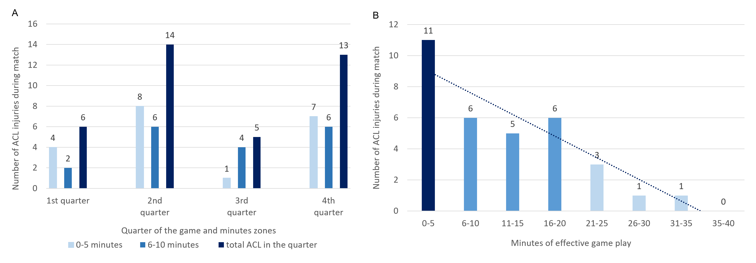 Figure 5. Distribution of ACL injuries during the match. A: distribution during the match duration and across the quarters. B: distribution of ACL injuries according to minutes of effective match-time.
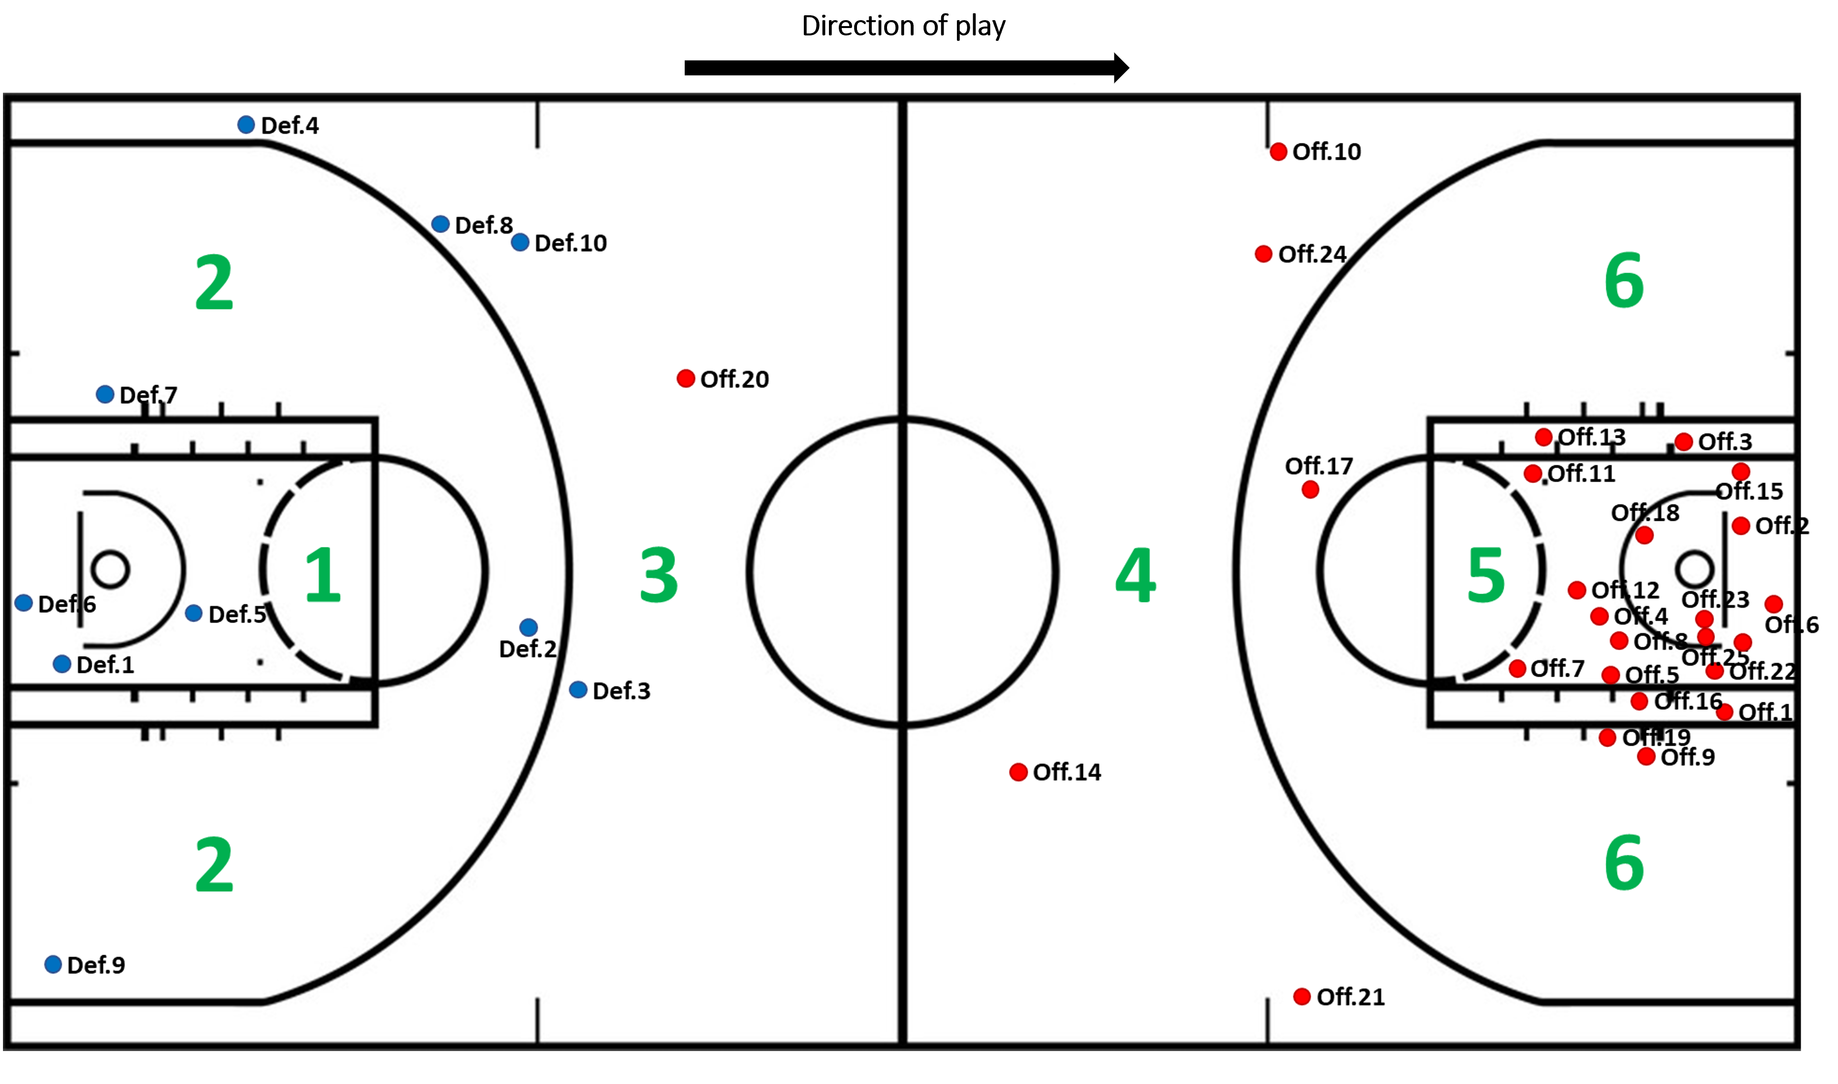
Figure 6. Distribution of ACL injuries on the basketball court. The court has been divided into six zones. Zone 1 and 5 represent the three second zones, often referred to as the ‘paint zone’ in the back and front court respectively involving the key, up to the free throw line and not the top of the key; zones 2 and 6 are inside the semi-circle and 2-point scoring zone of the back and front court respectively minus the three second zone/key but including the top of the key from the free throw line and zones 3 and 4 are the 3-point scoring zones up to the mid-court line in the back and front court respectively. Blue dots: defensive injuries; red dots: offensive injuries. Def: defensive; Off: offensive.

DISCUSSION
The main findings of our study were that (1) virtually all (97%) ACL injuries in elite basketball occurred without direct contact to the knee, with more injuries occurring during indirect than non-contact mechanism; (2) there were three main situational patterns, with offensive cutting and not landing being the dominant pattern; (3) kinematic changes from IC to IF were multiplanar with differences between situational patterns and (4) there were differences in injuries between match quarters, location on the court and between positional roles.
Injury mechanism
Most ACL injuries occurred whilst attacking (69%), like previous research in basketball (74%).²¹ This is much higher than research in other sports such as soccer, which typically has noted more injuries, almost 70%, whilst defending,^{7,11,37} but very similar to another ball carrying sport, rugby (72% attacking).¹³ This suggests a higher risk of ACL injury in ball carrying sports, whilst attacking. Additionally, according to our data, ACL injuries in male basketball players are more commonly the result of horizontal deceleration (eg, cutting) rather than vertical deceleration (eg, landing from jump). Injury prevention programs should emphasize the importance of horizontal deceleration tasks.
We found a much lower number of direct contact injuries (3%) than previously reported in male basketball players (24%),²¹ although similar to that in female players.²¹ Basketball by rule is a ‘non-contact’ sport (although a large amount of contact does occur), and so lower values of direct contact ACL injuries versus other more contact-based sports like soccer (12%)^{11,37} and collision sports, as rugby (32%)¹³ are expected. This highlights the great potential for ACL injury risk mitigation strategies in basketball.
We found indirect contact (58%) as opposed to non-contact (39%) to be the dominant injury mechanism. This is very different to previous research on male basketball, which indicated few indirect contact injuries (12%), with most injuries being non-contact (65%).²¹ The importance of indirect contact in ACL injury causation has recently been reported other sports such as soccer,¹¹ rugby¹³ and American football,¹⁸ as well as in other injuries in soccer, including MCL.⁸ Our research highlights the importance of indirect contact injuries in ACL causation. Most of these indirect contact injuries involved contact to the injured players upper body at or prior to IF, which is thought to lead to mechanical perturbation resulting in loss of neuromuscular control and sub-optimal kinematics.
Like previous research in basketball,^{6,21} injuries typically occurred with the ball or opposing player in proximity. The role of neurocognitive errors and distraction has been highlighted as important in the mechanics of injuries in soccer¹⁶ and should not be neglected. However, in the case of basketball ACL injuries, these aspects may be less relevant as these injuries are more frequently offensive in nature, with the player potentially “in control” of the playing situation. ‘Mechanical perturbation’ during these offensive actions opposed to ‘neurocognitive perturbation’ may be more relevant and should be considered in injury risk mitigation program design.

Situational patterns
Most injuries occurred with three main situational patterns (i) offensive cut (47%); (ii) landing from jump (22%) and (iii) defensive cut (14%). We found more injuries during cutting (61% vs 12%) and less during landing (22% vs 59%%) than previous research in basketball.²¹ Previous research has not distinguished between offensive and defensive cutting. Of the landing injuries, we found these to be predominantly indirect contact single leg injuries, which differs to previous research, which reported non-contact single leg and double leg landing injuries.²¹ Offensive cutting ACL injuries were the most represented and therefore critical to be addressed. In our cohort, most of these injuries were indirect contact (~60%), with a mechanical perturbation at the upper body, suggesting a key role of player-to-player interactions. On the other hand, nearly 40% were non-contact, even in these very selected male professional players cohort. A potential approach to mitigate these injuries could be to address cutting technique¹⁴ while eccentrically strengthening the lower limb building the capacity to absorb high deceleration forces.³⁹ The defensive cut injury is a new situational pattern, not previously mentioned in basketball, apparent in 13% of injuries. These are like the pressing-type pattern identified by our group, and others in soccer^{11,24,37} and rugby.¹³ They often involve a neurocognitive perturbation,^{11,16} where the player must change direction to attempt to make a tackle/block. Pattern specific injury reduction principles are suggested.

Biomechanics
Data from our kinematic analysis largely confirms existing knowledge of ACL injuries, that they occur due to multiplanar loading.^{6,11,13,21,25,31,37} On the sagittal plane, our results support a ‘‘knee dominant’’ pattern at the time of injury,^{11,13,24} although with some differences between situational patterns. At IC, considering all injuries, we found an upright trunk, early flexed hip, and knee, and plantarflexed ankle. From IC to IF, there was minimal change in trunk or hip flexion, but moderate increase in knee flexion angle (+22º), as well as ankle dorsi-flexion (+20º). The 24º knee angle at IC is thought to correspond to high ACL loading and a vulnerable position.^{9,40} The knee flexion angle at IF (46º) is higher than previously found in basketball (18-23º),²¹ but more aligned with more recent video analysis research (30-53º),^{11,13,24} and those using model-based image matching approaches (47º).²³ Whilst we reported a “knee dominant” pattern on the sagittal plane (eg, preferential flexion at the knee and minimal hip/trunk flexion and reduced ankle plantar flexion), the change in knee flexion from IC to IF was still less than that found in similar movements, not resulting in injury (+22º vs +34º).⁶ The increase in ankle dorsi-flexion from IC to IF (+20º) was greater than previously found for ACL injuries in other sports (+0-16º),^{6,11,13,24,37} but still less than half that reported in controls performing similar movements and not sustaining ACL injuries (44º).⁶ The increase in ankle dorsi-flexion from IC to IF was less during cutting (18-20º) than landing (+45º), suggesting reduced ankle acceptance during cutting but not landing, may be associated with ACL injury. Interestingly, we also reported almost two times longer difference between IC and IF for landing (74 ms), than cutting (40 ms) injuries. A flat-footed strike pattern (95% of cases at IF during cutting) and reduced ankle angular motion (18-20 º vs 44º) likely contributed to ankle stiffness and knee joint loading by hindering the calf muscle’s ability to absorb external ground-reaction forces during cutting.^{10,38} This in combination with minimal trunk and hip motion, suggests preferential sagittal plane loading at the knee level, specifically during offensive cutting.
We also found altered frontal and transverse plane motions, thought to be essential for ACL injury.^{25,31} Knee valgus and valgus type loading from IC to IF was common, like previous research.^{11,13,23,37} Similarly, hip abduction motion was common^{11,13,37} with a significant increase in hip internal rotation and/or adduction (medial thigh motion) from IC to IF in most cases.
We found a lateral trunk tilt towards the injured limb at IC and IF (11-13º), like in other sports, but larger than in male professional soccer and rugby players (5º),^{11,13} suggesting a lower control of the upper body. The lateral trunk tilt was particularly high for landing injuries (21º). A lateral orientated trunk is thought to increase ACL loading due to resulting in a lateral shift of the center of mass, achieving a resultant vector line lateral to the knee joint, thereby increasing the knee abduction moment.³⁰
Complete valgus collapse occurred in 22% of cases, which is like that found previously in male basketball players (17%), but substantially lower than reported in female basketball players (53%).²¹ Compared to other sports, it is slightly higher than found for elite male soccer players (8%-13%),^{11,37} identical to elite female soccer players,²⁴ but substantially lower than reported in elite male rugby players (34%).¹³ It is likely a mix of task demands, player’s weight, and neuromuscular control/function, as well as sex-specific differences, account for the variability in complete valgus collapse across sports and sex and situational patterns.

Distribution of injuries across position, court location and timing in the match
We found positional differences in injury incidence suggesting greater risk for ACL injuries for Guards (58% of injuries, including point guard and shooting guard, 29% each), and lower incidence amongst centers (10%). Previous research on positional differences found less injuries for Guards than our study (42-45%) and higher incidence for Centers (19-22%) than we found,¹⁷ with minimal differences between positions.
Three quarters of all ACL injuries occurred within the attacking zone. Schultz et al.³³ found that NBA players with higher drive tendencies with the ball towards the basket, had a significantly higher rate of ACL injury (5.2%) than those with lower drive tendencies (3.8%). They suggested that players with high drive tendency more likely rely on quick lateral movements and acceleration/deceleration movements, shown here to be components of ACL injuries.
We found a similar number of injuries across first (53%) and second halves (47%). Previous research reported more injuries in the second half (62%)¹⁷ and suggested the role of fatigue as a mechanism of injury, which our work somewhat contradicts. Interestingly, we found more injuries in the second (37%) and fourth quarters (34%), compared to the first (16%) and third quarters (13%). The higher rate in the fourth quarter (34%), is similar to previous research (40%),¹⁷ but the high incidence in the second quarter (37%), contradicts with previous research (13%).¹⁷ Whilst higher numbers in the second and fourth quarters could indicate the role of fatigue within each half (as opposed to accumulative fatigue over the course of the match), when examining effective match minutes played, a third of injuries occurred in the first five minutes and more than 50% in the first ten minutes of a players effective playing time (when correcting for substitutions), with a strong trend showing less injuries as match minutes increased. It is not clear why there was a higher number of injuries in the second and fourth quarters. Typically, there is either similar workloads (total distance, distance per minute, acceleration and/or decelerations performed) across quarters^{1,2} or a gradual decline throughout the match.^{32,36} It is possible that use of substitutions during these quarters (two and four), with players arriving in the match with a lack of neuromuscular/neurocognitive preparation when coming from the bench may be responsible. Equally, given the complexity of ACL injury aetiology,⁴ we cannot rule out fatigue as a risk factor in some players. It is likely that injuries are due to multiple factors, including neuromuscular readiness, match intensity and still possibly acute and cumulative (fatigue over the course of match-play) fatigue, in some cases, amongst others.

Practical implications
Our work collectively suggests that many ACL injuries in male basketball players may be preventable, with few direct contact injuries found. Most injuries are indirect contact suggesting mechanical perturbation as an important factor in ACL causation. Whilst 40% were non-contact, these typically involved the ball or an opposing player close by, potentially indicating a role of neurocognitive error and/or distraction in injury causation. Understanding injury mechanisms is considered important for prevention.^{3,35} Our work suggests that improving neuromuscular control/kinematics during single leg landing and cutting actions, in response to either mechanical or neurocognitive perturbation may be important to reduce ACL injury risk. Previous research has shown that change of direction technique may be effectively trained to reduce external knee abduction moment¹⁴ and altered kinematics at the time of screening for change of direction kinematics has been shown to be prospectively associated with ACL injury risk, in a small group of female soccer players.¹⁵

Methodological considerations
The main strengths of our study are: (1) the sample size, the largest to date in systematic video analysis study of ACL injuries in elite male basketball players (the only other video analysis study in basketball had 39 player, but split across male (n=17) and female players (n=22)); (2) the consecutive nature of the injuries analyzed; (3) the consistent biomechanical (kinematic) analysis using measurement tools and three independent viewers; and (4) the inclusion of court and match distribution data. The weaknesses of the study lie in the methodology used to identify ACL injuries, different from the gold standard of prospective studies with frequent contact with the teams. This limits the information concerning concomitant injuries of the players. We determined kinematics prior to and at the time of injury using video analysis, as opposed to the gold standard model-based image-matching technique.²³ Video analysis though is valid²² and consistently adopted in similar studies.^{8,11,13,37} We have a male only elite level sample and thus this may not be generalisable to female players and players at lower levels. Further work to elucidate the injury mechanisms in these samples is warranted.

CONCLUSIONS
Indirect contact as opposed to non-contact, is the main ACL injury mechanism in male professional basketball players. Three main situational patterns were described, with offensive cut being the most prevalent. Biomechanical analysis confirms a multiplanar mechanism, with knee loading patterning in the sagittal plane accompanied with dynamic valgus. More injuries occurred in the first 10 minutes of a player’s effective playing time, within the attacking zone and amongst Guards.

References
- Ben Abdelkrim N, Castagna C, Jabri I, Battikh T, El Fazaa S, El Ati J. Activity profile and physiological requirements of junior elite basketball players in relation to aerobic-anaerobic fitness. J Strength Cond Res. 2010;24(9):2330-2342.
- Ben Abdelkrim N, El Fazaa S, El Ati J. Time-motion analysis and physiological data of elite under-19-year-old basketball players during competition. Br J Sports Med. 2007;41(2):69–75.
- Bahr R, Krosshaug T. Understanding injury mechanisms: a key component of preventing injuries in sport. Br J Sports Med. 2005;39(6):324-329.
- Bittencourt NFN, Meeuwisse WH, Mendonça LD, Nettel-Aguirre A, Ocarino JM, Fonseca ST. Complex systems approach for sports injuries: moving from risk factor identification to injury pattern recognition-narrative review and new concept. Br J Sports Med. 2016;50(21):1309-1314.
- Boden BP, Sheehan FT, Torg JS, Hewett TE. Noncontact anterior cruciate ligament injuries: mechanisms and risk factors. J Am Acad Orthop Surg. 2010;18(9):520-527.
- Boden BP, Torg JS, Knowles SB, Hewett TE. Video analysis of anterior cruciate ligament injury: abnormalities in hip and ankle kinematics. Am J Sports Med. 2009;37(2):252-259.
- Brophy RH, Stepan JG, Silvers HJ, Mandelbaum BR. Defending puts the anterior cruciate ligament at risk during soccer: a gender-based analysis. Sports Health. 2015;7(3):244-249.
- Buckthorpe M, Pisoni D, Tosarelli F, Danelon F, Grassi A, Della Villa F. Three Main Mechanisms Characterize Medial Collateral Ligament Injuries in Professional Male Soccer-Blow to the Knee, Contact to the Leg or Foot, and Sliding: Video Analysis of 37 Consecutive Injuries. J Orthop Sports Phys Ther. 2021;51(12):611-618.
- Butler DL, Noyes FR, Grood ES. Ligamentous restraints to anterior posterior drawer in the human knee: a biomechanical study. J Bone Joint Surg Am. 1980;62:259-270.
- David S, Komnik I, Peters M, Funken J, Potthast W. Identification and risk estimation of movement strategies during cutting maneuvers. J Sci Med Sport. 2017;20(12):1075-1080.
- Della Villa F, Buckthorpe M, Grassi A, et al. Systematic video analysis of ACL injuries in professional male football (soccer): injury mechanisms, situational patterns and biomechanics study on 134 consecutive cases. Br J Sports Med. 2020;54(23):1423-1432.
- Della Villa F, Buckthorpe M, Tosarelli F, et al Video analysis of Achilles tendon rupture in male professional football (soccer) players: injury mechanisms, patterns and biomechanics. BMJ Open Sport Exerc Med. 2022;8:e001419. doi: 10.1136/bmjsem-2022-001419
- Della Villa F, Tosarelli F, Ferrari R, et al. Systematic video analysis of Anterior Cruciate Ligament injuries in professional male rugby players: Pattern, injury mechanism, and biomechanics in 57 consecutive cases. Orthop J Sports Med. 2021;9(11):23259671211048182. doi: 10.1177/23259671211048182. PMID: 34805419;
- Dempsey AR, Lloyd DG, Elliot BC, Steele JR, Munro BJ. Changing sidestep cutting technique reduces knee valgus loading. Am J Sports Med. 2009;37:2194-2200.
- Dix C, Arundale A, Silvers-Granelli H, Marmon A, Zarzycki R, Snyder-Mackler L. Biomechanical measures during two sport-specific tasks differentiate between soccer players who go on to anterior cruciate ligament injury and those who do not: a prospective cohort analysis. Int J Sports Phys Ther. 2020;15(6):928-935.
- Gokeler A, Benjaminse A, Della Villa F, Tosarelli F, Verhagen E, Baumeister J. Anterior cruciate ligament injury mechanisms through a neurocognition lens: implications for injury screening. BMJ Open Sport Exerc Med. 2021;7(2):e001091. doi: 10.1136/bmjsem-2021-001091. PMID: 34055386.
- Harris JD, Erickson BJ, Bach BR, et al. Return-to-sport and performance after anterior cruciate ligament reconstruction in National Basketball Association players. Sports Health. 2013;5(6):562-568.
- Johnston JT, Mandelbaum BR, Schub D, et al. Video analysis of Anterior Cruciate Ligament tears in professional American football athletes. Am J Sports Med. 2018;46(4):862-868.
- Kessler MA, Behrend H, Henz S, Stutz G, Rukavina A, Kuster MS. Function, osteoarthritis and activity after ACL-rupture: 11 years follow-up results of conservative versus reconstructive treatment. Knee Surg Sports Traumatol Arthrosc. 2008;16(5):442-448.
- Kester BS, Behery OA, Minhas SV, Hsu WK. Athletic performance and career longevity following anterior cruciate ligament reconstruction in the National Basketball Association. Knee Surg Sports Traumatol Arthrosc. 2017;25(10):3031-3037.
- Krosshaug T, Nakamae A, Boden BP, et al. Mechanisms of Anterior Cruciate Ligament injury in basketball: Video analysis of 39 cases. Am J Sports Med. 2007;35:359-357.
- Krosshaug T, Nakamae A, Boden BP, et al. Estimating 3D joint kinematics from video sequences of running and cutting maneuvers— assessing the accuracy of simple visual inspection. Gait Posture. 2007;26:378-385.
- Koga H, Nakamae A, Shima Y, et al. Mechanisms for noncontact Anterior Cruciate Ligament injuries: knee joint kinematics in 10 injury situations from female team handball and basketball. Am J Sports Med. 2010;38(11):2218-2225.
- Lucarno S, Zago M, Buckthorpe M, et al. Systematic video analysis of Anterior Cruciate Ligament injuries in professional female soccer players. Am J Sports Med. 2021;49(7):1794-1802.
- McLean SG, Huang X, Su A, Van Den Bogert AJ. Sagittal plane biomechanics cannot injure the ACL during sidestep cutting. Clin Biomech (Bristol, Avon). 2004;19:828-838.
- Minhas SV, Kester BS, Larkin KE, Hsu WK. The effect of an orthopaedic surgical procedure in the National Basketball Association. Am J Sports Med. 2016;44(4):1056-1061.
- Montgomery C, Blackburn J, Withers D, Tierney G, Moran C, Simms C. Mechanisms of ACL injury in professional rugby union: a systematic video analysis of 36 cases. Br J Sports Med. 2018;52(15):994-1001.
- Nwachukwu BU, Anthony SG, Lin KM, Wang T, Altchek DW, Allen AA. Return to play and performance after anterior cruciate ligament reconstruction in the National Basketball Association: surgeon case series and literature review. Phys Sportsmed. 2017;45(3):303-308.
- Patterson B, Culvenor AG, Barton CJ, et al. Poor functional performance 1 year after ACL reconstruction increases the risk of early osteoarthritis progression. Br J Sports Med. 2020;54:546-555.
- Powers CM. The influence of abnormal hip mechanics on knee injury: a biomechanical perspective. J Orthop Sports Phys Ther. 2010;40(2): 42-51.
- Quatman CE, Quatman-Yates CC, Hewett TE. A “plane” explanation of anterior cruciate ligament injury mechanisms: a systematic review. Sports Med. 2010;40:729-746.
- Scanlan A, Tucker P, Dascombe B, et al. Fluctuations in activity demands across game quarters in professional and semiprofessional male basketball. J Strength Cond Res. 2015;29(11):3006–3015.
- Schultz BJ, Thomas KA, Cinque M, Harris JD, Maloney WJ, Abrams GD. Tendency of driving to the basket is associated with increased risk of Anterior Cruciate Ligament tears in National Basketball Association players: A Cohort Study. Orthop J Sports Med. 2021;9(11):23259671211052953. doi: 10.1177/23259671211052953. PMID: 34778484.
- Starkey C. Injuries and illnesses in the National Basketball Association: A 10-year perspective. J Athl Train. 2000;35:161-167.
- van Mechelen W, Hlobil H, Kemper HC. Incidence, severity, aetiology and prevention of sports injuries: a review of concepts. Sports Med. 1992;14:82-99.
- Vázquez-Guerrero J, Fernández-Valdés B, Jones B, Moras G, Reche X, Sampaio J. Changes in physical demands between game quarters of U18 elite official basketball games. PLoS One. 2019;14(9):e0221818.
- Waldén M, Krosshaug T, Bjørneboe J, Andersen TE, Faul O, Hägglund M. Three distinct mechanisms predominate in non-contact anterior cruciate ligament injuries in male professional football players: a systematic video analysis of 39 cases. Br J Sports Med. 2015;49(22):1452-60.
- Weiss K, Whatman C. Biomechanics associated with patellofemoral pain and ACL injuries in sports. Sports Med. 2015;45(9):1325-1337.
- Weir G. Anterior cruciate ligament injury prevention in sport: biomechanically informed approaches. Sports Biomech. 2021:1-21. doi: 10.1080/14763141.2021.2016925. Epub ahead of print. PMID: 34965847.
- Withrow TJ, Huston LJ, Wojtys EM, Ashton-Miller JA. The relationship between quadriceps muscle force, knee flexion, and anterior cruciate ligament strain in an in vitro simulated jump landing. Am J Sports Med. 2006;34:269-274.

